Department of Computer Science

Lab Manual

of

Tiny MACHINE LEARNING

(MAI524B-5)

Class Name: V MSAIM

Master of Science Artificial Intelligence and Machine Learning

2026

Prepared by: Verified by:
Tejas R M 2548560
Dr. Helen K Joy

Department Overview
Department of Computer Science of CHRIST (Deemed to be University) strives to shape outstanding computer professionals with ethical and human values to reshape nation’s destiny. The training imparted aims to prepare young minds for the challenging opportunities in the IT industry with a global awareness rooted in the Indian soil, nourished and supported by experts in the field.

Vision
The Department of Computer Science endeavours to imbibe the vision of the University “Excellence and Service”. The department is committed to this philosophy which pervades every aspect and functioning of the department.

Mission
“To develop IT professionals with ethical and human values”. To accomplish our mission, the department encourages students to apply their acquired knowledge and skills towards professional achievements in their career. The department also moulds the students to be socially responsible and ethically sound.

Introduction to the Programme
Master of Computer Applications (MCA) is a post-graduate programme of CHRIST (Deemed to be University) and approved by the All India Council of Technical Education (AICTE). It is a two-year programme spread over six trimesters to bridge the chasm between computer studies and applications, bringing within reach of enthusiastic youngsters an excellent group of experienced and dedicated staff and experts, and an enviable infrastructure. MCA at CHRIST (Deemed to be University) strives to shape outstanding computer professionals with ethical and human values to reshape the nation’s destiny. The training programme aims to prepare young minds for challenging opportunities in the IT industry with a global awareness rooted in the Indian soil, nourished and supported by experts in the field. The Department is committed to the motto “Excellence and Service,” and this philosophy pervades every aspect of its functioning.

Programme Objective
This programme is conceptualised and designed based on the strong commitment of the
department to provide better quality education to the students. The principal objectives of this
course are to:
● Heighten technological awareness
● Train future industry specialists
● Encourage effective software development
● Provide research training
● Involve students in innovative research
● Produce graduates with a two-year professional education in Computer Science with
technical, professional, and communications skills.

Ethics and Human Values
1. Only proprietary or open-source software would be used for academic teaching and
learning purposes.
2. Copying of programs from the internet, friends or from other sources is strictly
discouraged since it impairs development of programming skills.
3. Unique Practical (Domain based) exercises ensure that the students don’t get involved in
code plagiarism.
4. Projects undertaken by students during the course are done in teams to improve
collaborative work and synergy between team members.
5. Projects involve modularization which initiates students to take individual responsibility
for common goals.
6. Passion for excellence is promoted among the students, be it in software development or
project documentation.
7. Giving due credit to sources during the seminar and research assignment is promoted
among the students
8. The course and its design enforce the practice of good referencing technique to improve
the sense of integrity.
9. Courses involving group discussions and debates on ethical practices and human values
are designed to sensitize the students in dealing with customers and members within the
Organization.

Programme Outcomes:
PO1 : Conduct investigation and develop innovative solutions for real world problems in industry and research establishments related to Artificial Intelligence and Machine Learning PO2 : Apply programming principles and practices for developing automation solutions to meet future business and society needs.
PO3 : Ability to use or develop the right tools to develop high end intelligent systems
PO4 : Adopt professional and ethical practices in Artificial Intelligence application development
PO5 : Understand the importance and the judicious use of technology for the sustainability of the environment.

Programme Educational Objectives(PEO’s)
PEO1: Develop innovative and effective software solutions through research that addresses
real-world challenges, grounded in a commitment to continuous learning and adaptability.
PEO2: Advance the knowledge and practices in the field of computer applications through
lifelong learning and rigorous research, supporting professional growth and academic excellence.
PEO3: Exhibit ethical leadership, social responsibility to contribute and enhance community
well-being by innovating solutions.

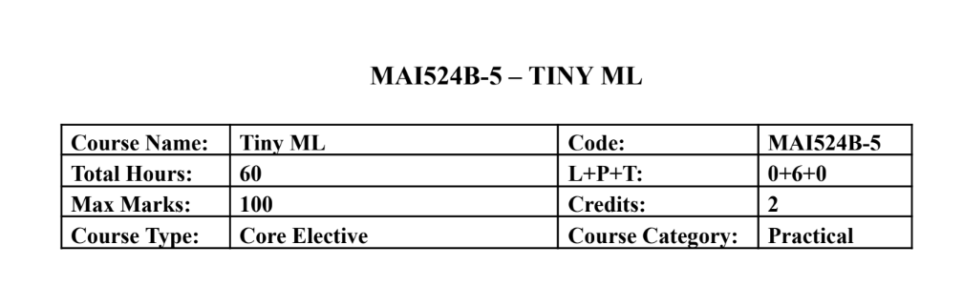Course Description
This course focuses on hands-on development of TinyML applications on mobile, edge, and
embedded platforms. Students learn the end to end workflow including data preparation,
lightweight model development, optimization, and deployment on microcontrollers using
sensors. Emphasis is placed on practical implementation using TensorFlow Lite, TensorFlow Lite
Micro, and embedded development environments with minimal theory and extensive laboratory
work.
Course Objectives
This course introduces the TinyML development workflow for edge intelligence and builds
practical skills in model optimization and embedded deployment. It enables students to develop
audio, vision, and sensor based TinyML applications and implement real time intelligent systems
using microcontrollers and hardware sensors.

Course Outcomes
CO1: Design TinyML workflows and lightweight models for edge devices.
CO2: Implement TensorFlow Lite-based optimisation and deployment.
CO3: Develop keyword spotting and visual TinyML applications.
CO4: Deploy sensor based TinyML solutions on embedded hardware.
CO5: Build end to end practical TinyML systems integrating hardware

Unit-1 Teaching Hours: 12
TINYML FOUNDATIONS AND WORKFLOW DESIGN
TinyML ecosystem overview – edge AI concepts – machine learning lifecycle – sensor roles in
TinyML – dataset planning – development environment setup – lightweight application
workflow design.Edge Computing vs Cloud Computing: A Comparative Demonstration of On
Device and Remote AI Inference
Practical Exercises:
1. Sensor data exploration and TinyML workflow planning using Colab.
2. Design and simulation of a TinyML application pipeline including preprocessing and
inference stages.

Unit-2 Teaching Hours: 12
TENSORFLOW LITE AND MODEL OPTIMIZATION
TensorFlow Lite workflow – model conversion – inference pipelines – low precision
computation – post training quantization – quantization aware training – performance
benchmarking.Human Activity Recognition Using Accelerometer and Multisensor Data
Practical Exercises:
3. Convert TensorFlow models to TensorFlow Lite and perform inference evaluation.
4. Implement quantization techniques and compare accuracy, latency, and memory usage.

Unit-3 Teaching Hours: 12
AUDIO TINYML AND KEYWORD SPOTTING
Keyword spotting architecture – audio preprocessing – MFCC and spectrogram features –
dataset preparation – training workflow – streaming audio inference.
Practical Exercises:
5. Train a keyword spotting model using speech datasets in Colab.
6. Deploy and test keyword spotting inference using live or recorded audio input.

Unit-4 Teaching Hours: 12
Visual Wake Words and Anomaly Detection
Visual wake word applications – transfer learning – lightweight vision models – anomaly
detection concepts – autoencoders and clustering – responsible dataset handling.Deploying a
Lightweight MLP and 1D CNN on Embedded Targets: Challenges and Performance Analysis
Practical Exercises:
7. Develop a visual wake word model using transfer learning techniques.
8. Build an anomaly detection system using sensor or industrial datasets.

Unit-5 Teaching Hours: 12
Embedded Deployment with TensorFlow Lite Micro
Microcontroller basics – embedded ML workflow – TensorFlow Lite Micro interpreter –
memory allocation – sensor integration – real time inference – deployment practices.
Practical Exercises:
9. Deploy a pretrained TinyML model on Arduino Nano 33 BLE Sense or equivalent
board.
10. Develop an integrated TinyML application such as gesture recognition, sensor anomaly
detection, or embedded keyword spotting.

Text & Reference Books
[1] TinyML, Pete Warden and Daniel Situnayake, O Reilly Media, First Edition, 2019
[2] Deep Learning with Python, Francois Chollet, Manning Publications, Second Edition,
2021
Essential Reading
[1] TinyML Cookbook, Gian Marco Iodice, Packt Publishing, First Edition, 2022
[2] Practical Edge AI, O Reilly Media, First Edition, 2023
Additional Information (Web Resources):
1. TensorFlow Lite Documentation: https://www.tensorflow.org/api_docs/python/tf/lite
2. TensorFlow Lite Micro GitHub Repository: https://github.com/tensorflow/tflite-micro
3. Arduino TinyML Tutorials:
https://docs.arduino.cc/tutorials/nano-33-ble-sense/get-started-with-machine-learning/
4. Edge Impulse TinyML Labs: https://www.edgeimpulse.com/
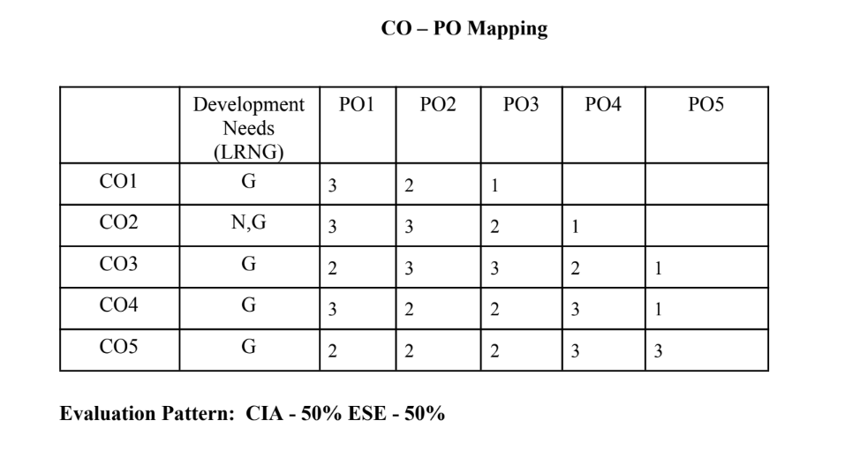

LIST OF PROGRAMS

MSCAIML
Sl.no | Title of lab Experiment | Page number | RBT | CO
1 | Real-Time Rotational Dynamics & Edge-AI Payload Safety System | 8 | L3 | CO1,3
2 | Multi-Class Human Activity Recognition & Model Quantization Scheme Analysis | 65 | L3 | CO2,3
3 | Quantization-Aware Training (QAT) | 108 | L3 | CO3
4 | "Shout STOP!": Train a Voice Emergency Stop Model | 123 | L3 | CO3
5 |  |  | L3 | CO3
6 |  |  | L3 | CO3,4
7 |  |  | L4 | CO3
8 |  |  | L3 | CO3,4
9 |  |  | L3 | CO4,5
10 |  |  | L5 | CO5

Evaluation Rubrics:
Evaluation Rubrics for each program would be
EVALUATION RUBRICS
(R1) Concept Clarity (Viva) - 3 M
(R2) Code Execution - 3M
(R3) Complexity Addition (Self Learning) -2 M
(R4) Timely Submission - 2 M

Submission Guidelines:
- Make a copy of the lab manual template with your <name_reg:no_subject name >,
- Copy the given question and the answer (lab code) with results, followed by the conclusion of that lab. Title the lab as lab number.
- Keep updating your lab manual and show the lab manual of that particular lab for evaluation.
- Create a Git Repository in your profile <tiny_ML_lab-reg no> . Follow a different branch for each lab <Lab 1, Lab 2…>, and push the code to Git. The link should be provided in Google Classroom along with the PDF of the lab manual.
- Upload the PDF to Google Classroom before the deadline.

Lab Question 1: Real-Time Rotational Dynamics & Edge-AI Payload Safety System

Tools Required: Smartphone with phyphox app, flat rotating platform, small test payload (e.g., coin or eraser), Python 3.x (Google Colab / Jupyter).

1. Aim
To measure tri-axial angular velocityusing a smartphone's gyroscope via phyphox, derive the physical threshold for rotational static friction failure, extract time-series features, and build an optimized TinyML classification model to predict payload stability (SAFE vs. UNSAFE/FALL) on an edge device.

2. Scenario & Problem Statement
An autonomous warehouse mobile robot carries an unanchored payload on its top surface. A smartphone mounted to the chassis acts as the primary Inertial Measurement Unit (IMU). When the robot negotiates sharp turns at high angular speeds, centripetal forces exceed static friction, causing cargo to slide off.
Your Task:
- Physical Setup: Place a test object on the smartphone screen
- Data Acquisition: Use phyphox to log gyroscope data while gradually increasing tilt and rotation speed until the object slides off.
- Data Engineering: Process raw CSV data
- Edge ML Pipeline: Label windowed data into binary classes (0 = SAFE, 1 = UNSAFE/FALL), train a lightweight classifier, and quantize it to .tflite format for local edge execution.

3. Submission Deliverables
- Workflow of the problem.
- Raw Dataset: Exported phyphox_gyro_data.csv.
- Python Code Script and git repo : Complete pipeline covering feature extraction, threshold determination, model training, and .tflite export.
- Lab Report: Experimental coefficient of static friction ($\mu_s$), model confusion matrix, and TFLite model size footprint in kilobytes.

Evaluation Rubric (10 Marks Total)
Assessment Module | Performance Criteria | Marks
1. Data Acquisition & Preprocessing | • Proper experimental setup and clean data collection.  • Correct signal processing, normalization, and feature engineering. | / 3
2. Implementation & Model Optimization | • Correct implementation of baseline models and algorithms.  • Successful execution of optimization, quantization, or deployment pipelines. | / 3
3. Results Analysis, Code & Deliverables | • Complete benchmarking/results analysis (accuracy, memory, speed, or system metrics).  • Clean, well-documented code with a clear final technical report. | / 4
TOTAL SCORE: _____ / 10 MARKS

Workflow:
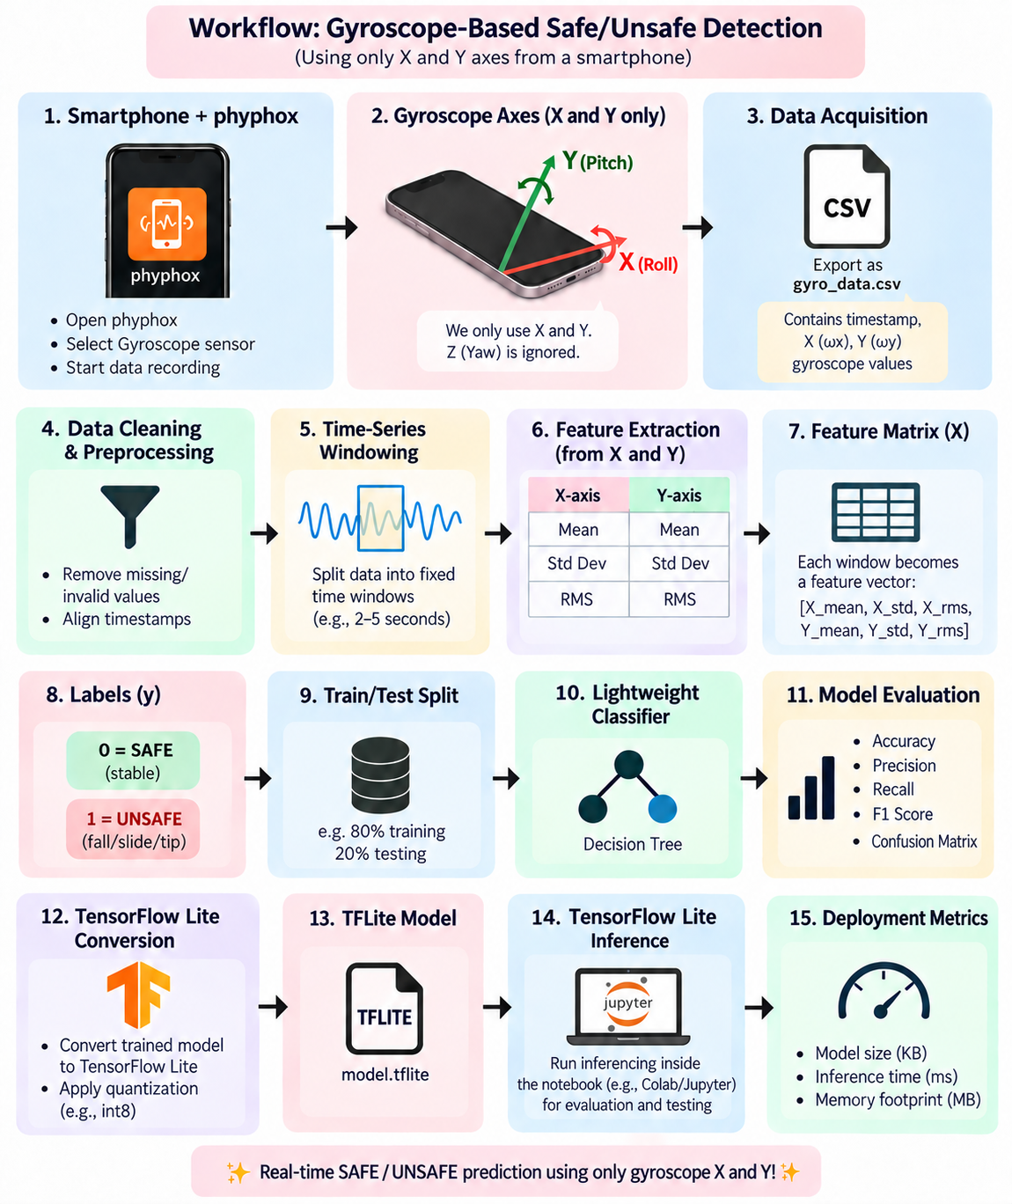

CODE:
import os
import glob
import time
import json
import warnings
from pathlib import Path
import numpy as np
import pandas as pd
import matplotlib.pyplot as plt
import seaborn as sns
from sklearn.tree import DecisionTreeClassifier, plot_tree
from sklearn.model_selection import GroupShuffleSplit
from sklearn.preprocessing import StandardScaler
from sklearn.metrics import (
accuracy_score, precision_score, recall_score, f1_score,
confusion_matrix, classification_report
)
import tensorflow as tf
from tensorflow import keras
sns.set_theme(style="whitegrid")
plt.rcParams["figure.figsize"] = (9, 5)
plt.rcParams["axes.titlesize"] = 13
plt.rcParams["axes.labelsize"] = 11
warnings.filterwarnings("ignore")
print("TensorFlow version:", tf.__version__)
print("All libraries imported successfully.")
DATA_DIR = Path("dataset")
RAW_DATA_DIR = DATA_DIR / "raw"
RAW_DATA_FILENAME = "Main_Raw Data.csv"
RAW_DATA_PATH = RAW_DATA_DIR / RAW_DATA_FILENAME
METADATA_PATH = DATA_DIR / "metadata" / "trial_metadata.csv"
OUTPUT_DIR = Path("outputs")
FIGURES_DIR = OUTPUT_DIR / "figures"
PROCESSED_DIR = OUTPUT_DIR / "processed"
MODELS_DIR = OUTPUT_DIR / "models"
REPORTS_DIR = OUTPUT_DIR / "reports"
for d in [RAW_DATA_DIR, METADATA_PATH.parent, FIGURES_DIR, PROCESSED_DIR, MODELS_DIR, REPORTS_DIR]:
d.mkdir(parents=True, exist_ok=True) if d == METADATA_PATH.parent or d.suffix == "" else None

WINDOW_SIZE_SECONDS = 3.0
WINDOW_OVERLAP = 0.5
EVENT_TIMES = [
3.00, 5.75, 8.27, 11.89, 18.71,
22.14, 25.94, 29.89, 32.51, 34.96,
42.31, 44.76, 49.25, 52.09, 55.33,
58.10, 60.65, 64.13, 68.37, 71.19,
]
EVENT_WINDOW_BEFORE = WINDOW_SIZE_SECONDS
EVENT_WINDOW_AFTER = WINDOW_SIZE_SECONDS
TEST_SIZE = 0.2
RANDOM_STATE = 42
DT_MAX_DEPTH = 5
KERAS_EPOCHS = 50
KERAS_BATCH_SIZE = 16
PAYLOAD_MASS_KG = None
ROTATION_RADIUS_M = None
GRAVITY = 9.81
np.random.seed(RANDOM_STATE)
tf.random.set_seed(RANDOM_STATE)

print("Configuration loaded.")
print(f"RAW_DATA_PATH = {RAW_DATA_PATH.resolve()}")
print(f"METADATA_PATH = {METADATA_PATH.resolve()}")
print(f"WINDOW_SIZE_SECONDS = {WINDOW_SIZE_SECONDS}, WINDOW_OVERLAP = {WINDOW_OVERLAP}")
print(f"EVENT_WINDOW_BEFORE = {EVENT_WINDOW_BEFORE}s, EVENT_WINDOW_AFTER = {EVENT_WINDOW_AFTER}s")
print(f"Number of recorded fall events: {len(EVENT_TIMES)}")
COLUMN_ALIASES = {
"timestamp": ["time (s)", "t (s)", "time", "timestamp"],
"gyro_x": ["gyroscope x (rad/s)", "gyroscope x (deg/s)", "wx (rad/s)",
"gyro x", "gyroscope x", "x (rad/s)"],
"gyro_y": ["gyroscope y (rad/s)", "gyroscope y (deg/s)", "wy (rad/s)",
"gyro y", "gyroscope y", "y (rad/s)"],
}
MANUAL_COLUMN_MAP = {
"timestamp": None,
"gyro_x": None,
"gyro_y": None,
}

def detect_column(df_columns, candidates):
"""Case-insensitive substring match of candidate names against actual columns."""
lowered = {c.lower(): c for c in df_columns}
for cand in candidates:
for lc, original in lowered.items():
if cand.lower() in lc or lc in cand.lower():
return original
return None

def standardize_columns(df, verbose=False):
"""
Map a raw phyphox dataframe's columns onto ['timestamp', 'gyro_x', 'gyro_y'].
Uses MANUAL_COLUMN_MAP first (if set), otherwise falls back to automatic
detection via COLUMN_ALIASES. Raises a clear error if a required column
cannot be resolved either way. Gyroscope Z (if present) is dropped.
"""
resolved = {}
for std_name, aliases in COLUMN_ALIASES.items():
manual = MANUAL_COLUMN_MAP.get(std_name)
if manual is not None:
if manual not in df.columns:
raise ValueError(
f"MANUAL_COLUMN_MAP['{std_name}'] = '{manual}' not found in "
f"columns: {list(df.columns)}"
)
resolved[std_name] = manual
else:
found = detect_column(df.columns, aliases)
if found is None:
raise ValueError(
f"Could not automatically detect a column for '{std_name}'. "
f"Available columns: {list(df.columns)}. "
f"Please set MANUAL_COLUMN_MAP['{std_name}'] explicitly."
)
resolved[std_name] = found

if verbose:
print("Resolved column mapping:", resolved)

out = df[[resolved["timestamp"], resolved["gyro_x"], resolved["gyro_y"]]].copy()
out.columns = ["timestamp", "gyro_x", "gyro_y"]
return out

print("Column mapping configuration ready.")
print("COLUMN_ALIASES:", json.dumps(COLUMN_ALIASES, indent=2))
if RAW_DATA_PATH.exists():
raw_df = pd.read_csv(RAW_DATA_PATH)
print(f"Loaded raw recording: {RAW_DATA_PATH.resolve()}")
else:
raw_df = pd.DataFrame()
print(f"[WARNING] Raw data file not found at {RAW_DATA_PATH.resolve()}. "
f"Place the phyphox export there (as '{RAW_DATA_FILENAME}') and re-run this cell.")

if not raw_df.empty:
print("\nRaw columns found:", list(raw_df.columns))
std_df = standardize_columns(raw_df, verbose=True)
std_df = std_df.sort_values("timestamp").reset_index(drop=True)
z_candidates = ["gyroscope z (rad/s)", "gyroscope z (deg/s)", "wz (rad/s)",
"gyro z", "gyroscope z", "z (rad/s)"]
z_col_name = detect_column(raw_df.columns, z_candidates)
if z_col_name is not None:
print(f"Detected Gyroscope Z column: '{z_col_name}' "
f"(kept for reference only — NOT used anywhere in the ML feature pipeline).")
else:
print("No Gyroscope Z column detected (not required — this pipeline only uses X and Y).")
n_raw_samples = len(std_df)
recording_duration = float(std_df["timestamp"].max() - std_df["timestamp"].min())
dt_all = std_df["timestamp"].diff().dropna()
est_sampling_hz = float(1.0 / dt_all.median()) if len(dt_all) else float("nan")
print(f"\nNumber of raw samples : {n_raw_samples}")
print(f"Recording duration (s) : {recording_duration:.3f}")
print(f"Estimated sampling freq : {est_sampling_hz:.2f} Hz (median dt = {dt_all.median():.6f} s)")
ts_values = std_df["timestamp"].values
event_rows = []
for i, event_time in enumerate(EVENT_TIMES):
nearest_idx = int(np.argmin(np.abs(ts_values - event_time)))
event_rows.append({
"trial_id": f"trial_{i + 1:02d}",
"trial": i + 1,
"event_time_s": event_time,
"matched_gyro_time_s": float(ts_values[nearest_idx]),
"event_index": nearest_idx,
})
event_table_df = pd.DataFrame(event_rows)
t_min, t_max = float(ts_values.min()), float(ts_values.max())
n_events = len(EVENT_TIMES)
seg_starts, seg_ends = [], []
for i, event_time in enumerate(EVENT_TIMES):
left_neighbor = t_min if i == 0 else EVENT_TIMES[i - 1]
right_neighbor = t_max if i == n_events - 1 else EVENT_TIMES[i + 1]
clamp_before = left_neighbor if i == 0 else (event_time + left_neighbor) / 2.0
clamp_after = right_neighbor if i == n_events - 1 else (event_time + right_neighbor) / 2.0
seg_starts.append(max(event_time - EVENT_WINDOW_BEFORE, clamp_before, t_min))
seg_ends.append(min(event_time + EVENT_WINDOW_AFTER, clamp_after, t_max))

event_table_df["segment_start_s"] = seg_starts
event_table_df["segment_end_s"] = seg_ends

trial_frames = []
trial_load_report = []
for _, row in event_table_df.iterrows():
tid = row["trial_id"]
seg = std_df[(std_df["timestamp"] >= row["segment_start_s"]) &
(std_df["timestamp"] <= row["segment_end_s"])].copy()
seg["trial_id"] = tid
trial_frames.append(seg[["trial_id", "timestamp", "gyro_x", "gyro_y"]])
trial_load_report.append({
"trial_id": tid,
"status": "loaded" if len(seg) > 0 else "empty_segment",
"n_samples": len(seg),
})

master_df = pd.concat(trial_frames, ignore_index=True) if trial_frames else \
pd.DataFrame(columns=["trial_id", "timestamp", "gyro_x", "gyro_y"])
auto_metadata_df = event_table_df[["trial_id", "matched_gyro_time_s"]].rename(
columns={"matched_gyro_time_s": "failure_time"}
).copy()
auto_metadata_df["label"] = 1
auto_metadata_df = auto_metadata_df[["trial_id", "label", "failure_time"]]

else:
std_df = pd.DataFrame(columns=["timestamp", "gyro_x", "gyro_y"])
event_table_df = pd.DataFrame(columns=["trial_id", "trial", "event_time_s",
"matched_gyro_time_s", "event_index",
"segment_start_s", "segment_end_s"])
trial_frames = []
trial_load_report = []
master_df = pd.DataFrame(columns=["trial_id", "timestamp", "gyro_x", "gyro_y"])
auto_metadata_df = pd.DataFrame(columns=["trial_id", "label", "failure_time"])
load_report_df = pd.DataFrame(trial_load_report)
print("\n=== Trial Load Report ===")
print(load_report_df if not load_report_df.empty else "No trials loaded.")
if not master_df.empty:
duration_rows = []
for tid, g in master_df.groupby("trial_id"):
duration_rows.append({
"trial_id": tid,
"n_samples": len(g),
"duration_s": float(g["timestamp"].max() - g["timestamp"].min()) if len(g) > 1 else 0.0,
})
trial_duration_df = pd.DataFrame(duration_rows)
print("\n=== Per-Trial Duration Summary ===")
print(trial_duration_df)

print(f"\nTotal trials loaded : {master_df['trial_id'].nunique()}")
print(f"Total raw samples : {len(master_df)}")

empty_trials = load_report_df.loc[load_report_df["n_samples"] == 0, "trial_id"].tolist() \
if not load_report_df.empty else []
if empty_trials:
print(f"\n[NOTE] {len(empty_trials)} trial(s) produced 0 samples because their real "
f"fall events are closer together than EVENT_WINDOW_BEFORE/AFTER allow without "
f"overlapping a neighboring trial: {empty_trials}. This reflects the actual "
f"spacing of the recorded falls, not a data error.")
else:
trial_duration_df = pd.DataFrame(columns=["trial_id", "n_samples", "duration_s"])
print("\nSummary not available until data is provided.")

if not event_table_df.empty:
display_table = event_table_df[["trial", "event_time_s", "matched_gyro_time_s", "event_index"]].rename(
columns={
"trial": "Trial",
"event_time_s": "Event Time (s)",
"matched_gyro_time_s": "Matched Gyro Time (s)",
"event_index": "Event Index",
}
)
print(display_table.to_string(index=False))
else:
print("Event table not available until data is provided.")

if not std_df.empty:
fig, ax = plt.subplots(figsize=(14, 5))
ax.plot(std_df["timestamp"], std_df["gyro_x"], color="darkorange", alpha=0.7, label="Gyro X")
ax.plot(std_df["timestamp"], std_df["gyro_y"], color="seagreen", alpha=0.7, label="Gyro Y")

ymax = max(std_df["gyro_x"].max(), std_df["gyro_y"].max())
for _, row in event_table_df.iterrows():
ax.axvline(row["matched_gyro_time_s"], color="black", linestyle="--", alpha=0.5)
ax.text(row["matched_gyro_time_s"], ymax * 0.92, str(int(row["trial"])),
rotation=90, fontsize=7, ha="right", va="top")

ax.set_title("Continuous Gyroscope Recording — 20 Recorded Fall Events Marked")
ax.set_xlabel("Time (s)")
ax.set_ylabel("Angular Velocity (rad/s)")
ax.legend()
plt.tight_layout()
plt.savefig(FIGURES_DIR / "continuous_recording_event_markers.png", dpi=150)
plt.show()
else:
print("Continuous recording plot skipped — no data available yet.")

if METADATA_PATH.exists():
metadata_df = pd.read_csv(METADATA_PATH)
print(f"Loaded metadata from {METADATA_PATH} with {len(metadata_df)} row(s) (external override).")
elif not auto_metadata_df.empty:
metadata_df = auto_metadata_df.copy()
print(f"No external metadata override found at {METADATA_PATH}. "
f"Using metadata auto-derived from the 20 matched fall events "
f"({len(metadata_df)} row(s)).")
else:
metadata_df = pd.DataFrame(columns=["trial_id", "label", "failure_time"])
print(f"[WARNING] Metadata file not found at {METADATA_PATH} and no trials were "
f"segmented in Step 3. Create {METADATA_PATH} with columns: "
f"trial_id, label, failure_time.")

validation_issues = []

if not metadata_df.empty:
dup_ids = metadata_df["trial_id"][metadata_df["trial_id"].duplicated()].unique().tolist()
if dup_ids:
validation_issues.append(f"Duplicate trial_id entries in metadata: {dup_ids}")
metadata_df = metadata_df.drop_duplicates(subset="trial_id", keep="first")

if not metadata_df.empty and "label" in metadata_df.columns:
invalid_labels = metadata_df[~metadata_df["label"].isin([0, 1])]
if not invalid_labels.empty:
validation_issues.append(
f"Invalid label values found (must be 0 or 1): "
f"{invalid_labels[['trial_id', 'label']].to_dict('records')}"
)

raw_trial_ids = set(master_df["trial_id"].unique()) if not master_df.empty else set()
meta_trial_ids = set(metadata_df["trial_id"].unique()) if not metadata_df.empty else set()

missing_metadata = sorted(raw_trial_ids - meta_trial_ids)
missing_raw = sorted(meta_trial_ids - raw_trial_ids)

if missing_metadata:
validation_issues.append(f"Raw trials with NO metadata entry: {missing_metadata}")
if missing_raw:
validation_issues.append(f"Metadata entries with NO matching raw CSV: {missing_raw}")

print("\n=== Metadata Validation Report ===")
if validation_issues:
for issue in validation_issues:
print(" [ISSUE]", issue)
else:
print(" No validation issues found." if (raw_trial_ids or meta_trial_ids)
else " Not available until data is provided.")

def run_quality_checks(df, meta=None, stage="unspecified"):
"""Run a battery of data-quality checks and print a report. Never silently
continues past a structural problem: known issues are always surfaced."""
print(f"\n=== Data Quality Report [{stage}] ===")

if df is None or df.empty:
print(" [ISSUE] Dataframe is empty — no data available yet.")
return

required_cols = {"trial_id", "timestamp", "gyro_x", "gyro_y"}
missing_cols = required_cols - set(df.columns)
if missing_cols:
print(f" [ISSUE] Missing required columns: {missing_cols}")

for col in ["gyro_x", "gyro_y"]:
if col in df.columns:
non_numeric = pd.to_numeric(df[col], errors="coerce").isna() & df[col].notna()
if non_numeric.any():
print(f" [ISSUE] {non_numeric.sum()} non-numeric value(s) found in '{col}'.")

nan_counts = df[[c for c in ["timestamp", "gyro_x", "gyro_y"] if c in df.columns]].isna().sum()
if nan_counts.sum() > 0:
print(f" [ISSUE] NaN values found:\n{nan_counts[nan_counts > 0]}")

numeric_df = df.select_dtypes(include=[np.number])
inf_counts = np.isinf(numeric_df).sum()
if inf_counts.sum() > 0:
print(f" [ISSUE] Infinite values found:\n{inf_counts[inf_counts > 0]}")

if {"trial_id", "timestamp"}.issubset(df.columns):
dup_ts = df.duplicated(subset=["trial_id", "timestamp"]).sum()
if dup_ts > 0:
print(f" [ISSUE] {dup_ts} duplicate (trial_id, timestamp) row(s) found.")

if "trial_id" in df.columns:
counts = df.groupby("trial_id").size()
short_trials = counts[counts < 10]
if not short_trials.empty:
print(f" [ISSUE] Very short trials (<10 samples): {short_trials.to_dict()}")

n_trials = df["trial_id"].nunique() if "trial_id" in df.columns else 0
if n_trials < 2:
print(f" [ISSUE] Insufficient number of trials for train/test splitting (found {n_trials}).")

if meta is not None and not meta.empty and "label" in meta.columns:
counts = meta["label"].value_counts()
if 0 not in counts.index:
print(" [ISSUE] No SAFE (label=0) trials found in metadata.")
if 1 not in counts.index:
print(" [ISSUE] No UNSAFE (label=1) trials found in metadata.")
if len(counts) == 2 and (counts.min() / counts.sum()) < 0.2:
print(f" [WARNING] Class imbalance detected in metadata: {counts.to_dict()}")

print(f" Rows checked: {len(df)}, Trials checked: {n_trials}")

run_quality_checks(master_df, metadata_df, stage="post-acquisition")

clean_df = master_df.copy()

print("=== dtypes ===")
print(clean_df.dtypes)

print("\n=== Missing values per column ===")
missing_summary = clean_df.isna().sum()
print(missing_summary)
n_dupes = clean_df.duplicated().sum()
print(f"\nExact duplicate rows: {n_dupes}")
clean_df = clean_df.drop_duplicates()
for col in ["gyro_x", "gyro_y"]:
before_na = clean_df[col].isna().sum() if col in clean_df.columns else 0
if col in clean_df.columns:
clean_df[col] = pd.to_numeric(clean_df[col], errors="coerce")
after_na = clean_df[col].isna().sum()
introduced = after_na - before_na
if introduced > 0:
print(f"[INFO] {introduced} non-numeric '{col}' value(s) coerced to NaN.")

if "timestamp" in clean_df.columns:
clean_df["timestamp"] = pd.to_numeric(clean_df["timestamp"], errors="coerce")
clean_df = clean_df.sort_values(["trial_id", "timestamp"]).reset_index(drop=True)

before_rows = len(clean_df)
clean_df = clean_df.dropna(subset=["timestamp", "gyro_x", "gyro_y"])
after_rows = len(clean_df)
print(f"\nDropped {before_rows - after_rows} row(s) with missing timestamp/gyro_x/gyro_y "
f"(explicit removal — no blanket interpolation applied).")
sampling_stats = []
for tid, g in clean_df.groupby("trial_id"):
dt = g["timestamp"].diff().dropna()
if len(dt) > 0:
sampling_stats.append({
"trial_id": tid,
"n_samples": len(g),
"duration_s": float(g["timestamp"].max() - g["timestamp"].min()),
"mean_dt": float(dt.mean()),
"std_dt": float(dt.std()),
"min_dt": float(dt.min()),
"max_dt": float(dt.max()),
})
sampling_stats_df = pd.DataFrame(sampling_stats)
print("\n=== Per-Trial Sampling Statistics ===")
print(sampling_stats_df if not sampling_stats_df.empty else "Not available until data is provided.")

run_quality_checks(clean_df, metadata_df, stage="post-cleaning")
fig, ax = plt.subplots()
missing_summary.plot(kind="bar", ax=ax, color="indianred")
ax.set_title("Missing Value Summary (Raw Master Dataframe)")
ax.set_xlabel("Column")
ax.set_ylabel("Number of Missing Values")
plt.tight_layout()
plt.savefig(FIGURES_DIR / "missing_value_summary.png", dpi=150)
plt.show()
if not sampling_stats_df.empty:
all_dt = clean_df.groupby("trial_id")["timestamp"].diff().dropna()
fig, ax = plt.subplots()
ax.hist(all_dt, bins=40, color="steelblue", edgecolor="black")
ax.set_title("Sampling Interval (Δt) Distribution Across All Trials")
ax.set_xlabel("Δt (seconds)")
ax.set_ylabel("Frequency")
plt.tight_layout()
plt.savefig(FIGURES_DIR / "sampling_interval_distribution.png", dpi=150)
plt.show()
else:
print("Sampling interval plot skipped — no data available yet.")
if not clean_df.empty:
representative_trial = sorted(clean_df["trial_id"].unique())[0]
trial_data = clean_df[clean_df["trial_id"] == representative_trial]

fig, ax = plt.subplots()
ax.plot(trial_data["timestamp"], trial_data["gyro_x"], color="darkorange")
ax.set_title(f"Raw Gyroscope X Signal — {representative_trial}")
ax.set_xlabel("Time (s)")
ax.set_ylabel("Angular Velocity X (rad/s)")
plt.tight_layout()
plt.savefig(FIGURES_DIR / "raw_gyro_x_signal.png", dpi=150)
plt.show()

fig, ax = plt.subplots()
ax.plot(trial_data["timestamp"], trial_data["gyro_y"], color="seagreen")
ax.set_title(f"Raw Gyroscope Y Signal — {representative_trial}")
ax.set_xlabel("Time (s)")
ax.set_ylabel("Angular Velocity Y (rad/s)")
plt.tight_layout()
plt.savefig(FIGURES_DIR / "raw_gyro_y_signal.png", dpi=150)
plt.show()

fig, ax = plt.subplots()
ax.plot(trial_data["timestamp"], trial_data["gyro_x"], label="Gyro X", color="darkorange")
ax.plot(trial_data["timestamp"], trial_data["gyro_y"], label="Gyro Y", color="seagreen")
ax.set_title(f"Gyroscope X vs Y — Representative Trial ({representative_trial})")
ax.set_xlabel("Time (s)")
ax.set_ylabel("Angular Velocity (rad/s)")
ax.legend()
plt.tight_layout()
plt.savefig(FIGURES_DIR / "raw_xy_comparison.png", dpi=150)
plt.show()
else:
print("Signal plots skipped — no data available yet.")

def generate_windows(df, window_size_s, overlap_frac, trial_col="trial_id", time_col="timestamp"):
"""
Generate (trial_id, window_start, window_end, start_idx, end_idx) tuples for
every trial independently. Windows never cross trial boundaries. Uses the
trial's own empirical sampling rate to convert the time-based window size
into an approximate sample count.
"""
window_rows = []

for tid, g in df.groupby(trial_col):
g = g.sort_values(time_col).reset_index(drop=True)
if len(g) < 2:
continue

dt_median = g[time_col].diff().median()
if pd.isna(dt_median) or dt_median <= 0:
continue

samples_per_window = max(int(round(window_size_s / dt_median)), 1)
step = max(int(round(samples_per_window * (1 - overlap_frac))), 1)

start_idx = 0
while start_idx + samples_per_window <= len(g):
end_idx = start_idx + samples_per_window
window_rows.append({
"trial_id": tid,
"start_idx": start_idx,
"end_idx": end_idx,
"window_start": float(g[time_col].iloc[start_idx]),
"window_end": float(g[time_col].iloc[end_idx - 1]),
})
start_idx += step

return pd.DataFrame(window_rows)

windows_index_df = generate_windows(clean_df, WINDOW_SIZE_SECONDS, WINDOW_OVERLAP)

print(f"Total windows generated: {len(windows_index_df)}")
if not windows_index_df.empty:
print(windows_index_df.groupby("trial_id").size().rename("n_windows"))
else:
print("No windows generated yet — check that dataset/raw/Raw Data.csv is present and covers the configured EVENT_TIMES.")
if not clean_df.empty and not windows_index_df.empty:
representative_trial = sorted(clean_df["trial_id"].unique())[0]
trial_data = clean_df[clean_df["trial_id"] == representative_trial].sort_values("timestamp").reset_index(drop=True)
trial_windows = windows_index_df[windows_index_df["trial_id"] == representative_trial]

fig, ax = plt.subplots(figsize=(11, 5))
ax.plot(trial_data["timestamp"], trial_data["gyro_x"], color="darkorange", label="Gyro X", alpha=0.8)
ax.plot(trial_data["timestamp"], trial_data["gyro_y"], color="seagreen", label="Gyro Y", alpha=0.8)

for i, (_, w) in enumerate(trial_windows.iterrows()):
ax.axvspan(w["window_start"], w["window_end"],
color="grey", alpha=0.15 if i % 2 == 0 else 0.05)

ax.set_title(f"Windowing Visualization — {representative_trial} "
f"(window={WINDOW_SIZE_SECONDS}s, overlap={WINDOW_OVERLAP})")
ax.set_xlabel("Time (s)")
ax.set_ylabel("Angular Velocity (rad/s)")
ax.legend()
plt.tight_layout()
plt.savefig(FIGURES_DIR / "windowing_visualization.png", dpi=150)
plt.show()
else:
print("Windowing visualization skipped — no data available yet.")

def rms(values):
values = np.asarray(values, dtype=float)
return float(np.sqrt(np.mean(np.square(values)))) if len(values) else np.nan

def extract_features_from_window(x_vals, y_vals):
"""
Compute the primary 6-feature vector [X_mean, X_std, X_rms, Y_mean, Y_std, Y_rms]
plus optional supplementary omega_xy statistics, from arrays of gyro_x/gyro_y
samples belonging to a single window. Z is never used.
"""
x_vals = np.asarray(x_vals, dtype=float)
y_vals = np.asarray(y_vals, dtype=float)
omega_xy = np.sqrt(x_vals ** 2 + y_vals ** 2)

return {

"X_mean": float(np.mean(x_vals)),
"X_std": float(np.std(x_vals)),
"X_rms": rms(x_vals),
"Y_mean": float(np.mean(y_vals)),
"Y_std": float(np.std(y_vals)),
"Y_rms": rms(y_vals),

"omega_xy_mean": float(np.mean(omega_xy)),
"omega_xy_std": float(np.std(omega_xy)),
"omega_xy_rms": rms(omega_xy),
}
feature_rows = []
for tid, g in clean_df.groupby("trial_id"):
g = g.sort_values("timestamp").reset_index(drop=True)
trial_windows = windows_index_df[windows_index_df["trial_id"] == tid]

for _, w in trial_windows.iterrows():
window_slice = g.iloc[w["start_idx"]:w["end_idx"]]
feats = extract_features_from_window(window_slice["gyro_x"].values,
window_slice["gyro_y"].values)
feats.update({
"trial_id": tid,
"window_start": w["window_start"],
"window_end": w["window_end"],
})
feature_rows.append(feats)

features_df = pd.DataFrame(feature_rows)

PRIMARY_FEATURE_COLS = ["X_mean", "X_std", "X_rms", "Y_mean", "Y_std", "Y_rms"]
SUPPLEMENTARY_FEATURE_COLS = ["omega_xy_mean", "omega_xy_std", "omega_xy_rms"]

print(f"Total feature windows extracted: {len(features_df)}")
if not features_df.empty:
ordered_cols = ["trial_id", "window_start", "window_end"] + PRIMARY_FEATURE_COLS + SUPPLEMENTARY_FEATURE_COLS
features_df = features_df[ordered_cols]
print(features_df.head())
else:
print("Not available until data is provided.")

X_matrix = features_df[PRIMARY_FEATURE_COLS].copy() if not features_df.empty else pd.DataFrame(columns=PRIMARY_FEATURE_COLS)

print("Feature matrix shape:", X_matrix.shape)
print("\nFirst rows:")
print(X_matrix.head())

print("\nDescriptive statistics:")
print(X_matrix.describe() if not X_matrix.empty else "Not available until data is provided.")

if not X_matrix.empty:

fig, axes = plt.subplots(2, 3, figsize=(15, 8))
for ax, col in zip(axes.ravel(), PRIMARY_FEATURE_COLS):
ax.hist(X_matrix[col], bins=25, color="cornflowerblue", edgecolor="black")
ax.set_title(f"Distribution of {col}")
ax.set_xlabel(col)
ax.set_ylabel("Frequency")
plt.tight_layout()
plt.savefig(FIGURES_DIR / "feature_distributions.png", dpi=150)
plt.show()

fig, ax = plt.subplots(figsize=(10, 6))
X_matrix.boxplot(column=PRIMARY_FEATURE_COLS, ax=ax)
ax.set_title("Feature Box Plots (Primary 6-Feature Vector)")
ax.set_ylabel("Value")
plt.tight_layout()
plt.savefig(FIGURES_DIR / "feature_boxplots.png", dpi=150)
plt.show()

fig, ax = plt.subplots(figsize=(7, 6))
sns.heatmap(X_matrix.corr(), annot=True, fmt=".2f", cmap="coolwarm", square=True, ax=ax)
ax.set_title("Feature Correlation Heatmap")
plt.tight_layout()
plt.savefig(FIGURES_DIR / "feature_correlation_heatmap.png", dpi=150)
plt.show()
else:
print("Feature plots skipped — no data available yet.")

def assign_labels(features_df, metadata_df):
"""
Assign a 0/1 label to every window using the documented rule:
- SAFE trial -> all windows = 0
- UNSAFE trial, no failure_time -> all windows = 1
- UNSAFE trial, with failure_time:
window fully before failure_time -> 0
window overlapping or after failure_time -> 1
"""
if features_df.empty or metadata_df.empty:
return pd.Series(dtype="Int64"), pd.DataFrame(
columns=["trial_id", "window_start", "window_end", "label"]
)

meta_lookup = metadata_df.set_index("trial_id")
labels = []
label_records = []

for _, row in features_df.iterrows():
tid = row["trial_id"]
if tid not in meta_lookup.index:
labels.append(pd.NA)
continue

trial_label = meta_lookup.loc[tid, "label"]
failure_time = meta_lookup.loc[tid, "failure_time"] if "failure_time" in meta_lookup.columns else np.nan

if trial_label == 0:
window_label = 0
else:
if pd.isna(failure_time):
window_label = 1
else:
if row["window_end"] <= failure_time:
window_label = 0
else:
window_label = 1

labels.append(window_label)
label_records.append({
"trial_id": tid,
"window_start": row["window_start"],
"window_end": row["window_end"],
"label": window_label,
})

return pd.Series(labels, name="label"), pd.DataFrame(label_records)

y_labels, label_trace_df = assign_labels(features_df, metadata_df)

if not features_df.empty:
features_df["label"] = y_labels

unlabelled = features_df["label"].isna().sum()
if unlabelled > 0:
print(f"[WARNING] {unlabelled} window(s) dropped — no matching metadata entry.")
features_df = features_df.dropna(subset=["label"]).reset_index(drop=True)
features_df["label"] = features_df["label"].astype(int)
X_matrix = features_df[PRIMARY_FEATURE_COLS].copy()
y_labels = features_df["label"].copy()

print("\n=== Class Counts ===")
if not features_df.empty:
counts = y_labels.value_counts().sort_index()
percentages = (counts / counts.sum() * 100).round(2)
class_summary_df = pd.DataFrame({"count": counts, "percentage": percentages})
class_summary_df.index = class_summary_df.index.map({0: "SAFE (0)", 1: "UNSAFE (1)"})
print(class_summary_df)

fig, ax = plt.subplots()
class_summary_df["count"].plot(kind="bar", ax=ax, color=["seagreen", "indianred"])
ax.set_title("SAFE vs UNSAFE Window Class Distribution")
ax.set_xlabel("Class")
ax.set_ylabel("Number of Windows")
plt.tight_layout()
plt.savefig(FIGURES_DIR / "class_distribution.png", dpi=150)
plt.show()
else:
print("Not available until data is provided.")

run_quality_checks(clean_df, metadata_df, stage="post-labelling")

if features_df.empty:
print("Train/test split not available until data is provided.")
X_train = X_test = pd.DataFrame(columns=PRIMARY_FEATURE_COLS)
y_train = y_test = pd.Series(dtype=int)
train_trials = test_trials = []
else:
n_trials_total = features_df["trial_id"].nunique()
class_trial_counts = metadata_df.set_index("trial_id").loc[
features_df["trial_id"].unique()
]["label"].value_counts()

if n_trials_total < 4 or class_trial_counts.min() < 1:
print(f"[WARNING] Only {n_trials_total} trial(s) available — this may be too few "
f"for a statistically meaningful trial-aware 80/20 split. Proceeding, but "
f"treat the resulting evaluation with caution.")

groups = features_df["trial_id"].values
splitter = GroupShuffleSplit(n_splits=1, test_size=TEST_SIZE, random_state=RANDOM_STATE)
train_idx, test_idx = next(splitter.split(X_matrix, y_labels, groups=groups))

X_train, X_test = X_matrix.iloc[train_idx], X_matrix.iloc[test_idx]
y_train, y_test = y_labels.iloc[train_idx], y_labels.iloc[test_idx]

train_trials = sorted(features_df.iloc[train_idx]["trial_id"].unique().tolist())
test_trials = sorted(features_df.iloc[test_idx]["trial_id"].unique().tolist())

overlap = set(train_trials) & set(test_trials)
if overlap:
print(f"[ERROR] Trial leakage detected between train and test: {overlap}")
else:
print("No trial leakage between train and test splits — confirmed.")

print(f"\nTraining trials ({len(train_trials)}): {train_trials}")
print(f"Testing trials ({len(test_trials)}): {test_trials}")
print(f"\nTraining windows: {len(X_train)}")
print(f"Testing windows : {len(X_test)}")

print("\nClass distribution — Training set:")
print(y_train.value_counts().sort_index())
print("\nClass distribution — Test set:")
print(y_test.value_counts().sort_index())

if len(X_train) == 0:
print("Decision Tree training skipped — no training data available yet.")
dt_model = None
else:
dt_model = DecisionTreeClassifier(max_depth=DT_MAX_DEPTH, random_state=RANDOM_STATE)
dt_model.fit(X_train, y_train)

print("Decision Tree trained.")
print("Parameters:", dt_model.get_params())
print(f"\nActual tree depth : {dt_model.tree_.max_depth}")
print(f"Number of leaves : {dt_model.tree_.n_leaves}")
print(f"Number of nodes : {dt_model.tree_.node_count}")

fig, ax = plt.subplots(figsize=(16, 8))
plot_tree(dt_model, feature_names=PRIMARY_FEATURE_COLS,
class_names=["SAFE", "UNSAFE"], filled=True, rounded=True, fontsize=9, ax=ax)
ax.set_title("Decision Tree Structure (Primary Lightweight Classifier)")
plt.tight_layout()
plt.savefig(FIGURES_DIR / "decision_tree_structure.png", dpi=150)
plt.show()

if dt_model is None or len(X_test) == 0:
print("Model evaluation not available until data is provided.")
dt_accuracy = dt_precision = dt_recall = dt_f1 = None
else:
y_pred = dt_model.predict(X_test)

dt_accuracy = accuracy_score(y_test, y_pred)
dt_precision = precision_score(y_test, y_pred, zero_division=0)
dt_recall = recall_score(y_test, y_pred, zero_division=0)
dt_f1 = f1_score(y_test, y_pred, zero_division=0)

print("=== Decision Tree — Test Set Performance ===")
print(f"Accuracy : {dt_accuracy:.4f}")
print(f"Precision: {dt_precision:.4f}")
print(f"Recall : {dt_recall:.4f}")
print(f"F1-score : {dt_f1:.4f}")

print("\n=== Classification Report ===")
print(classification_report(y_test, y_pred, target_names=["SAFE (0)", "UNSAFE (1)"], zero_division=0))

cm = confusion_matrix(y_test, y_pred, labels=[0, 1])
print("\nConfusion Matrix layout:")
print(" Pred SAFE Pred UNSAFE")
print(f"True SAFE TN={cm[0,0]} FP={cm[0,1]}")
print(f"True UNSAFE FN={cm[1,0]} TP={cm[1,1]}")

fig, ax = plt.subplots(figsize=(6, 5))
sns.heatmap(cm, annot=True, fmt="d", cmap="Blues",
xticklabels=["SAFE", "UNSAFE"], yticklabels=["SAFE", "UNSAFE"], ax=ax)
ax.set_title("Confusion Matrix — Decision Tree")
ax.set_xlabel("Predicted Label")
ax.set_ylabel("True Label")
plt.tight_layout()
plt.savefig(FIGURES_DIR / "confusion_matrix.png", dpi=150)
plt.show()

fig, ax = plt.subplots(figsize=(8, 5))
importances = pd.Series(dt_model.feature_importances_, index=PRIMARY_FEATURE_COLS).sort_values()
importances.plot(kind="barh", ax=ax, color="teal")
ax.set_title("Decision Tree Feature Importance")
ax.set_xlabel("Importance")
plt.tight_layout()
plt.savefig(FIGURES_DIR / "feature_importance.png", dpi=150)
plt.show()

if len(X_train) == 0:
print("Tiny Keras model training skipped — no training data available yet.")
keras_model = None
feature_scaler = None
X_train_scaled = X_test_scaled = None
else:

feature_scaler = StandardScaler()
X_train_scaled = feature_scaler.fit_transform(X_train.values).astype(np.float32)
X_test_scaled = feature_scaler.transform(X_test.values).astype(np.float32)

scaler_params = {
"mean": feature_scaler.mean_.tolist(),
"scale": feature_scaler.scale_.tolist(),
"feature_order": PRIMARY_FEATURE_COLS,
}
with open(MODELS_DIR / "feature_scaler.json", "w") as f:
json.dump(scaler_params, f, indent=2)
print("Feature scaler parameters saved to:", MODELS_DIR / "feature_scaler.json")

keras_model = keras.Sequential([
keras.layers.Input(shape=(len(PRIMARY_FEATURE_COLS),)),
keras.layers.Dense(16, activation="relu"),
keras.layers.Dense(8, activation="relu"),
keras.layers.Dense(1, activation="sigmoid"),
], name="tiny_tflite_deployment_model")

keras_model.compile(optimizer="adam", loss="binary_crossentropy", metrics=["accuracy"])
keras_model.summary()

history = keras_model.fit(
X_train_scaled, y_train.values,
validation_data=(X_test_scaled, y_test.values),
epochs=KERAS_EPOCHS,
batch_size=KERAS_BATCH_SIZE,
verbose=0,
)

print(f"\nFinal training accuracy : {history.history['accuracy'][-1]:.4f}")
print(f"Final validation accuracy: {history.history['val_accuracy'][-1]:.4f}")

fig, ax = plt.subplots()
ax.plot(history.history["accuracy"], label="Train Accuracy")
ax.plot(history.history["val_accuracy"], label="Validation Accuracy")
ax.set_title("Tiny Keras Model — Training History")
ax.set_xlabel("Epoch")
ax.set_ylabel("Accuracy")
ax.legend()
plt.tight_layout()
plt.savefig(FIGURES_DIR / "keras_training_history.png", dpi=150)
plt.show()

if keras_model is None:
print("TFLite conversion skipped — no trained Keras model available yet.")
float32_tflite_path = int8_tflite_path = None
else:

converter_fp32 = tf.lite.TFLiteConverter.from_keras_model(keras_model)
tflite_fp32_model = converter_fp32.convert()

float32_tflite_path = MODELS_DIR / "model_float32.tflite"
with open(float32_tflite_path, "wb") as f:
f.write(tflite_fp32_model)
print(f"Float32 TFLite model saved to: {float32_tflite_path}")

def representative_dataset():
"""Yields calibration batches from the TRAINING set only (never test data)."""
for i in range(X_train_scaled.shape[0]):
sample = X_train_scaled[i:i + 1].astype(np.float32)
yield [sample]

converter_int8 = tf.lite.TFLiteConverter.from_keras_model(keras_model)
converter_int8.optimizations = [tf.lite.Optimize.DEFAULT]
converter_int8.representative_dataset = representative_dataset
converter_int8.target_spec.supported_ops = [tf.lite.OpsSet.TFLITE_BUILTINS_INT8]
converter_int8.inference_input_type = tf.int8
converter_int8.inference_output_type = tf.int8

try:
tflite_int8_model = converter_int8.convert()
int8_tflite_path = MODELS_DIR / "model_int8.tflite"
with open(int8_tflite_path, "wb") as f:
f.write(tflite_int8_model)
print(f"INT8 quantized TFLite model saved to: {int8_tflite_path}")
except Exception as e:
print(f"[WARNING] Full INT8 conversion failed ({e}); falling back to dynamic-range quantization.")
converter_dyn = tf.lite.TFLiteConverter.from_keras_model(keras_model)
converter_dyn.optimizations = [tf.lite.Optimize.DEFAULT]
tflite_int8_model = converter_dyn.convert()
int8_tflite_path = MODELS_DIR / "model_int8.tflite"
with open(int8_tflite_path, "wb") as f:
f.write(tflite_int8_model)
print(f"Dynamic-range quantized TFLite model saved to: {int8_tflite_path}")

if float32_tflite_path is None or not float32_tflite_path.exists() or not int8_tflite_path.exists():
print("TFLite model size comparison not available until data is provided.")
size_comparison_df = pd.DataFrame(columns=["Model", "Size (KB)"])
size_reduction_pct = None
else:
fp32_size_bytes = os.path.getsize(float32_tflite_path)
int8_size_bytes = os.path.getsize(int8_tflite_path)

fp32_size_kb = fp32_size_bytes / 1024
int8_size_kb = int8_size_bytes / 1024

size_reduction_pct = (1 - (int8_size_bytes / fp32_size_bytes)) * 100 if fp32_size_bytes > 0 else None

print(f"Float32 model path: {float32_tflite_path} | {fp32_size_bytes} bytes | {fp32_size_kb:.2f} KB")
print(f"INT8 model path: {int8_tflite_path} | {int8_size_bytes} bytes | {int8_size_kb:.2f} KB")
print(f"\nSize reduction (INT8 vs Float32): {size_reduction_pct:.2f}%")

size_comparison_df = pd.DataFrame({
"Model": ["Float32 TFLite", "INT8 TFLite"],
"Size (KB)": [round(fp32_size_kb, 2), round(int8_size_kb, 2)],
})
print("\n", size_comparison_df)

fig, ax = plt.subplots()
ax.bar(size_comparison_df["Model"], size_comparison_df["Size (KB)"], color=["slateblue", "darkorange"])
ax.set_title("TFLite Model Size Comparison")
ax.set_ylabel("Size (KB)")
plt.tight_layout()
plt.savefig(FIGURES_DIR / "tflite_size_comparison.png", dpi=150)
plt.show()

if int8_tflite_path is None or not int8_tflite_path.exists() or X_test_scaled is None or len(X_test_scaled) == 0:
print("TFLite inference not available until data is provided.")
tflite_predictions = None
else:
interpreter = tf.lite.Interpreter(model_path=str(int8_tflite_path))
interpreter.allocate_tensors()

input_details = interpreter.get_input_details()[0]
output_details = interpreter.get_output_details()[0]

print("Input tensor details :", input_details)
print("Output tensor details:", output_details)

input_scale, input_zero_point = input_details.get("quantization", (0.0, 0))
output_scale, output_zero_point = output_details.get("quantization", (0.0, 0))

tflite_preds = []
for i in range(X_test_scaled.shape[0]):
sample = X_test_scaled[i:i + 1]

if input_details["dtype"] == np.int8 and input_scale > 0:
sample_q = (sample / input_scale + input_zero_point).astype(np.int8)
else:
sample_q = sample.astype(input_details["dtype"])

interpreter.set_tensor(input_details["index"], sample_q)
interpreter.invoke()
raw_output = interpreter.get_tensor(output_details["index"])

if output_details["dtype"] == np.int8 and output_scale > 0:
prob = (raw_output.astype(np.float32) - output_zero_point) * output_scale
else:
prob = raw_output.astype(np.float32)

tflite_preds.append(int(prob.squeeze() >= 0.5))

tflite_predictions = np.array(tflite_preds)

tflite_accuracy = accuracy_score(y_test.values, tflite_predictions)
print(f"\nTFLite (INT8) in-notebook inference accuracy on test set: {tflite_accuracy:.4f}")

comparison_df = pd.DataFrame({
"true_label": y_test.values,
"tflite_prediction": tflite_predictions,
})
print("\nSample of predictions vs true labels:")
print(comparison_df.head(10))

N_BENCHMARK_ITERATIONS = 200

if int8_tflite_path is None or not int8_tflite_path.exists() or X_test_scaled is None or len(X_test_scaled) == 0:
print("Deployment benchmarking not available until data is provided.")
mean_inference_time_ms = median_inference_time_ms = None
else:
sample = X_test_scaled[0:1]
if input_details["dtype"] == np.int8 and input_scale > 0:
sample_q = (sample / input_scale + input_zero_point).astype(np.int8)
else:
sample_q = sample.astype(input_details["dtype"])

inference_times_ms = []
for _ in range(N_BENCHMARK_ITERATIONS):
start = time.perf_counter()
interpreter.set_tensor(input_details["index"], sample_q)
interpreter.invoke()
_ = interpreter.get_tensor(output_details["index"])
end = time.perf_counter()
inference_times_ms.append((end - start) * 1000.0)

inference_times_ms = np.array(inference_times_ms)
mean_inference_time_ms = float(np.mean(inference_times_ms))
median_inference_time_ms = float(np.median(inference_times_ms))
std_inference_time_ms = float(np.std(inference_times_ms))

int8_size_kb_final = os.path.getsize(int8_tflite_path) / 1024
model_buffer_kb = len(open(int8_tflite_path, "rb").read()) / 1024

print("=== Notebook-based TFLite Inference Benchmarks (INT8 model) ===")
print(f"Iterations : {N_BENCHMARK_ITERATIONS}")
print(f"Mean inference time : {mean_inference_time_ms:.4f} ms")
print(f"Median inference time : {median_inference_time_ms:.4f} ms")
print(f"Std dev inference time : {std_inference_time_ms:.4f} ms")
print(f"Model size on disk : {int8_size_kb_final:.2f} KB")
print(f"Loaded model buffer : {model_buffer_kb:.2f} KB (memory-footprint proxy)")

fig, ax = plt.subplots()
ax.hist(inference_times_ms, bins=30, color="mediumpurple", edgecolor="black")
ax.axvline(mean_inference_time_ms, color="red", linestyle="--", label=f"Mean = {mean_inference_time_ms:.3f} ms")
ax.axvline(median_inference_time_ms, color="black", linestyle=":", label=f"Median = {median_inference_time_ms:.3f} ms")
ax.set_title("Notebook-Based TFLite Inference Latency Distribution (INT8)")
ax.set_xlabel("Inference Time (ms)")
ax.set_ylabel("Frequency")
ax.legend()
plt.tight_layout()
plt.savefig(FIGURES_DIR / "inference_latency_distribution.png", dpi=150)
plt.show()

def compute_mu_s(omega_critical, radius_m, gravity=GRAVITY):
"""mu_s = omega_critical^2 * r / g. Requires a REAL experimentally observed
omega_critical value (rad/s) and radius (m) — never fabricated."""
if omega_critical is None or radius_m is None:
return None
return (omega_critical ** 2) * radius_m / gravity

OMEGA_CRITICAL_OBSERVED = None

if PAYLOAD_MASS_KG is None or ROTATION_RADIUS_M is None or OMEGA_CRITICAL_OBSERVED is None:
print("Static friction coefficient (mu_s) not available: set PAYLOAD_MASS_KG, "
"ROTATION_RADIUS_M (in the configuration cell) and OMEGA_CRITICAL_OBSERVED "
"(above) to real experimentally observed values before running this calculation.")
mu_s_estimate = None
else:
mu_s_estimate = compute_mu_s(OMEGA_CRITICAL_OBSERVED, ROTATION_RADIUS_M, GRAVITY)
print(f"Estimated coefficient of static friction (mu_s): {mu_s_estimate:.4f}")

if not clean_df.empty and not metadata_df.empty and "label" in metadata_df.columns:
unsafe_trials = metadata_df[metadata_df["label"] == 1]["trial_id"].tolist()
unsafe_trials = [t for t in unsafe_trials if t in clean_df["trial_id"].unique()]

if unsafe_trials:
rep_trial = unsafe_trials[0]
trial_data = clean_df[clean_df["trial_id"] == rep_trial].sort_values("timestamp")
omega_xy_series = np.sqrt(trial_data["gyro_x"] ** 2 + trial_data["gyro_y"] ** 2)

fig, ax = plt.subplots(figsize=(10, 5))
ax.plot(trial_data["timestamp"], omega_xy_series, color="crimson", label=r"$\omega_{xy}$")

failure_time_row = metadata_df[metadata_df["trial_id"] == rep_trial]
if not failure_time_row.empty and pd.notna(failure_time_row["failure_time"].values[0]):
ft = failure_time_row["failure_time"].values[0]
ax.axvline(ft, color="black", linestyle="--", label=f"failure_time = {ft}s")

ax.set_title(rf"Angular Velocity Magnitude $\omega_{{xy}}$ — {rep_trial} (X, Y only)")
ax.set_xlabel("Time (s)")
ax.set_ylabel(r"$\omega_{xy}$ (rad/s)")
ax.legend()
plt.tight_layout()
plt.savefig(FIGURES_DIR / "omega_xy_critical_point.png", dpi=150)
plt.show()
else:
print("No UNSAFE trials with matching raw data found yet for the omega_xy critical-point plot.")
else:
print("omega_xy critical-point plot skipped — no data/metadata available yet.")

def fmt(value, suffix="", precision=4):
if value is None:
return "Not available until data is provided"
if isinstance(value, (int, np.integer)):
return f"{value}{suffix}"
return f"{value:.{precision}f}{suffix}"

n_trials_final = master_df["trial_id"].nunique() if not master_df.empty else None
n_raw_samples_final = len(master_df) if not master_df.empty else None
n_windows_final = len(features_df) if not features_df.empty else None
n_safe_windows = int((features_df["label"] == 0).sum()) if not features_df.empty and "label" in features_df.columns else None
n_unsafe_windows = int((features_df["label"] == 1).sum()) if not features_df.empty and "label" in features_df.columns else None

summary_rows = [
("Number of trials", fmt(n_trials_final, precision=0)),
("Number of raw samples", fmt(n_raw_samples_final, precision=0)),
("Number of windows", fmt(n_windows_final, precision=0)),
("SAFE windows", fmt(n_safe_windows, precision=0)),
("UNSAFE windows", fmt(n_unsafe_windows, precision=0)),
("Decision Tree accuracy", fmt(dt_accuracy)),
("Decision Tree precision", fmt(dt_precision)),
("Decision Tree recall", fmt(dt_recall)),
("Decision Tree F1-score", fmt(dt_f1)),
("Float32 TFLite size (KB)",
fmt(size_comparison_df.loc[size_comparison_df["Model"] == "Float32 TFLite", "Size (KB)"].values[0]
if not size_comparison_df.empty else None, suffix=" KB", precision=2)),
("INT8 TFLite size (KB)",
fmt(size_comparison_df.loc[size_comparison_df["Model"] == "INT8 TFLite", "Size (KB)"].values[0]
if not size_comparison_df.empty else None, suffix=" KB", precision=2)),
("TFLite size reduction (%)", fmt(size_reduction_pct, suffix="%", precision=2)),
("Mean TFLite inference time (ms)", fmt(mean_inference_time_ms, suffix=" ms", precision=4)),
("Median TFLite inference time (ms)", fmt(median_inference_time_ms, suffix=" ms", precision=4)),
]

summary_df = pd.DataFrame(summary_rows, columns=["Metric", "Value"])
print(summary_df.to_string(index=False))

summary_df.to_csv(REPORTS_DIR / "final_results_summary.csv", index=False)
if not features_df.empty:
features_df.to_csv(PROCESSED_DIR / "processed_features.csv", index=False)
print(f"\nSaved processed features to: {PROCESSED_DIR / 'processed_features.csv'}")
print(f"Saved final summary to: {REPORTS_DIR / 'final_results_summary.csv'}")

OUTPUTS:
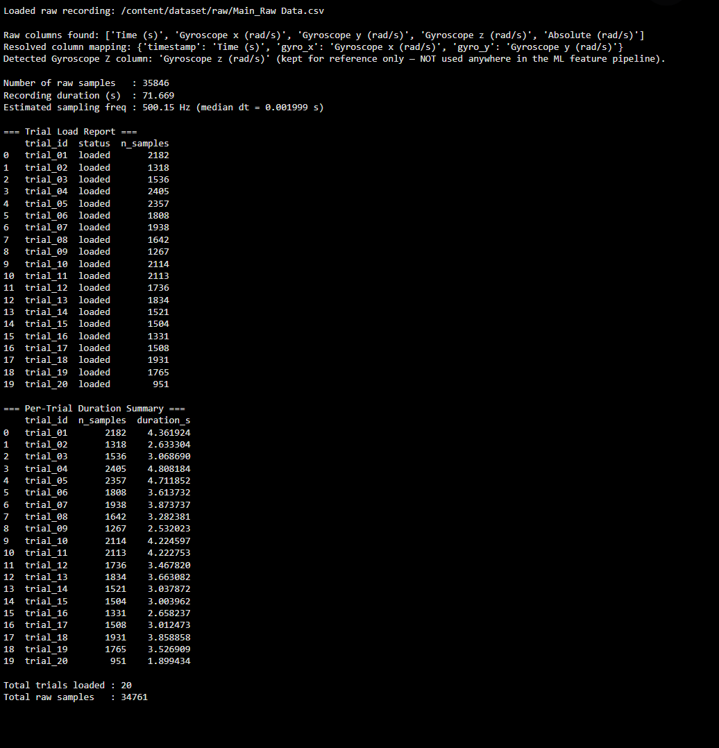
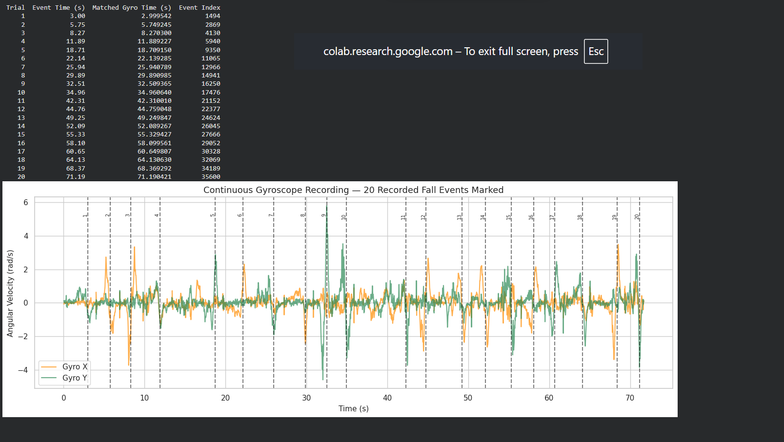
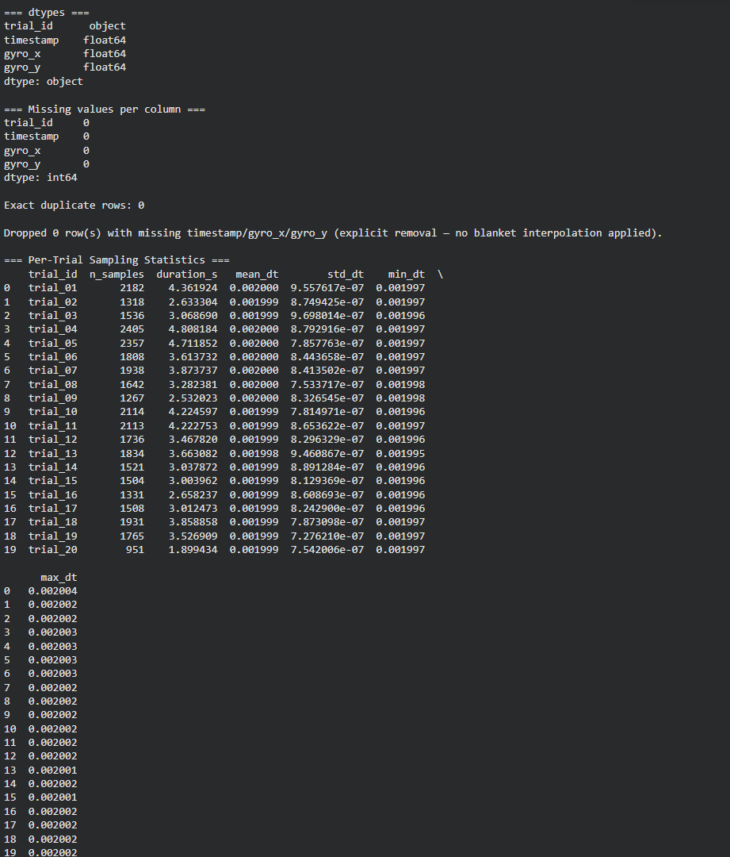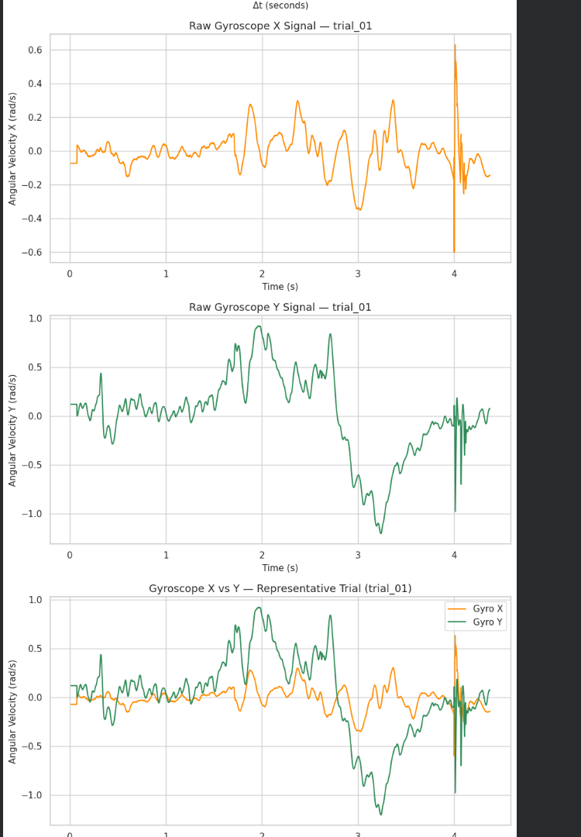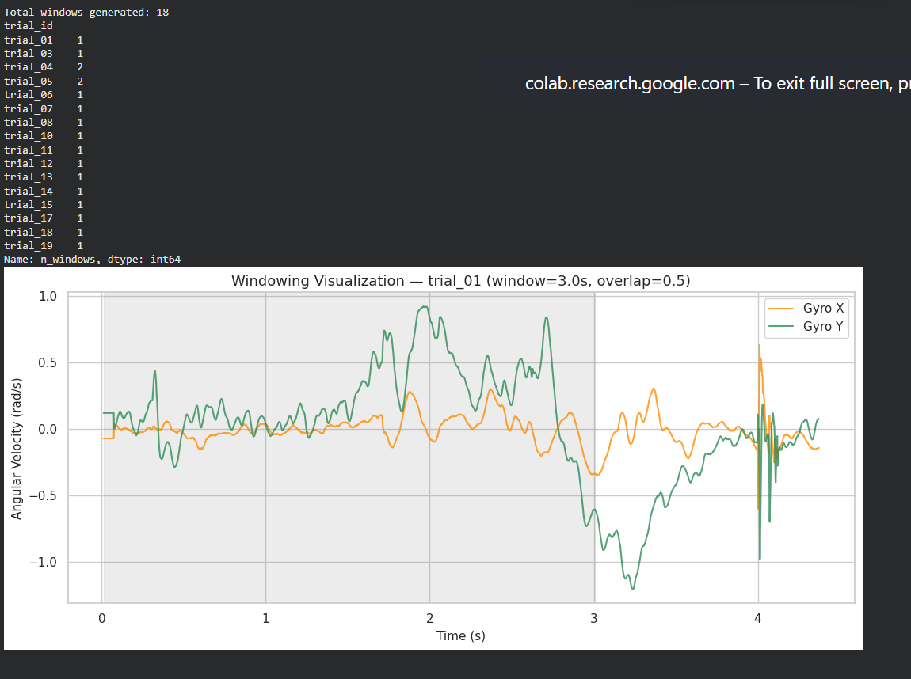
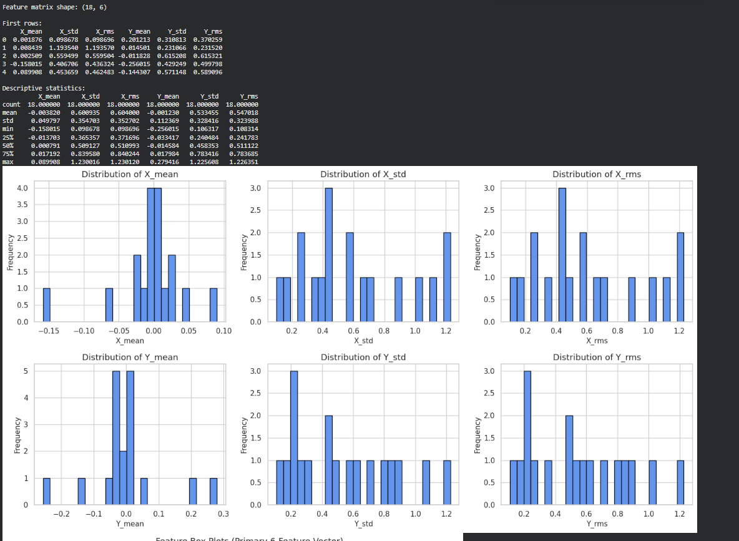
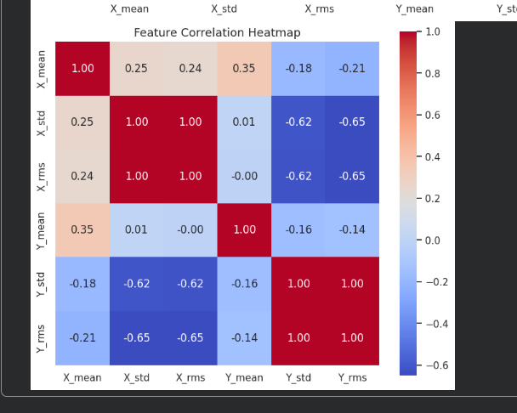
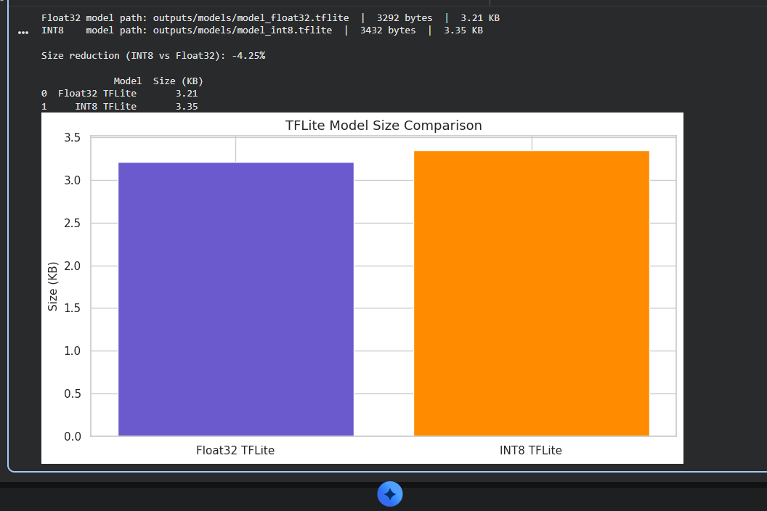
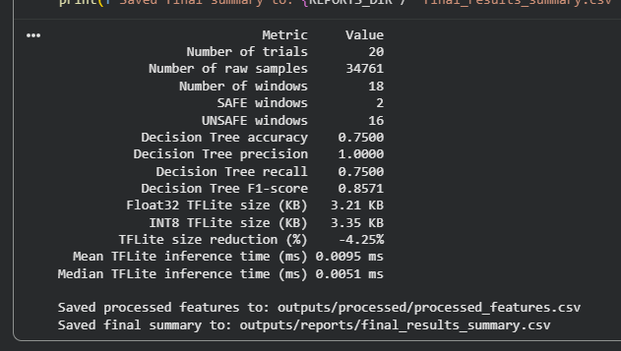

CONCLUSION:
The lab successfully implemented a TinyML pipeline using smartphone gyroscope data to detect payload falls. The data was processed, features were extracted, and a lightweight classifier was evaluated and converted to TensorFlow Lite. The results demonstrate the feasibility of using gyroscope-based TinyML for real-time edge safety applications.

3: Multi-Class Human Activity Recognition & Model Quantization Scheme Analysis

Course Outcomes: CO1, CO2
Total Marks: 10 Marks

1. Aim
To collect multi-axis accelerometer motion data for three distinct activity classes (Idle, Walking, and Sit-ups) using phyphox, train a 3-class Human Activity Recognition (HAR) classifier, implement three TensorFlow Lite model quantization techniques, and systematically benchmark their effects on memory footprint, execution speed, and classification accuracy.

2. Lab Question & Problem Statement
Scenario:
You are an Embedded AI Engineer designing an activity-tracking algorithm for an ultralow-power wearable device. The device must run on-device inference to classify physical activity states (Idle/Static, Walking/Locomotion, and Sit-ups/Repetitive Exercise) without sending raw sensor streams to the cloud. Before deploying the model to hardware, you are tasked with conducting an optimization study comparing the trade-offs between accuracy retention, RAM/ROM footprint, and execution speed across different quantization paradigms.

Your Task:

- Data Acquisition: Secure your smartphone against your chest or waist. Use phyphox > Accelerometer (or Linear Acceleration) to collect sensor streams for three distinct activity states: Idle/Sitting, Walking, and Sit-ups. Export the raw files as idle.csv, walking.csv, and situps.csv.

- Feature Extraction & Processing: Segment continuous acceleration streams into 1-second window intervals (100 samples/sec). Compute the 3D acceleration vector magnitude:

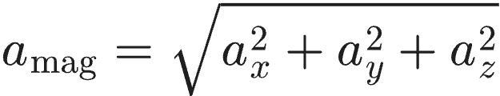
- Extract statistical features per window interval:

Mean Acceleration (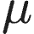):

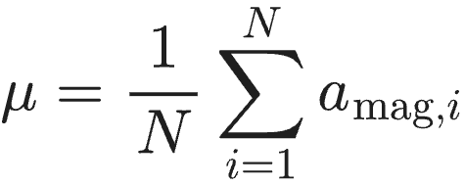
Standard Deviation ():

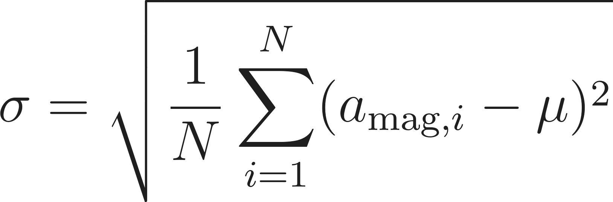
Root Mean Square ():

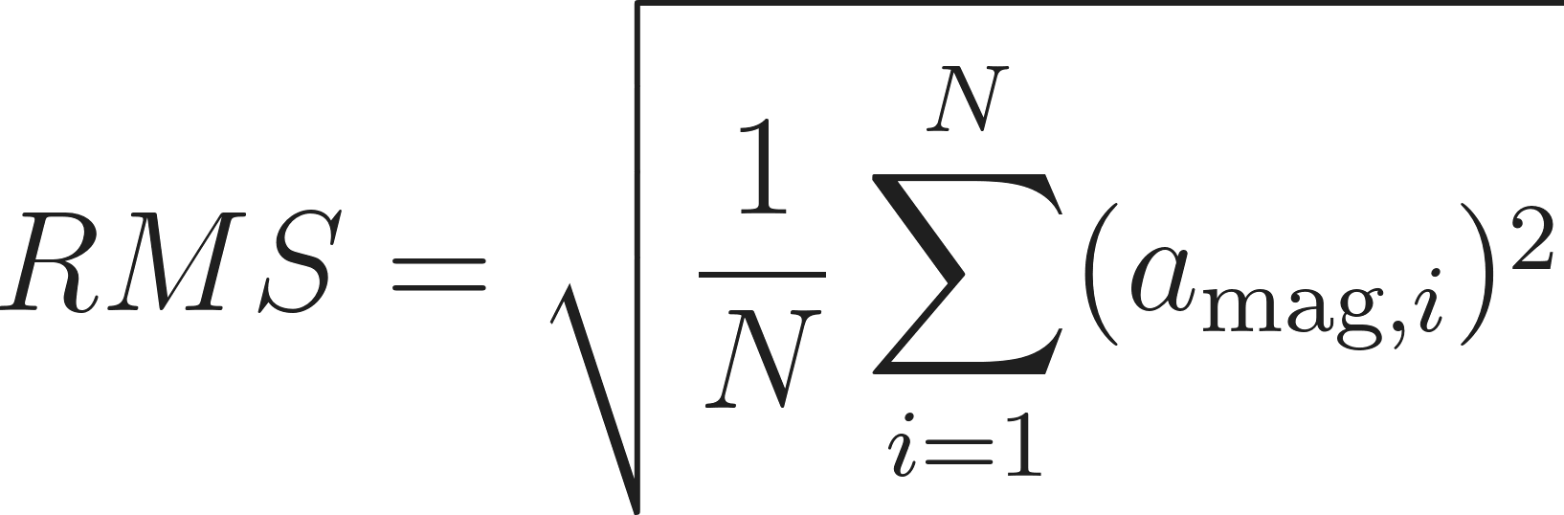
- Model Development: Train a baseline 3-class Multi-Layer Perceptron (MLP) neural network in Python / Google Colab using the extracted feature matrices.

- Quantization Comparison Experiment: Convert the baseline model into four distinct TensorFlow Lite variants:
Variant A: Unquantized Baseline (Float32)

Variant B: Dynamic Range Quantization (Weights quantized to int8, activations in float32)

Variant C: Float16 Quantization (Weights converted to 16-bit float)

Variant D: Full Integer Quantization (Weights and activations strictly quantized to int8 using a representative calibration dataset)

- Comparative Analysis: Benchmark all four variants on the test dataset and record model file sizes (in KB), test classification accuracy (%), memory reduction (%), and average inference execution time () per window.

3. Submission Deliverables
- Raw Datasets and work flow diagram : idle.csv, walking.csv, and situps.csv collected via phyphox.
- Python Script: Complete pipeline implementing windowing, 3-class model training, generation of all 4 TFLite quantisation variants, and automated latency/memory benchmarking.
- Quantisation Benchmarking Report: Completed evaluation table and analysis explaining why full integer quantisation is required for microcontroller deployment.

4. Benchmarking Results Table (To Be Completed by Student)
Quantization Scheme | Target Data Type | Model Size (KB) | Accuracy (%) | Memory Reduction (%)
Baseline (Unquantized) | Float32 | Baseline | Baseline | 0.0%
Dynamic Range | Weights int8, Act float32
Float16 Quantization | Float16
Full Integer (PTQ) | Weights int8, Act int8

5. Evaluation Rubric (10 Marks Total)

Assessment Module | Performance Criteria | Marks
1. Data Acquisition & Preprocessing | • Proper experimental setup and clean data collection.  • Correct signal processing, normalization, and feature engineering. | / 3
2. Implementation & Model Optimization | • Correct implementation of baseline models and algorithms.  • Successful execution of optimization, quantization, or deployment pipelines. | / 3
3. Results Analysis, Code & Deliverables | • Complete benchmarking/results analysis (accuracy, memory, speed, or system metrics).  • Clean, well-documented code with a clear final technical report. | / 4
TOTAL SCORE: _____ / 10 MARKS

WORKFLOW:
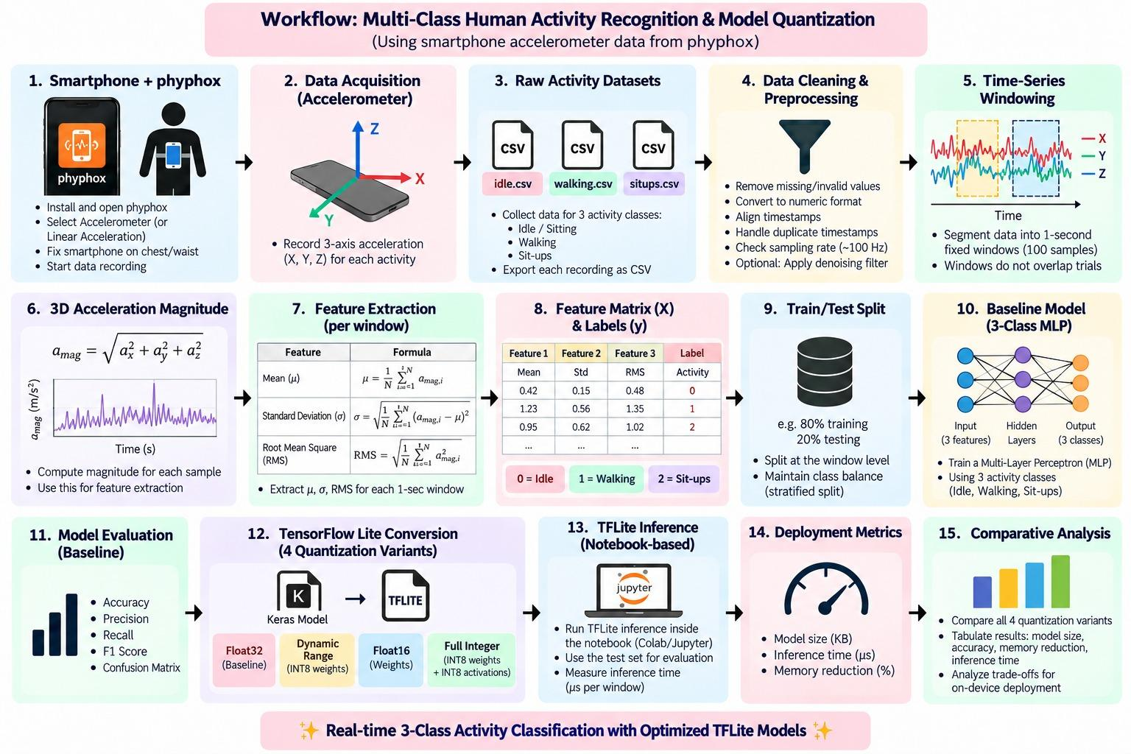
CODE:
import os
import io
import time
import glob
import json
import math
import numpy as np
import pandas as pd
import matplotlib.pyplot as plt
import tensorflow as tf
from tensorflow import keras
from tensorflow.keras import layers
from sklearn.model_selection import train_test_split
from sklearn.metrics import (
accuracy_score,
precision_recall_fscore_support,
classification_report,
confusion_matrix,
ConfusionMatrixDisplay,
)

RANDOM_STATE = 42
np.random.seed(RANDOM_STATE)
tf.random.set_seed(RANDOM_STATE)
CLASS_NAMES = ["Idle", "Walking", "Sit-ups"]
LABEL_MAP = {"Idle": 0, "Walking": 1, "Sit-ups": 2}
print("TensorFlow version:", tf.__version__)
print("Random seed set to:", RANDOM_STATE)
import os
os.makedirs("dataset", exist_ok=True)
DATA_DIR = "dataset"
IDLE_FILE = os.path.join(DATA_DIR, "idle.csv")
WALKING_FILE = os.path.join(DATA_DIR, "walking.csv")
SITUPS_FILE = os.path.join(DATA_DIR, "situps.csv")

TARGET_SAMPLING_RATE_HZ = 100
WINDOW_DURATION_SEC = 1
WINDOW_SIZE = TARGET_SAMPLING_RATE_HZ * WINDOW_DURATION_SEC

print("Expected dataset directory:", DATA_DIR)
print("Expected files:")
print(" -", IDLE_FILE)
print(" -", WALKING_FILE)
print(" -", SITUPS_FILE)
print("Target sampling rate (Hz):", TARGET_SAMPLING_RATE_HZ)
print("Window size (samples):", WINDOW_SIZE)

def identify_columns(df):
"""
Attempt to automatically identify the timestamp and ax/ay/az columns
from a phyphox-exported dataframe, tolerating common naming variations.
Returns a dict: {'time': col_or_None, 'ax': col_or_None, 'ay': col_or_None, 'az': col_or_None}
"""
cols_lower = {c: c.lower().strip() for c in df.columns}
detected = {"time": None, "ax": None, "ay": None, "az": None}

for original, lower in cols_lower.items():
if detected["time"] is None and ("time" in lower):
detected["time"] = original
if detected["ax"] is None and (
lower in ("ax", "x", "acceleration x", "acceleration x (m/s^2)", "acceleration x (m/s2)")
or ("acceleration" in lower and lower.endswith("x") is False and " x" in lower)
):
detected["ax"] = original
if detected["ay"] is None and (
lower in ("ay", "y", "acceleration y", "acceleration y (m/s^2)", "acceleration y (m/s2)")
or ("acceleration" in lower and " y" in lower)
):
detected["ay"] = original
if detected["az"] is None and (
lower in ("az", "z", "acceleration z", "acceleration z (m/s^2)", "acceleration z (m/s2)")
or ("acceleration" in lower and " z" in lower)
):
detected["az"] = original

for axis, key in zip(["x", "y", "z"], ["ax", "ay", "az"]):
if detected[key] is None:
for original, lower in cols_lower.items():
tokens = lower.replace("(", " ").replace(")", " ").replace(",", " ").split()
if axis in tokens:
detected[key] = original
break

return detected

def load_activity_csv(filepath, activity_name):
"""
Dynamically load a single activity CSV file, or report clearly if it is missing.
Returns (dataframe_or_None, column_map_or_None).
"""
if not os.path.exists(filepath):
print(f"[{activity_name}] Dataset not found at '{filepath}'.")
print(f"[{activity_name}] Place idle.csv, walking.csv and situps.csv inside the "
f"'{DATA_DIR}' folder and rerun this cell.")
return None, None

df = pd.read_csv(filepath)
col_map = identify_columns(df)

print(f"--- {activity_name} ---")
print("File:", filepath)
print("Shape:", df.shape)
print("Columns:", list(df.columns))
print("Detected column mapping:", col_map)
display(df.head())
print()

return df, col_map
raw_idle_df, idle_cols = load_activity_csv(IDLE_FILE, "Idle")
raw_walking_df, walking_cols = load_activity_csv(WALKING_FILE, "Walking")
raw_situps_df, situps_cols = load_activity_csv(SITUPS_FILE, "Sit-ups")

RAW_DATA = {
"Idle": (raw_idle_df, idle_cols),
"Walking": (raw_walking_df, walking_cols),
"Sit-ups": (raw_situps_df, situps_cols),
}

datasets_ready = all(df is not None for df, _ in RAW_DATA.values())
print("All three datasets available:", datasets_ready)

def clean_activity_df(df, col_map, activity_name):
"""
Clean a single activity dataframe:
- keep only relevant columns (time, ax, ay, az) where available
- coerce acceleration columns to numeric
- drop missing / invalid rows
- drop duplicate timestamps and sort by time (if a timestamp column exists)
- estimate the sampling frequency
Returns (cleaned_df, estimated_fs_hz_or_None)
"""
if df is None:
return None, None

before_shape = df.shape

time_col, ax_col, ay_col, az_col = col_map["time"], col_map["ax"], col_map["ay"], col_map["az"]

keep_cols = [c for c in [time_col, ax_col, ay_col, az_col] if c is not None]
work_df = df[keep_cols].copy()

rename_map = {}
if time_col is not None:
rename_map[time_col] = "time"
if ax_col is not None:
rename_map[ax_col] = "ax"
if ay_col is not None:
rename_map[ay_col] = "ay"
if az_col is not None:
rename_map[az_col] = "az"
work_df = work_df.rename(columns=rename_map)

for c in ["ax", "ay", "az"]:
if c in work_df.columns:
work_df[c] = pd.to_numeric(work_df[c], errors="coerce")
if "time" in work_df.columns:
work_df["time"] = pd.to_numeric(work_df["time"], errors="coerce")

required_cols = [c for c in ["ax", "ay", "az"] if c in work_df.columns]
work_df = work_df.dropna(subset=required_cols)

est_fs = None
if "time" in work_df.columns:
work_df = work_df.drop_duplicates(subset=["time"])
work_df = work_df.sort_values("time").reset_index(drop=True)

if len(work_df) > 1:
intervals = np.diff(work_df["time"].values)
intervals = intervals[intervals > 0]
if len(intervals) > 0:
median_interval = np.median(intervals)
est_fs = 1.0 / median_interval if median_interval > 0 else None
else:
work_df = work_df.reset_index(drop=True)

after_shape = work_df.shape

print(f"--- {activity_name}: cleaning summary ---")
print("Shape before cleaning:", before_shape)
print("Shape after cleaning :", after_shape)
if est_fs is not None:
print(f"Estimated sampling rate: {est_fs:.2f} Hz")
else:
print("Estimated sampling rate: could not be determined (no usable timestamp column)")
print()

return work_df, est_fs

CLEAN_DATA = {}
for activity_name, (raw_df, col_map) in RAW_DATA.items():
cleaned_df, est_fs = clean_activity_df(raw_df, col_map, activity_name)
CLEAN_DATA[activity_name] = {"df": cleaned_df, "fs": est_fs}

def plot_raw_signal(df, activity_name):
"""Plot the raw X, Y, Z acceleration signals for one activity, if data is available."""
if df is None or df.empty:
print(f"[{activity_name}] No data available to plot yet.")
return

x_axis = df["time"].values if "time" in df.columns else np.arange(len(df))
x_label = "Time (s)" if "time" in df.columns else "Sample index"

fig, axes = plt.subplots(3, 1, figsize=(10, 6), sharex=True)
for ax_obj, col, color in zip(axes, ["ax", "ay", "az"], ["tab:blue", "tab:orange", "tab:green"]):
if col in df.columns:
ax_obj.plot(x_axis, df[col].values, color=color, linewidth=0.8)
ax_obj.set_ylabel(col)
ax_obj.grid(True, alpha=0.3)
axes[-1].set_xlabel(x_label)
fig.suptitle(f"Raw Acceleration Signals — {activity_name}")
plt.tight_layout()
plt.show()

for activity_name in CLASS_NAMES:
plot_raw_signal(CLEAN_DATA[activity_name]["df"], activity_name)

def resample_to_target_rate(df, target_rate_hz=TARGET_SAMPLING_RATE_HZ):
"""
Resample one cleaned activity recording from its estimated native rate
(~125 Hz for these phyphox recordings) onto a uniform target_rate_hz (100 Hz)
grid, using linear interpolation on the real timestamps.

Every output sample is a linear interpolation between two real, adjacent
recorded samples -- no samples are fabricated or discarded. After this step,
`target_rate_hz` consecutive samples correspond to exactly 1 second.
"""
if df is None or df.empty or "time" not in df.columns:
return df

t_raw = df["time"].values
duration = t_raw[-1] - t_raw[0]
n_out = int(np.floor(duration * target_rate_hz)) + 1
t_new = t_raw[0] + np.arange(n_out) / target_rate_hz

resampled = {"time": t_new}
for c in ["ax", "ay", "az"]:
resampled[c] = np.interp(t_new, t_raw, df[c].values)

return pd.DataFrame(resampled)

RESAMPLING_SUMMARY_ROWS = []
for activity_name in CLASS_NAMES:
original_df = CLEAN_DATA[activity_name]["df"]
original_fs = CLEAN_DATA[activity_name]["fs"]
resampled_df = resample_to_target_rate(original_df, TARGET_SAMPLING_RATE_HZ)

RESAMPLING_SUMMARY_ROWS.append({
"Activity": activity_name,
"Original Samples": len(original_df) if original_df is not None else 0,
"Estimated Original Rate (Hz)": round(original_fs, 2) if original_fs else None,
"Resampled Samples": len(resampled_df) if resampled_df is not None else 0,
"Target Rate (Hz)": TARGET_SAMPLING_RATE_HZ,
})

CLEAN_DATA[activity_name]["df"] = resampled_df
CLEAN_DATA[activity_name]["fs"] = float(TARGET_SAMPLING_RATE_HZ)

resampling_summary_df = pd.DataFrame(RESAMPLING_SUMMARY_ROWS)
print("Resampling summary (native rate -> 100 Hz, via linear interpolation on real timestamps):")
display(resampling_summary_df)

def create_windows(data, window_size=WINDOW_SIZE):
"""
Split ONE continuous activity recording into consecutive, non-overlapping
fixed-size windows.

Each of the three activity recordings (idle.csv, walking.csv, situps.csv) is a
single continuous ~3-minute capture containing only its own activity, and is
windowed independently here — no merging with other files, no shuffling, and
no splitting into smaller sub-files beforehand.

Only COMPLETE windows of exactly `window_size` samples are kept. If the recording
ends with fewer than `window_size` samples remaining, that trailing partial window
is discarded — it is never padded or filled with fabricated values.

Parameters
----------
data : pandas.DataFrame
Cleaned activity dataframe containing 'ax', 'ay', 'az' columns.
window_size : int
Number of consecutive samples per window (100 for a 1-second window at 100 Hz).

Returns
-------
list of pandas.DataFrame
Each element is one complete window (window_size rows x ['ax','ay','az']).
int
Number of trailing samples at the end of the recording that did not fill a
complete window and were therefore discarded (not padded with fabricated values).
"""
if data is None or data.empty:
return [], 0

signal = data[["ax", "ay", "az"]].reset_index(drop=True)
n_samples = len(signal)
n_windows = n_samples // window_size
n_leftover = n_samples - (n_windows * window_size)

windows = []
for i in range(n_windows):
start = i * window_size
end = start + window_size
windows.append(signal.iloc[start:end].reset_index(drop=True))

return windows, n_leftover

WINDOWS_BY_CLASS = {}
WINDOWING_SUMMARY_ROWS = []

for activity_name in CLASS_NAMES:
df = CLEAN_DATA[activity_name]["df"]
windows, n_leftover = create_windows(df, window_size=WINDOW_SIZE)
WINDOWS_BY_CLASS[activity_name] = windows

input_samples = len(df) if df is not None else 0
WINDOWING_SUMMARY_ROWS.append({
"Activity": activity_name,
"Input Samples (100 Hz)": input_samples,
"Complete 1-sec Windows": len(windows),
"Discarded Samples": n_leftover,
})

windowing_summary_df = pd.DataFrame(
WINDOWING_SUMMARY_ROWS,
columns=["Activity", "Input Samples (100 Hz)", "Complete 1-sec Windows", "Discarded Samples"],
)

print("Windowing summary (calculated automatically from the resampled 100 Hz recordings):")
display(windowing_summary_df)

print()

for activity_name in CLASS_NAMES:
if len(WINDOWS_BY_CLASS[activity_name]) > 0:
print(f"Example window from '{activity_name}':")
display(WINDOWS_BY_CLASS[activity_name][0])
break
else:
print("No windows available yet — place the real CSV files in the dataset folder and rerun.")

def compute_magnitude(window_df):
"""
Compute the 3D Acceleration Magnitude (a_mag) for every sample in a window.
a_mag = sqrt(ax^2 + ay^2 + az^2)
"""
ax = window_df["ax"].values
ay = window_df["ay"].values
az = window_df["az"].values
a_mag = np.sqrt(ax**2 + ay**2 + az**2)
return a_mag

MAGNITUDES_BY_CLASS = {}
for activity_name in CLASS_NAMES:
mags = [compute_magnitude(w) for w in WINDOWS_BY_CLASS[activity_name]]
MAGNITUDES_BY_CLASS[activity_name] = mags

fig, axes = plt.subplots(1, 3, figsize=(15, 4), sharey=True)
for ax_obj, activity_name in zip(axes, CLASS_NAMES):
mags = MAGNITUDES_BY_CLASS[activity_name]
if len(mags) > 0:
ax_obj.plot(mags[0], color="tab:red")
ax_obj.set_title(f"{activity_name} (window 0)")
else:
ax_obj.set_title(f"{activity_name} (no data yet)")
ax_obj.set_xlabel("Sample index within window")
ax_obj.grid(True, alpha=0.3)
axes[0].set_ylabel("3D Acceleration Magnitude (a_mag)")
fig.suptitle("3D Acceleration Magnitude — Representative Windows")
plt.tight_layout()
plt.show()

def extract_features(a_mag):
"""
Compute Mean, Standard Deviation and RMS of a 3D Acceleration Magnitude window.
Returns a dict: {'mean': ..., 'std': ..., 'rms': ...}
"""
n = len(a_mag)
mu = float(np.sum(a_mag) / n)
sigma = float(np.sqrt(np.sum((a_mag - mu) ** 2) / n))
rms = float(np.sqrt(np.sum(a_mag ** 2) / n))
return {"mean": mu, "std": sigma, "rms": rms}

FEATURES_BY_CLASS = {}
for activity_name in CLASS_NAMES:
feats = [extract_features(m) for m in MAGNITUDES_BY_CLASS[activity_name]]
FEATURES_BY_CLASS[activity_name] = feats

sample_rows = []
for activity_name in CLASS_NAMES:
for feat in FEATURES_BY_CLASS[activity_name][:5]:
row = {"activity": activity_name}
row.update(feat)
sample_rows.append(row)

sample_feature_table = pd.DataFrame(sample_rows)
print("Sample feature table (first few windows per class):")
display(sample_feature_table)

X_rows = []
y_rows = []

for activity_name in CLASS_NAMES:
label = LABEL_MAP[activity_name]
for feat in FEATURES_BY_CLASS[activity_name]:
X_rows.append([feat["mean"], feat["std"], feat["rms"]])
y_rows.append(label)

X = np.array(X_rows, dtype=np.float32)
y = np.array(y_rows, dtype=np.int64)

print("Feature matrix X shape:", X.shape)
print("Label vector y shape:", y.shape)

feature_df = pd.DataFrame(X, columns=["mean", "std", "rms"])
feature_df["activity"] = [CLASS_NAMES[i] for i in y]
print("\nFirst few feature rows:")
display(feature_df.head())

print("\nClass distribution:")
class_counts = feature_df["activity"].value_counts().reindex(CLASS_NAMES)
display(class_counts)

plt.figure(figsize=(5, 4))
class_counts.plot(kind="bar", color=["tab:blue", "tab:orange", "tab:green"])
plt.title("Class Distribution (Number of Windows)")
plt.xlabel("Activity")
plt.ylabel("Number of windows")
plt.xticks(rotation=0)
plt.tight_layout()
plt.show()

X_train, X_test, y_train, y_test = train_test_split(
X, y,
test_size=0.20,
random_state=RANDOM_STATE,
stratify=y,
)

print("X_train shape:", X_train.shape)
print("X_test shape :", X_test.shape)
print("y_train shape:", y_train.shape)
print("y_test shape :", y_test.shape)

def class_distribution(y_arr, title):
counts = pd.Series(y_arr).value_counts().sort_index()
counts.index = [CLASS_NAMES[i] for i in counts.index]
print(f"\n{title}:")
display(counts)

class_distribution(y_train, "Training set class distribution")
class_distribution(y_test, "Test set class distribution")

def build_baseline_model():
model = keras.Sequential([
layers.Input(shape=(3,), name="features_mean_std_rms"),
layers.Dense(16, activation="relu", name="dense_1"),
layers.Dense(8, activation="relu", name="dense_2"),
layers.Dense(len(CLASS_NAMES), activation="softmax", name="output"),
], name="HAR_Baseline_MLP")

model.compile(
optimizer=keras.optimizers.Adam(learning_rate=1e-3),
loss="sparse_categorical_crossentropy",
metrics=["accuracy"],
)
return model

baseline_model = build_baseline_model()
baseline_model.summary()

print("\nTotal trainable parameters:", baseline_model.count_params())

EPOCHS = 60
BATCH_SIZE = 16

history = baseline_model.fit(
X_train, y_train,
validation_split=0.2,
epochs=EPOCHS,
batch_size=BATCH_SIZE,
verbose=1,
)

fig, axes = plt.subplots(1, 2, figsize=(12, 4))

axes[0].plot(history.history["accuracy"], label="Train Accuracy")
axes[0].plot(history.history["val_accuracy"], label="Validation Accuracy")
axes[0].set_title("Accuracy over Epochs")
axes[0].set_xlabel("Epoch")
axes[0].set_ylabel("Accuracy")
axes[0].legend()
axes[0].grid(True, alpha=0.3)

axes[1].plot(history.history["loss"], label="Train Loss")
axes[1].plot(history.history["val_loss"], label="Validation Loss")
axes[1].set_title("Loss over Epochs")
axes[1].set_xlabel("Epoch")
axes[1].set_ylabel("Loss")
axes[1].legend()
axes[1].grid(True, alpha=0.3)

plt.tight_layout()
plt.show()

baseline_test_loss, baseline_test_accuracy = baseline_model.evaluate(X_test, y_test, verbose=0)
print(f"Baseline (Float32, Keras) Test Accuracy: {baseline_test_accuracy * 100:.2f}%")
print(f"Baseline (Float32, Keras) Test Loss : {baseline_test_loss:.4f}")

baseline_pred_probs = baseline_model.predict(X_test, verbose=0)
baseline_test_predictions = np.argmax(baseline_pred_probs, axis=1)

precision, recall, f1, _ = precision_recall_fscore_support(
y_test, baseline_test_predictions, average="weighted", zero_division=0
)
print(f"Precision (weighted): {precision:.4f}")
print(f"Recall (weighted): {recall:.4f}")
print(f"F1-score (weighted): {f1:.4f}")

print("\nClassification Report (Float32 Baseline):")
print(classification_report(
y_test, baseline_test_predictions, target_names=CLASS_NAMES, zero_division=0
))

cm = confusion_matrix(y_test, baseline_test_predictions)
disp = ConfusionMatrixDisplay(confusion_matrix=cm, display_labels=CLASS_NAMES)
fig, ax = plt.subplots(figsize=(5, 5))
disp.plot(ax=ax, cmap="Blues", colorbar=False)
ax.set_title("Confusion Matrix — Float32 Baseline (Keras)")
plt.tight_layout()
plt.show()

TFLITE_DIR = "tflite_models"
os.makedirs(TFLITE_DIR, exist_ok=True)

MODEL_FLOAT32_PATH = os.path.join(TFLITE_DIR, "model_float32.tflite")
MODEL_DYNAMIC_RANGE_PATH = os.path.join(TFLITE_DIR, "model_dynamic_range.tflite")
MODEL_FLOAT16_PATH = os.path.join(TFLITE_DIR, "model_float16.tflite")
MODEL_INT8_PATH = os.path.join(TFLITE_DIR, "model_int8.tflite")

print("TFLite output directory:", TFLITE_DIR)
print("Planned output files:")
for p in [MODEL_FLOAT32_PATH, MODEL_DYNAMIC_RANGE_PATH, MODEL_FLOAT16_PATH, MODEL_INT8_PATH]:
print(" -", p)

converter_f32 = tf.lite.TFLiteConverter.from_keras_model(baseline_model)
tflite_float32_model = converter_f32.convert()

with open(MODEL_FLOAT32_PATH, "wb") as f:
f.write(tflite_float32_model)

print(f"Saved Float32 unquantized TFLite model to: {MODEL_FLOAT32_PATH}")
print(f"File size: {os.path.getsize(MODEL_FLOAT32_PATH) / 1024:.2f} KB")

converter_dr = tf.lite.TFLiteConverter.from_keras_model(baseline_model)
converter_dr.optimizations = [tf.lite.Optimize.DEFAULT]
tflite_dynamic_range_model = converter_dr.convert()

with open(MODEL_DYNAMIC_RANGE_PATH, "wb") as f:
f.write(tflite_dynamic_range_model)

print(f"Saved Dynamic Range quantized TFLite model to: {MODEL_DYNAMIC_RANGE_PATH}")
print(f"File size: {os.path.getsize(MODEL_DYNAMIC_RANGE_PATH) / 1024:.2f} KB")

converter_f16 = tf.lite.TFLiteConverter.from_keras_model(baseline_model)
converter_f16.optimizations = [tf.lite.Optimize.DEFAULT]
converter_f16.target_spec.supported_types = [tf.float16]
tflite_float16_model = converter_f16.convert()

with open(MODEL_FLOAT16_PATH, "wb") as f:
f.write(tflite_float16_model)

print(f"Saved Float16 quantized TFLite model to: {MODEL_FLOAT16_PATH}")
print(f"File size: {os.path.getsize(MODEL_FLOAT16_PATH) / 1024:.2f} KB")

def representative_dataset():
"""
Yield representative, real (non-fabricated) input samples drawn from the actual
training feature matrix X_train, used by the TFLite converter to calibrate the
int8 quantization ranges for Full Integer PTQ.
"""
for i in range(X_train.shape[0]):
sample = X_train[i:i + 1].astype(np.float32)
yield [sample]

converter_int8 = tf.lite.TFLiteConverter.from_keras_model(baseline_model)
converter_int8.optimizations = [tf.lite.Optimize.DEFAULT]
converter_int8.representative_dataset = representative_dataset
converter_int8.target_spec.supported_ops = [tf.lite.OpsSet.TFLITE_BUILTINS_INT8]
converter_int8.inference_input_type = tf.int8
converter_int8.inference_output_type = tf.int8

tflite_int8_model = converter_int8.convert()

with open(MODEL_INT8_PATH, "wb") as f:
f.write(tflite_int8_model)

print(f"Saved Full Integer PTQ TFLite model to: {MODEL_INT8_PATH}")
print(f"File size: {os.path.getsize(MODEL_INT8_PATH) / 1024:.2f} KB")

def run_tflite_inference(tflite_path, X_input):
"""
Run inference for every row of X_input through a given TFLite model, handling
both floating-point and int8-quantized models automatically.

Returns
-------
predictions : np.ndarray of shape (n_samples,)
Predicted class indices.
interpreter : tf.lite.Interpreter
The (already allocated) interpreter, reusable for timing benchmarks.
"""
interpreter = tf.lite.Interpreter(model_path=tflite_path)
interpreter.allocate_tensors()

input_details = interpreter.get_input_details()
output_details = interpreter.get_output_details()

input_dtype = input_details[0]["dtype"]
input_scale, input_zero_point = input_details[0]["quantization"]

output_dtype = output_details[0]["dtype"]
output_scale, output_zero_point = output_details[0]["quantization"]

predictions = []

for i in range(X_input.shape[0]):
sample = X_input[i:i + 1].astype(np.float32)

if input_dtype == np.int8 or input_dtype == np.uint8:

if input_scale == 0:
quantized_sample = sample.astype(input_dtype)
else:
quantized_sample = (sample / input_scale) + input_zero_point
quantized_sample = np.clip(
quantized_sample,
np.iinfo(input_dtype).min,
np.iinfo(input_dtype).max,
).astype(input_dtype)
interpreter.set_tensor(input_details[0]["index"], quantized_sample)
else:
interpreter.set_tensor(input_details[0]["index"], sample.astype(input_dtype))

interpreter.invoke()
raw_output = interpreter.get_tensor(output_details[0]["index"])[0]

if output_dtype == np.int8 or output_dtype == np.uint8:
if output_scale == 0:
dequantized_output = raw_output.astype(np.float32)
else:
dequantized_output = (raw_output.astype(np.float32) - output_zero_point) * output_scale
else:
dequantized_output = raw_output.astype(np.float32)

predicted_class = int(np.argmax(dequantized_output))
predictions.append(predicted_class)

return np.array(predictions), interpreter

TFLITE_MODEL_PATHS = {
"Float32 Baseline": MODEL_FLOAT32_PATH,
"Dynamic Range": MODEL_DYNAMIC_RANGE_PATH,
"Float16": MODEL_FLOAT16_PATH,
"Full Integer PTQ": MODEL_INT8_PATH,
}

tflite_predictions = {}
tflite_accuracies = {}

for model_name, model_path in TFLITE_MODEL_PATHS.items():
preds, _ = run_tflite_inference(model_path, X_test)
acc = accuracy_score(y_test, preds)
tflite_predictions[model_name] = preds
tflite_accuracies[model_name] = acc
print(f"{model_name:<20s} -> Test Accuracy: {acc * 100:.2f}%")

def get_model_size_kb(model_path):
return os.path.getsize(model_path) / 1024.0

def benchmark_inference_time(model_path, X_input, n_repeats=50, n_warmup=5):
"""
Benchmark average per-window inference time for a TFLite model.

- Excludes model loading time (interpreter is created once, outside timing).
- Performs `n_warmup` untimed warm-up inferences before timing.
- Repeats the full pass over X_input `n_repeats` times and averages,
to obtain a stable estimate.

Returns
-------
avg_time_us_per_window : float
"""
interpreter = tf.lite.Interpreter(model_path=model_path)
interpreter.allocate_tensors()
input_details = interpreter.get_input_details()
output_details = interpreter.get_output_details()

input_dtype = input_details[0]["dtype"]
input_scale, input_zero_point = input_details[0]["quantization"]

def prepare_input(sample):
sample = sample.astype(np.float32)
if input_dtype == np.int8 or input_dtype == np.uint8:
if input_scale == 0:
return sample.astype(input_dtype)
q = (sample / input_scale) + input_zero_point
q = np.clip(q, np.iinfo(input_dtype).min, np.iinfo(input_dtype).max)
return q.astype(input_dtype)
return sample.astype(input_dtype)

for i in range(min(n_warmup, X_input.shape[0])):
sample = prepare_input(X_input[i:i + 1])
interpreter.set_tensor(input_details[0]["index"], sample)
interpreter.invoke()
_ = interpreter.get_tensor(output_details[0]["index"])

total_time_sec = 0.0
total_windows = 0

for _ in range(n_repeats):
for i in range(X_input.shape[0]):
sample = prepare_input(X_input[i:i + 1])
interpreter.set_tensor(input_details[0]["index"], sample)

start = time.perf_counter()
interpreter.invoke()
end = time.perf_counter()

_ = interpreter.get_tensor(output_details[0]["index"])

total_time_sec += (end - start)
total_windows += 1

avg_time_sec_per_window = total_time_sec / total_windows
avg_time_us_per_window = avg_time_sec_per_window * 1e6
return avg_time_us_per_window

N_TIMING_REPEATS = 50

deployment_metrics = []

float32_size_kb = get_model_size_kb(MODEL_FLOAT32_PATH)

for model_name, model_path in TFLITE_MODEL_PATHS.items():
size_kb = get_model_size_kb(model_path)
accuracy_pct = tflite_accuracies[model_name] * 100.0
memory_reduction_pct = ((float32_size_kb - size_kb) / float32_size_kb) * 100.0
avg_inference_time_us = benchmark_inference_time(model_path, X_test, n_repeats=N_TIMING_REPEATS)

deployment_metrics.append({
"Model": model_name,
"Model Size (KB)": round(size_kb, 3),
"Accuracy (%)": round(accuracy_pct, 2),
"Memory Reduction (%)": round(memory_reduction_pct, 2),
"Average Inference Time (µs/window)": round(avg_inference_time_us, 2),
})

deployment_metrics_df = pd.DataFrame(deployment_metrics)
print("Deployment metrics (computed automatically from the actual saved models):")
display(deployment_metrics_df)

row_order = ["Float32 Baseline", "Dynamic Range", "Float16", "Full Integer PTQ"]
results_df = deployment_metrics_df.set_index("Model").loc[row_order].reset_index()

print("Final Comparative Results Table:")
display(results_df)

fig, axes = plt.subplots(2, 2, figsize=(12, 9))

metrics_to_plot = [
("Model Size (KB)", "tab:blue", "Model Size Comparison"),
("Accuracy (%)", "tab:green", "Accuracy Comparison"),
("Memory Reduction (%)", "tab:orange", "Memory Reduction Comparison"),
("Average Inference Time (µs/window)", "tab:red", "Inference Time Comparison"),
]

for ax_obj, (col, color, title) in zip(axes.flat, metrics_to_plot):
ax_obj.bar(results_df["Model"], results_df[col], color=color)
ax_obj.set_title(title)
ax_obj.set_ylabel(col)
ax_obj.tick_params(axis="x", rotation=20)
ax_obj.grid(True, axis="y", alpha=0.3)

plt.tight_layout()
plt.show()

OUTPUT:
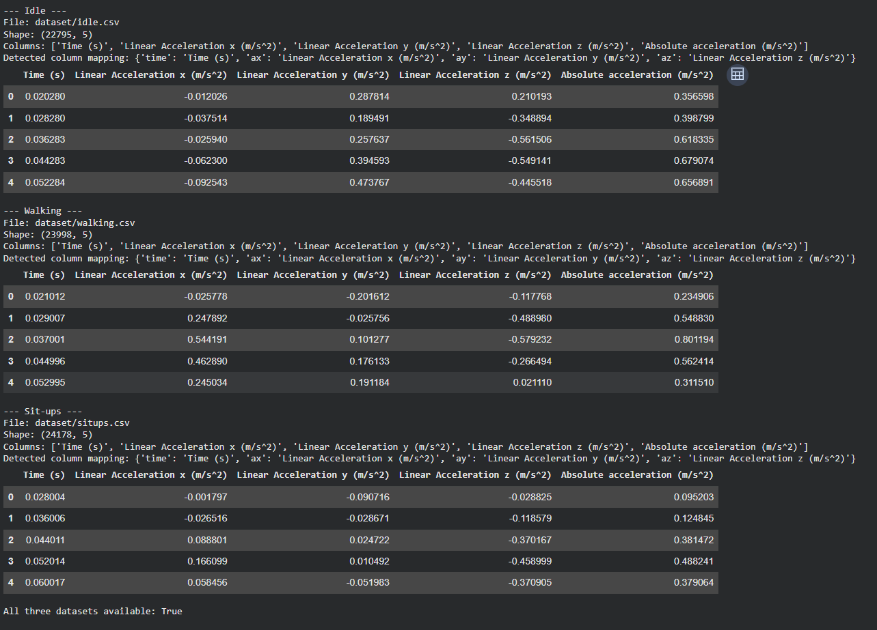
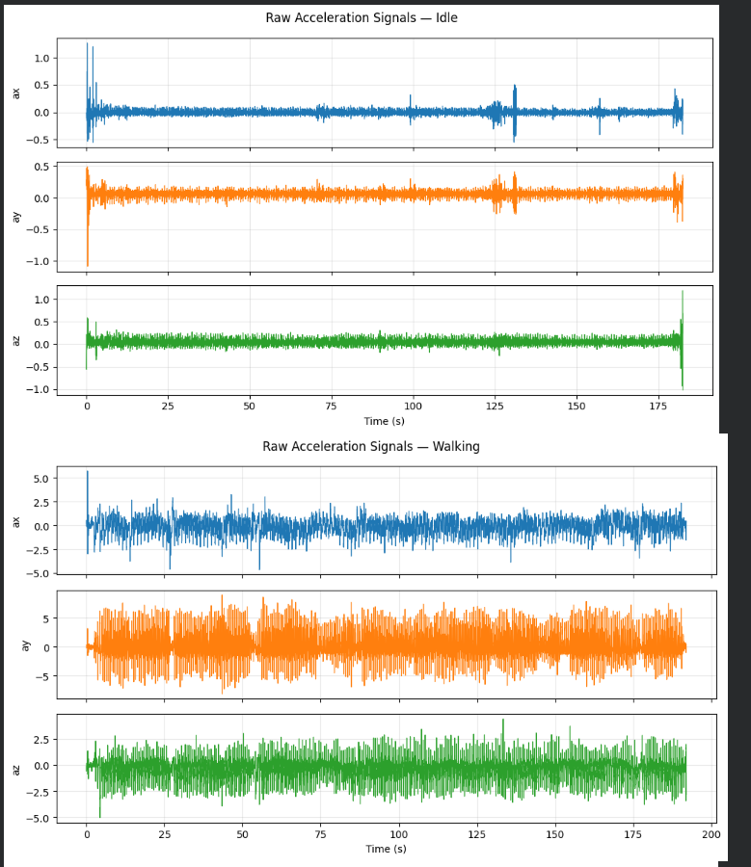

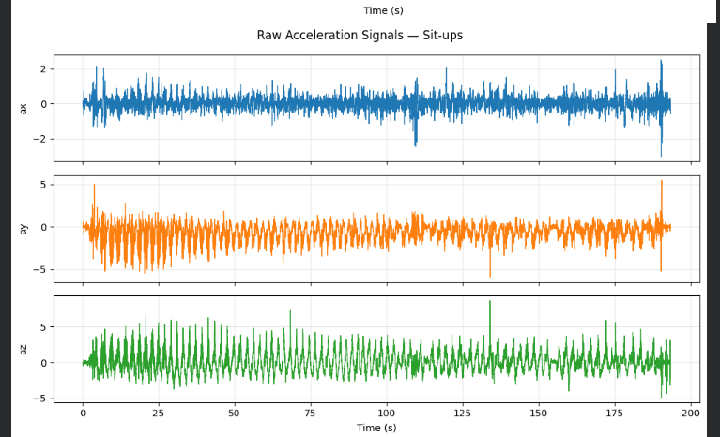
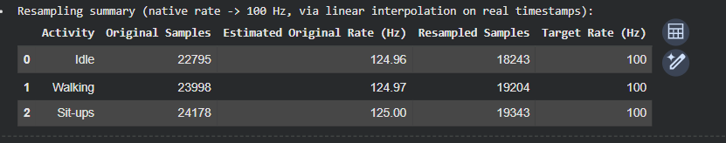
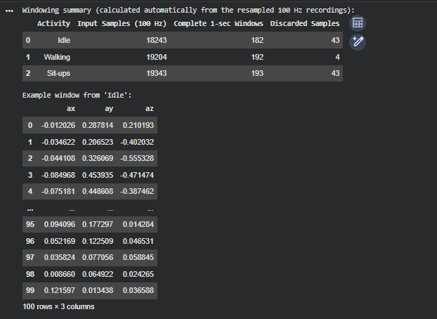
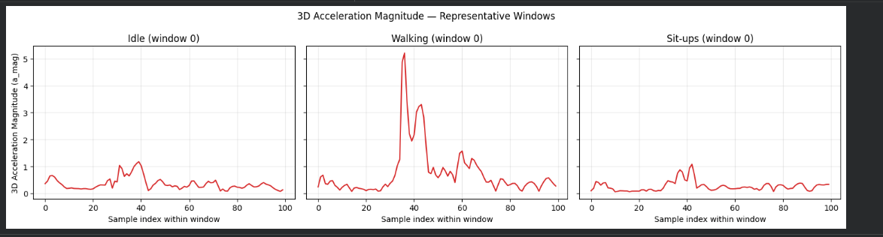
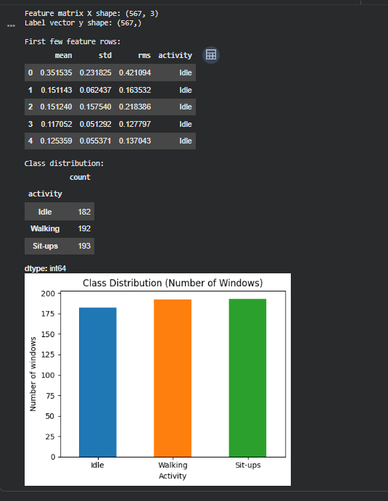
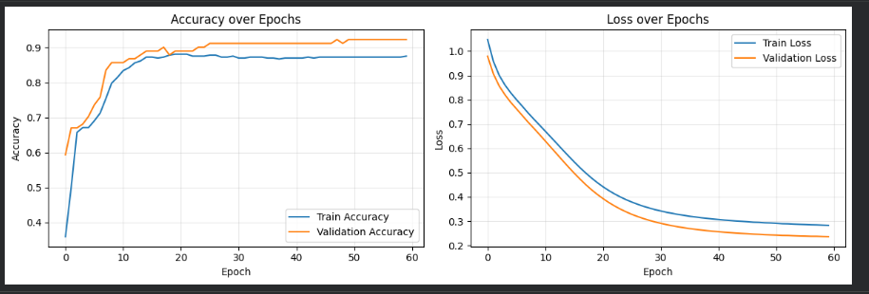

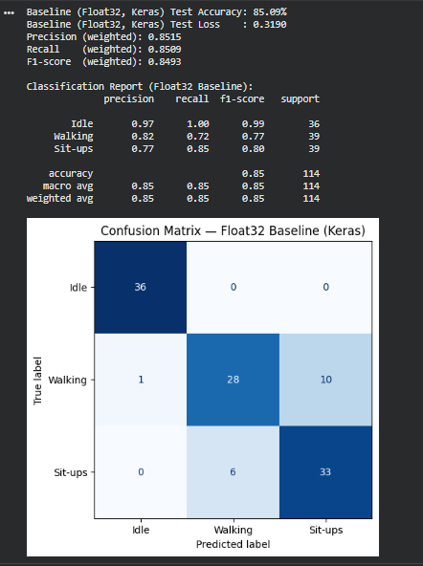
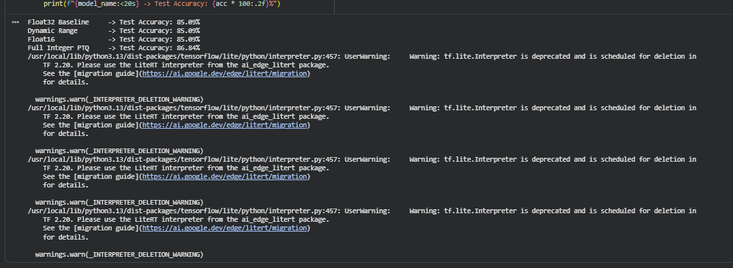
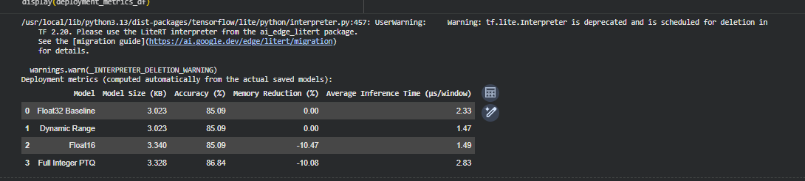
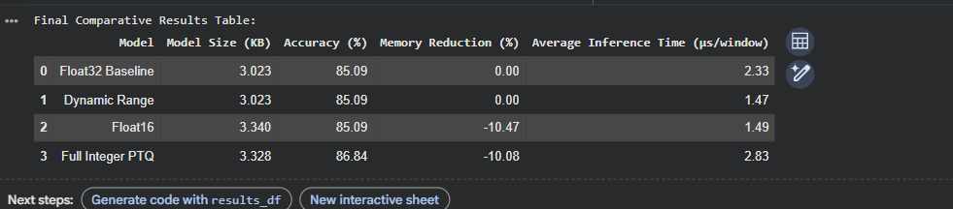
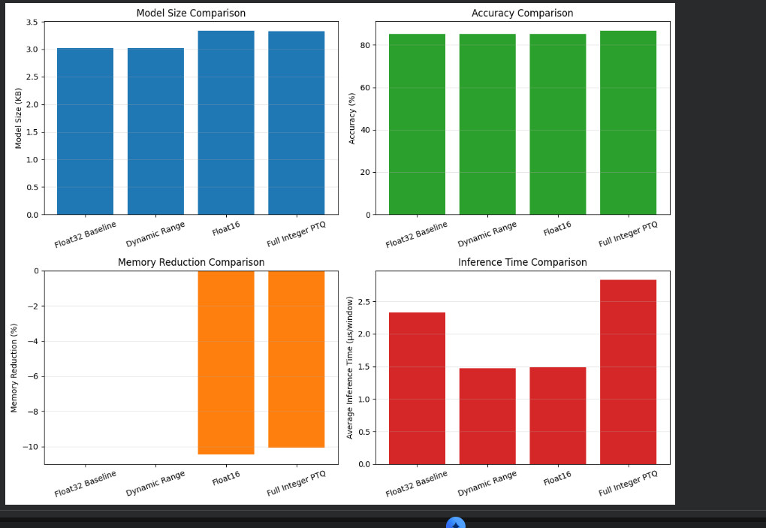

CONCLUSION:
The lab successfully implemented a 3-class Human Activity Recognition system using smartphone accelerometer data. The data was processed into 1-second windows, statistical features were extracted, and an MLP classifier was trained for Idle, Walking, and Sit-ups. Four TensorFlow Lite models were generated and benchmarked to compare accuracy, model size, and inference time. The experiment demonstrated the trade-offs of different quantization techniques and the feasibility of deploying lightweight activity recognition models on resource-constrained edge devices.

Lab 4 : TinyML Lab – Quantization-Aware Training (QAT)
Aim
To implement Quantization-Aware Training (QAT) on a TinyML model, using either motion-sensor data collected with the Phyphox app or a standard image dataset with MobileNetV2, and to compare it with Post-Training Quantization (PTQ).

Objectives
- Prepare input data from Phyphox sensor recordings or from a standard image dataset.
- Train a baseline model and apply full INT8 Post-Training Quantization.
- Apply Quantization-Aware Training and convert the model to full INT8 TensorFlow Lite.
- Compare the models in terms of accuracy, size and latency.

Lab Setup
Run the following as the first cell in a fresh Colab runtime:
!pip install -q tensorflow-model-optimization tf_keras
import os
os.environ["TF_USE_LEGACY_KERAS"] = "1" # set before importing tensorflow
import tensorflow as tf
import tensorflow_model_optimization as tfmot

Procedure
- Input data: choose one option.
  - Option A (sensor data): Using Phyphox, record four motion classes of your choice (for example: still, walking, shaking and circular motion) for about 60 seconds each. Export each recording as a CSV file and upload it to Colab.
  - Option B (image data): Load the CIFAR-10 dataset from tf.keras.datasets. Use a subset (for example, 5,000 training and 1,000 test images) resized to 96 × 96 pixels.
- Preprocessing: Option A: label and combine the CSV files, segment the signal into fixed-length windows, normalise, and split into training and test sets. Option B: scale the images as required by MobileNetV2.
- Baseline model: Option A: train a small Keras model. Option B: build a MobileNetV2 model (pre-trained on ImageNet, alpha = 0.35) with a new classification head, as a single functional model (not nested), and fine-tune it. Record the test accuracy.
- Post-Training Quantization: Convert the baseline model to a full INT8 TFLite model using a representative dataset, and evaluate it with the TFLite interpreter.
- Quantization-Aware Training: Apply QAT to the trained baseline model, fine-tune it, convert it to a full INT8 TFLite model, and evaluate it.
- Comparison: Record the results in the table below.
Model | Size (KB) | Test accuracy (%) | Avg latency (ms)
Float32 baseline
PTQ full INT8
QAT full INT8

Questions
- Why does Post-Training Quantization reduce model accuracy?
- What does QAT simulate during training, and how does this help the model?
- Was a representative dataset required to convert the QAT model? Justify your answer.
- Did QAT change the size of the INT8 model? Explain.
- Under what conditions is PTQ sufficient, so that QAT is not needed?

Result
State your conclusion on the effectiveness of QAT compared with PTQ, citing values from your comparison table.
Planned workflow .
Deliverables: the Colab notebook with all outputs, the Phyphox CSV files (Option A only), and the three .tflite models.

Evaluation Rubric
Component | Marks
Workflow +Data collection and preprocessing | 3
Baseline model and PTQ | 3
QAT, conversion and evaluation+Comparison table and result | 2
Questions | 2
Total | 10

WORKFLOW:

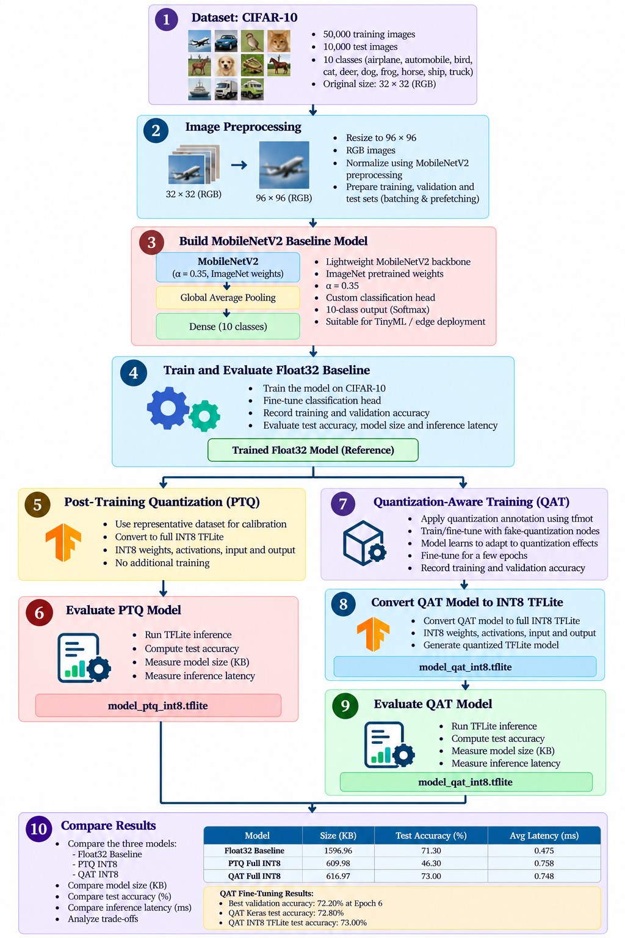

CODE:
!pip install -q tensorflow-model-optimization tf-keras

import os
os.environ["TF_USE_LEGACY_KERAS"] = "1"

import random
import time
from collections import Counter

import numpy as np
import pandas as pd
import matplotlib.pyplot as plt
import tensorflow as tf
import tensorflow_model_optimization as tfmot

SEED = 42
random.seed(SEED)
np.random.seed(SEED)
tf.random.set_seed(SEED)

(x_train_full, y_train_full), (x_test_full, y_test_full) = tf.keras.datasets.cifar10.load_data()

NUM_TRAIN, NUM_TEST = 5000, 1000
rng = np.random.default_rng(SEED)
train_idx = rng.permutation(len(x_train_full))[:NUM_TRAIN]
test_idx = rng.permutation(len(x_test_full))[:NUM_TEST]

x_train_raw, y_train_all = x_train_full[train_idx], y_train_full[train_idx].flatten()
x_test_raw, y_test = x_test_full[test_idx], y_test_full[test_idx].flatten()

class_names = ["airplane", "automobile", "bird", "cat", "deer",
"dog", "frog", "horse", "ship", "truck"]
NUM_CLASSES = len(class_names)

print("Full CIFAR-10 train / test :", x_train_full.shape, x_test_full.shape)
print("Subset train images :", x_train_raw.shape, "labels:", y_train_all.shape)
print("Subset test images :", x_test_raw.shape, "labels:", y_test.shape)
print("Image dtype / pixel range :", x_train_raw.dtype, f"[{x_train_raw.min()}, {x_train_raw.max()}]")
print("Classes :", class_names)
print("Train images per class :", np.bincount(y_train_all).tolist())
print("Test images per class :", np.bincount(y_test).tolist())

fig, axes = plt.subplots(1, 10, figsize=(15, 2))
for i, ax in enumerate(axes):
ax.imshow(x_train_raw[i])
ax.set_title(class_names[y_train_all[i]], fontsize=8)
ax.axis("off")
plt.show()

IMG_SIZE = 96

def preprocess(image, label):
image = tf.cast(image, tf.float32)
image = tf.image.resize(image, (IMG_SIZE, IMG_SIZE))
image = tf.keras.applications.mobilenet_v2.preprocess_input(image)
return image, label

sample_img, _ = preprocess(x_train_raw[0], y_train_all[0])
print("Before:", x_train_raw[0].shape, "range", (x_train_raw[0].min(), x_train_raw[0].max()))
print("After :", sample_img.shape, f"range ({sample_img.numpy().min():.2f}, {sample_img.numpy().max():.2f})")

BATCH_SIZE = 32
VAL_SIZE = 500
AUTOTUNE = tf.data.AUTOTUNE

x_val_raw, y_val = x_train_raw[:VAL_SIZE], y_train_all[:VAL_SIZE]
x_tr_raw, y_tr = x_train_raw[VAL_SIZE:], y_train_all[VAL_SIZE:]

def make_dataset(images, labels, training=False, batch_size=BATCH_SIZE):
ds = tf.data.Dataset.from_tensor_slices((images, labels))
if training:
ds = ds.shuffle(len(images), seed=SEED)
ds = ds.map(preprocess, num_parallel_calls=AUTOTUNE)
return ds.batch(batch_size).prefetch(AUTOTUNE)

train_ds = make_dataset(x_tr_raw, y_tr, training=True)
val_ds = make_dataset(x_val_raw, y_val)
test_ds = make_dataset(x_test_raw, y_test)

test_images = np.concatenate([xb.numpy() for xb, _ in test_ds])
test_labels = np.concatenate([yb.numpy() for _, yb in test_ds])

rep_images = next(iter(make_dataset(x_tr_raw, y_tr, batch_size=100)))[0].numpy()

print("Train / Val / Test samples:", len(x_tr_raw), len(x_val_raw), len(x_test_raw))
print("Test array :", test_images.shape, test_images.dtype)
print("Rep. array :", rep_images.shape)

base = tf.keras.applications.MobileNetV2(
input_shape=(IMG_SIZE, IMG_SIZE, 3),
alpha=0.35,
include_top=False,
weights="imagenet",
)

x = tf.keras.layers.GlobalAveragePooling2D()(base.output)
x = tf.keras.layers.Dropout(0.2)(x)
outputs = tf.keras.layers.Dense(NUM_CLASSES, activation="softmax")(x)

baseline_model = tf.keras.Model(inputs=base.input, outputs=outputs, name="mobilenetv2_cifar10")

print("Nested Model inside model:", any(isinstance(l, tf.keras.Model) for l in baseline_model.layers))
print("Output shape :", baseline_model.output_shape)
print("Total parameters :", baseline_model.count_params())

class RestoreBestWeights(tf.keras.callbacks.Callback):
"""Remembers the weights of the epoch with the best validation accuracy and restores them when training ends."""
def __init__(self):
super().__init__()
self.best_acc, self.best_epoch, self.best_weights = -1.0, 0, None

def on_epoch_end(self, epoch, logs=None):
if logs["val_accuracy"] > self.best_acc:
self.best_acc, self.best_epoch = logs["val_accuracy"], epoch + 1
self.best_weights = self.model.get_weights()

def on_train_end(self, logs=None):
self.model.set_weights(self.best_weights)
print(f"Restored weights of epoch {self.best_epoch} (validation accuracy {self.best_acc * 100:.2f}%)")

BASELINE_EPOCHS = 10

baseline_model.compile(
optimizer=tf.keras.optimizers.Adam(learning_rate=1e-4),
loss="sparse_categorical_crossentropy",
metrics=["accuracy"],
)

baseline_best = RestoreBestWeights()
baseline_history = baseline_model.fit(
train_ds, validation_data=val_ds, epochs=BASELINE_EPOCHS,
callbacks=[baseline_best], verbose=2
)

h = baseline_history.history
epochs_range = range(1, BASELINE_EPOCHS + 1)

fig, ax = plt.subplots(1, 2, figsize=(11, 4))
ax[0].plot(epochs_range, h["accuracy"], label="Train")
ax[0].plot(epochs_range, h["val_accuracy"], label="Validation")
ax[0].set_title("Baseline Accuracy"); ax[0].set_xlabel("Epoch"); ax[0].legend(); ax[0].grid(alpha=0.3)
ax[1].plot(epochs_range, h["loss"], label="Train")
ax[1].plot(epochs_range, h["val_loss"], label="Validation")
ax[1].set_title("Baseline Loss"); ax[1].set_xlabel("Epoch"); ax[1].legend(); ax[1].grid(alpha=0.3)
plt.tight_layout(); plt.show()

results = {}

def get_size_kb(path):
return os.path.getsize(path) / 1024

def evaluate_tflite(model_path, images, labels, warmup=10):
"""Returns (accuracy %, average latency in ms) for a .tflite model."""
interpreter = tf.lite.Interpreter(model_path=model_path, num_threads=1)
interpreter.allocate_tensors()
inp = interpreter.get_input_details()[0]
out = interpreter.get_output_details()[0]
in_scale, in_zp = inp["quantization"]
out_scale, out_zp = out["quantization"]

def prepare(sample):
x = sample[np.newaxis, ...]
if inp["dtype"] == np.int8:
x = np.round(x / in_scale + in_zp)
return np.clip(x, -128, 127).astype(np.int8)
return x.astype(np.float32)

for i in range(warmup):
interpreter.set_tensor(inp["index"], prepare(images[i]))
interpreter.invoke()

predictions, latencies = [], []
for sample in images:
interpreter.set_tensor(inp["index"], prepare(sample))
start = time.perf_counter()
interpreter.invoke()
latencies.append((time.perf_counter() - start) * 1000)
y = interpreter.get_tensor(out["index"])[0]
if out["dtype"] == np.int8:
y = (y.astype(np.float32) - out_zp) * out_scale
predictions.append(np.argmax(y))

accuracy = 100.0 * np.mean(np.array(predictions) == labels)
return accuracy, float(np.mean(latencies))

def inspect_tflite(model_path):
"""Prints input/output dtype and the tensor-type breakdown of a .tflite model."""
interpreter = tf.lite.Interpreter(model_path=model_path)
interpreter.allocate_tensors()
inp = interpreter.get_input_details()[0]
out = interpreter.get_output_details()[0]
print("Input dtype:", np.dtype(inp["dtype"]).name, "| (scale, zero_point) =", inp["quantization"])
print("Output dtype:", np.dtype(out["dtype"]).name, "| (scale, zero_point) =", out["quantization"])
counts = Counter(np.dtype(t["dtype"]).name for t in interpreter.get_tensor_details())
print("Tensor dtypes in model:", dict(counts))
return inp["dtype"], out["dtype"]

_, float_keras_acc = baseline_model.evaluate(test_ds, verbose=0)
print(f"Float32 Keras test accuracy: {float_keras_acc * 100:.2f}%")

converter = tf.lite.TFLiteConverter.from_keras_model(baseline_model)
tflite_float32 = converter.convert()
with open("model_float32.tflite", "wb") as f:
f.write(tflite_float32)

acc, lat = evaluate_tflite("model_float32.tflite", test_images, test_labels)
results["Float32 Baseline"] = {"Size (KB)": get_size_kb("model_float32.tflite"),
"Test Accuracy (%)": acc, "Avg Latency (ms)": lat}
print("Float32 TFLite ->", {k: round(v, 3) for k, v in results["Float32 Baseline"].items()})

def representative_dataset():
for i in range(len(rep_images)):
yield [rep_images[i:i + 1]]

converter = tf.lite.TFLiteConverter.from_keras_model(baseline_model)
converter.optimizations = [tf.lite.Optimize.DEFAULT]
converter.representative_dataset = representative_dataset
converter.target_spec.supported_ops = [tf.lite.OpsSet.TFLITE_BUILTINS_INT8]
converter.inference_input_type = tf.int8
converter.inference_output_type = tf.int8
tflite_ptq = converter.convert()

with open("model_ptq_int8.tflite", "wb") as f:
f.write(tflite_ptq)

print(f"model_ptq_int8.tflite saved: {get_size_kb('model_ptq_int8.tflite'):.2f} KB")
in_dtype, out_dtype = inspect_tflite("model_ptq_int8.tflite")
assert in_dtype == np.int8 and out_dtype == np.int8, "PTQ model is not full INT8"

acc, lat = evaluate_tflite("model_ptq_int8.tflite", test_images, test_labels)
results["PTQ Full INT8"] = {"Size (KB)": get_size_kb("model_ptq_int8.tflite"),
"Test Accuracy (%)": acc, "Avg Latency (ms)": lat}
print("PTQ INT8 ->", {k: round(v, 3) for k, v in results["PTQ Full INT8"].items()})

QAT_LR = 1e-5

quantize_model = tfmot.quantization.keras.quantize_model
qat_model = quantize_model(baseline_model)

qat_model.compile(
optimizer=tf.keras.optimizers.Adam(learning_rate=QAT_LR),
loss="sparse_categorical_crossentropy",
metrics=["accuracy"],
)

print("Layers in baseline model:", len(baseline_model.layers))
print("Layers in QAT model :", len(qat_model.layers))

_, qat_initial_val_acc = qat_model.evaluate(val_ds, verbose=0)
print(f"QAT validation accuracy right after wrapping (before fine-tuning): {qat_initial_val_acc * 100:.2f}%")

QAT_EPOCHS = 10

qat_best = RestoreBestWeights()
qat_history = qat_model.fit(
train_ds, validation_data=val_ds, epochs=QAT_EPOCHS,
callbacks=[qat_best], verbose=2
)

hb, hq = baseline_history.history, qat_history.history

plt.figure(figsize=(7, 4))
plt.plot(range(1, BASELINE_EPOCHS + 1), hb["val_accuracy"], marker="o", label="Baseline validation")
plt.plot(range(1, QAT_EPOCHS + 1), hq["val_accuracy"], marker="o", label="QAT validation")
plt.plot(range(1, BASELINE_EPOCHS + 1), hb["accuracy"], "--", alpha=0.5, label="Baseline train")
plt.plot(range(1, QAT_EPOCHS + 1), hq["accuracy"], "--", alpha=0.5, label="QAT train")
plt.xlabel("Epoch (within each training phase)"); plt.ylabel("Accuracy")
plt.title("Baseline training vs QAT fine-tuning"); plt.grid(alpha=0.3); plt.legend()
plt.tight_layout(); plt.show()

bb, qb = baseline_best.best_epoch - 1, qat_best.best_epoch - 1
summary = pd.DataFrame({
"Stage": ["Baseline (best-val epoch)", "QAT fine-tuned (best-val epoch)"],
"Epoch": [bb + 1, qb + 1],
"Train Acc (%)": [hb["accuracy"][bb] * 100, hq["accuracy"][qb] * 100],
"Val Acc (%)": [hb["val_accuracy"][bb] * 100, hq["val_accuracy"][qb] * 100],
"Train Loss": [hb["loss"][bb], hq["loss"][qb]],
"Val Loss": [hb["val_loss"][bb], hq["val_loss"][qb]],
}).round(3)
display(summary)

def convert_qat(use_representative_dataset):
converter = tf.lite.TFLiteConverter.from_keras_model(qat_model)
converter.optimizations = [tf.lite.Optimize.DEFAULT]
converter.target_spec.supported_ops = [tf.lite.OpsSet.TFLITE_BUILTINS_INT8]
converter.inference_input_type = tf.int8
converter.inference_output_type = tf.int8
if use_representative_dataset:
converter.representative_dataset = representative_dataset
return converter.convert()

qat_used_representative_dataset = False
try:
tflite_qat = convert_qat(use_representative_dataset=False)
except Exception as e:
print("Conversion without representative dataset failed:", str(e)[:200])
print("Retrying WITH representative dataset ...")
tflite_qat = convert_qat(use_representative_dataset=True)
qat_used_representative_dataset = True

with open("model_qat_int8.tflite", "wb") as f:
f.write(tflite_qat)

print("Representative dataset used for QAT conversion:", qat_used_representative_dataset)
print(f"model_qat_int8.tflite saved: {get_size_kb('model_qat_int8.tflite'):.2f} KB")
in_dtype, out_dtype = inspect_tflite("model_qat_int8.tflite")
assert in_dtype == np.int8 and out_dtype == np.int8, "QAT model is not full INT8"

_, qat_keras_acc = qat_model.evaluate(test_ds, verbose=0)
print(f"Float32 Keras test accuracy : {float_keras_acc * 100:.2f}%")
print(f"QAT Keras (fake-quant) test accuracy: {qat_keras_acc * 100:.2f}%")

acc, lat = evaluate_tflite("model_qat_int8.tflite", test_images, test_labels)
results["QAT Full INT8"] = {"Size (KB)": get_size_kb("model_qat_int8.tflite"),
"Test Accuracy (%)": acc, "Avg Latency (ms)": lat}
print("QAT INT8 ->", {k: round(v, 3) for k, v in results["QAT Full INT8"].items()})

results_df = pd.DataFrame(results).T.reset_index().rename(columns={"index": "Model"})
results_df = results_df[["Model", "Size (KB)", "Test Accuracy (%)", "Avg Latency (ms)"]]
display(results_df.round({"Size (KB)": 2, "Test Accuracy (%)": 2, "Avg Latency (ms)": 3}).style.hide(axis="index"))

fig, ax = plt.subplots(1, 3, figsize=(14, 3.8))
colors = ["tab:gray", "tab:blue", "tab:green"]
for a, col in zip(ax, ["Size (KB)", "Test Accuracy (%)", "Avg Latency (ms)"]):
bars = a.bar(results_df["Model"], results_df[col], color=colors)
a.set_title(col)
a.tick_params(axis="x", rotation=20)
a.bar_label(bars, fmt="%.2f", fontsize=8)
plt.tight_layout(); plt.show()

from IPython.display import Markdown, display

r = results_df.set_index("Model")
fl, pt, qt = r.loc["Float32 Baseline"], r.loc["PTQ Full INT8"], r.loc["QAT Full INT8"]
A, S, T = "Test Accuracy (%)", "Size (KB)", "Avg Latency (ms)"

def rel(a, b, more, less, same="the same as"):
return more if a > b else less if a < b else same

best_model = r[A].idxmax()
note = (" Because QAT includes extra fine-tuning epochs, an accuracy above Float32 reflects additional training and not quantization itself."
if qt[A] > fl[A] else "")

conclusion = f"""
The Float32 baseline reached {fl[A]:.2f}% accuracy ({fl[S]:.2f} KB, {fl[T]:.3f} ms), PTQ INT8 reached {pt[A]:.2f}% ({pt[S]:.2f} KB, {pt[T]:.3f} ms) and QAT INT8 reached {qt[A]:.2f}% ({qt[S]:.2f} KB, {qt[T]:.3f} ms). Both INT8 models are about {fl[S] / qt[S]:.1f}x smaller than Float32. QAT accuracy was {abs(qt[A] - pt[A]):.2f} points {rel(qt[A], pt[A], 'higher than', 'lower than')} PTQ and {abs(qt[A] - fl[A]):.2f} points {rel(qt[A], fl[A], 'higher than', 'lower than')} Float32; the highest accuracy in this run was {best_model} (a result for this run on 1000 test images, not a general guarantee).{note} The QAT model was {rel(qt[S], pt[S], 'larger', 'smaller', 'the same size')} than the PTQ model ({qt[S]:.2f} vs {pt[S]:.2f} KB) and its latency was {rel(qt[T], pt[T], 'higher', 'lower', 'equal')} ({qt[T]:.3f} vs {pt[T]:.3f} ms). In this TFLite benchmark the PTQ and QAT models were {rel(pt[T], fl[T], 'slower', 'faster', 'as fast as')} and {rel(qt[T], fl[T], 'slower', 'faster', 'as fast as')} than Float32 respectively. This shows the trade-off between accuracy, model size and latency.
"""
display(Markdown(conclusion))

OUTPUT:
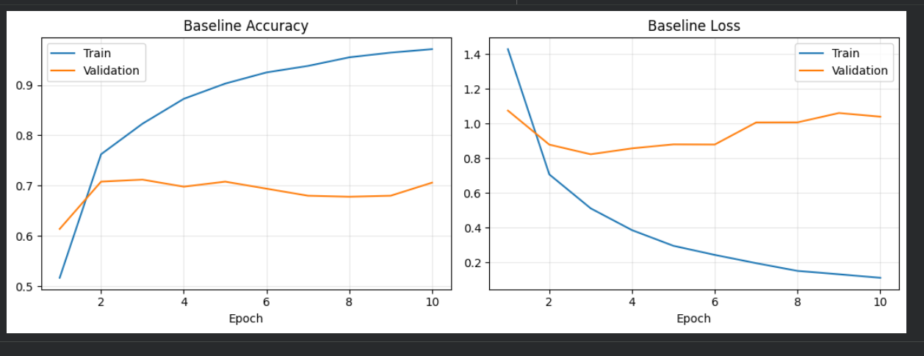
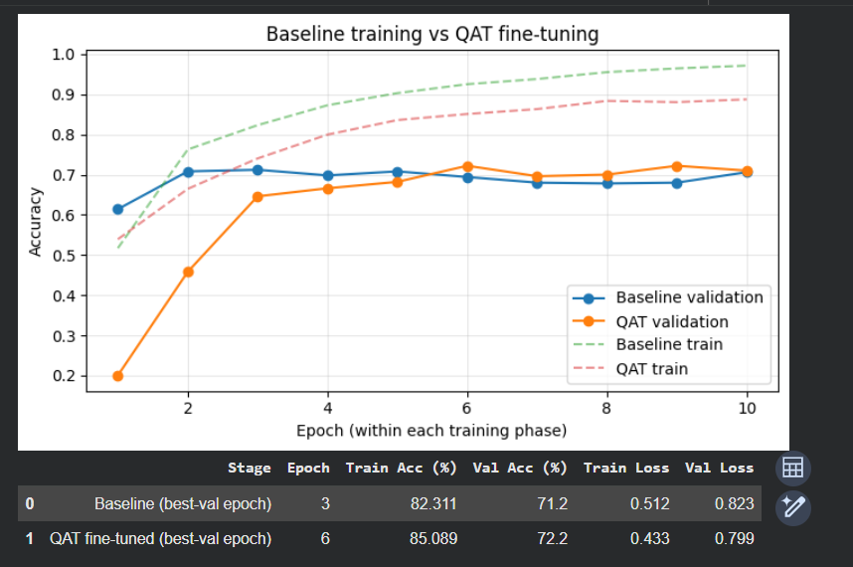
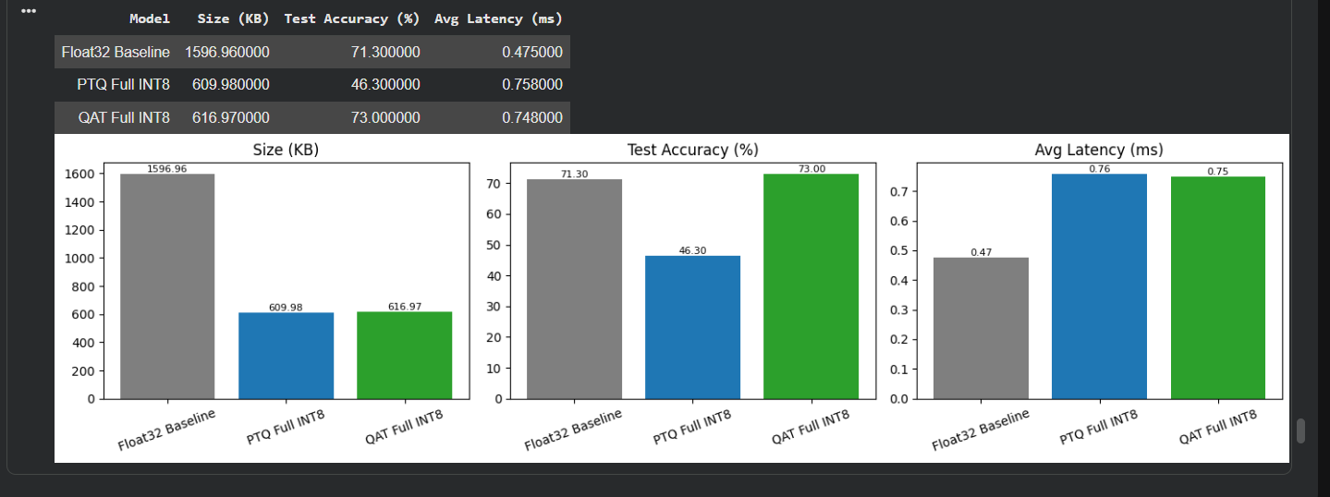

CONCLUSION:
The lab successfully implemented Quantization-Aware Training on a CIFAR-10 MobileNetV2 model and compared it with full INT8 Post-Training Quantization. The results demonstrated the trade-off between model size, accuracy, and inference latency, with QAT preserving higher accuracy than PTQ while maintaining a much smaller model size than the Float32 baseline. This shows the effectiveness of QAT for deploying accurate and compact TinyML models on resource-constrained edge devices.

Lab 5 – "Shout STOP!": Train a Voice Emergency Stop Model

A packaging factory needs a hands-free emergency stop: when a worker shouts "STOP", the conveyor belt must halt. The model must run on a tiny microcontroller with no internet.

Your task: Using the Google Speech Commands dataset in Google Colab, build a keyword spotting model with 3 classes: stop, _unknown_ and _silence_. Prepare the dataset with a speaker-wise split, extract MFCC features, train a DS-CNN, check misses and false alarms, and convert the model to int8 TFLite (under 100 KB).

Submit: Colab notebook (.ipynb), MFCC plots, training curves, confusion matrix, float vs int8 comparison, and the exported model files.
Marks: 10 (Dataset & features 3 | Training & evaluation 3 | Quantisation, analysis & viva 4)

WORKFLOW:
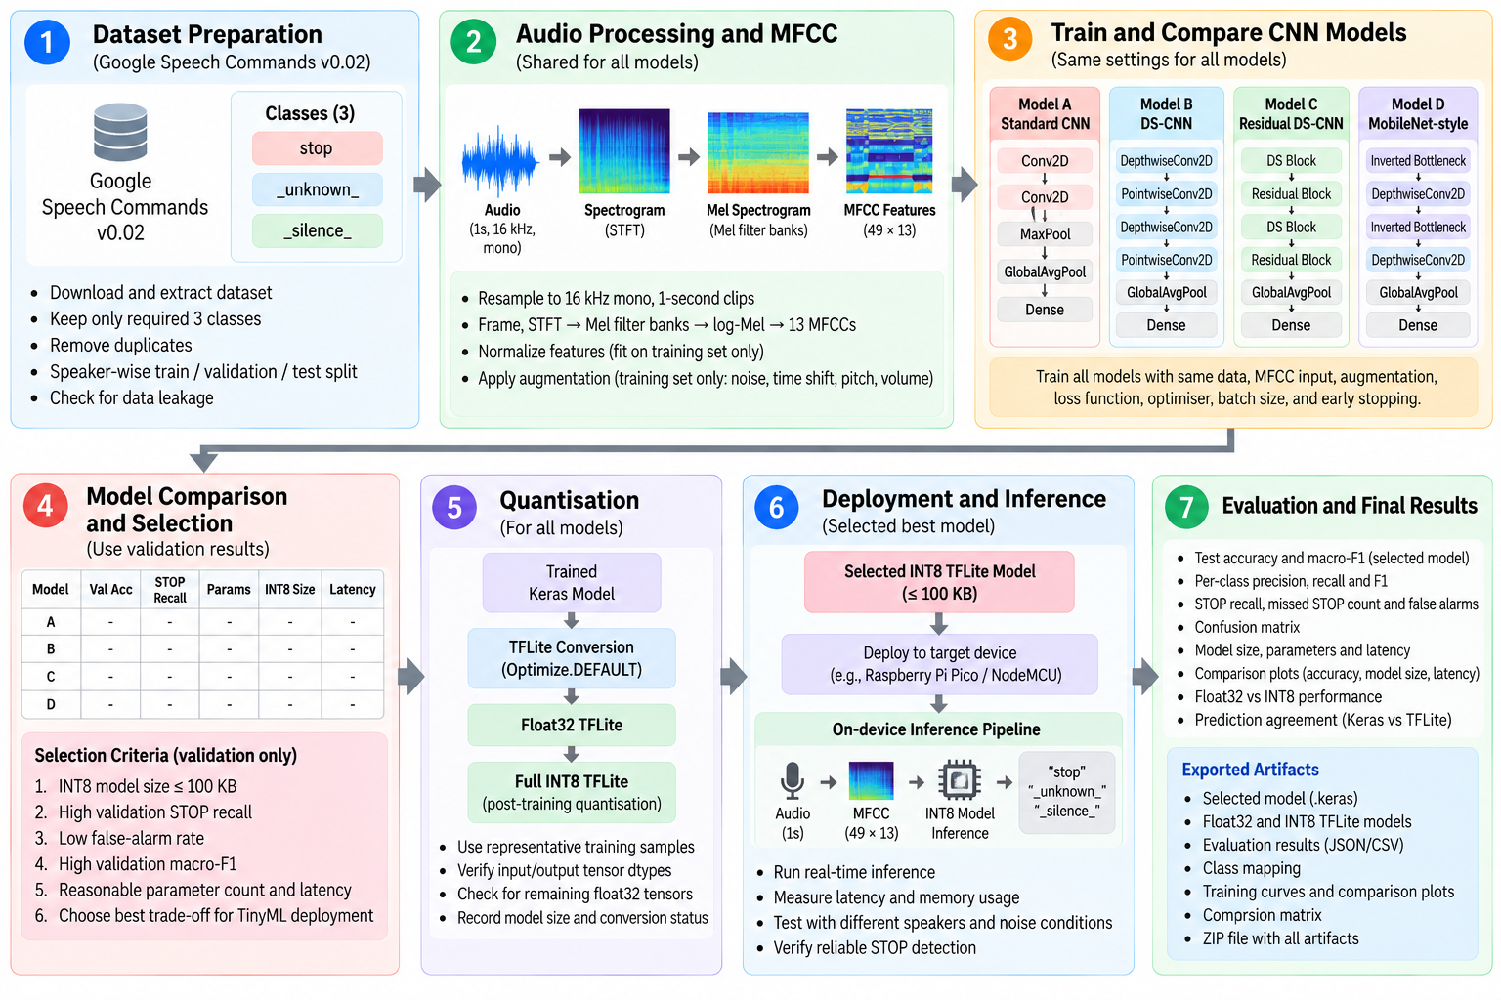

CODE:
import os, json, time, hashlib, random, tarfile, shutil, zipfile
from collections import Counter
import numpy as np
import pandas as pd
import matplotlib.pyplot as plt
from scipy.io import wavfile
from scipy.signal import resample_poly, get_window
import tensorflow as tf
from tensorflow import keras
from tensorflow.keras import layers
from sklearn.metrics import accuracy_score, precision_recall_fscore_support, f1_score, confusion_matrix
from sklearn.utils.class_weight import compute_class_weight

SEED = 42
os.environ["PYTHONHASHSEED"] = str(SEED)
keras.utils.set_random_seed(SEED)
random.seed(SEED); np.random.seed(SEED); tf.random.set_seed(SEED)

CLASSES = ["stop", "_unknown_", "_silence_"]
CLASS_TO_IDX = {c: i for i, c in enumerate(CLASSES)}
STOP, UNKNOWN, SILENCE = CLASS_TO_IDX["stop"], CLASS_TO_IDX["_unknown_"], CLASS_TO_IDX["_silence_"]
SPLITS = ["train", "val", "test"]

SR = 16000
CLIP_LEN = SR
SPLIT_FRAC = (0.70, 0.15, 0.15)
UNKNOWN_KEEP_PCT = 10
SILENCE_RATIO = 0.12
SILENCE_ZERO_FRAC = 0.20
SIZE_LIMIT_BYTES = 100_000

DATA_URLS = ["http://download.tensorflow.org/data/speech_commands_v0.02.tar.gz",
"https://storage.googleapis.com/download.tensorflow.org/data/speech_commands_v0.02.tar.gz"]
WORK_DIR = "/content/data"
SUBSET_DIR = os.path.join(WORK_DIR, "speech_subset_unk%dpct" % UNKNOWN_KEEP_PCT)
OUT_DIR = "/content/lab5_outputs"
for d in (WORK_DIR, OUT_DIR):
os.makedirs(d, exist_ok=True)
print("TensorFlow", tf.__version__, "| Keras", keras.__version__, "| NumPy", np.__version__)

def download_dataset():
errors = []
for url in DATA_URLS:
try:
path = keras.utils.get_file(fname="speech_commands_v0.02.tar.gz", origin=url,
cache_dir=WORK_DIR, cache_subdir="")
if os.path.getsize(path) > 2_000_000_000:
return path
errors.append("%s -> archive smaller than expected (incomplete download?)" % url)
except Exception as e:
errors.append("%s -> %s" % (url, e))
print("Download attempt failed:", errors[-1])
raise RuntimeError("Could not download Speech Commands v0.02:\n" + "\n".join(errors))

archive_path = download_dataset()
print("Archive:", archive_path, "| %.2f GB" % (os.path.getsize(archive_path) / 1e9))

MARKER = os.path.join(SUBSET_DIR, "_DONE")

def keep_file(word, base):
if word == "stop":
return True
h = int(hashlib.md5((word + "/" + base).encode()).hexdigest(), 16)
return (h % 100) < UNKNOWN_KEEP_PCT

if not os.path.exists(MARKER):
shutil.rmtree(SUBSET_DIR, ignore_errors=True)
os.makedirs(SUBSET_DIR)
try:
with tarfile.open(archive_path, "r|gz") as tar:
for m in tar:
if not m.isfile():
continue
name = m.name[2:] if m.name.startswith("./") else m.name
parts = name.split("/")
if len(parts) != 2 or not parts[1].endswith(".wav"):
continue
folder, base = parts
if folder == "_background_noise_":
wanted = True
elif folder.startswith("_"):
wanted = False
else:
wanted = keep_file(folder, base)
if not wanted:
continue
os.makedirs(os.path.join(SUBSET_DIR, folder), exist_ok=True)
with open(os.path.join(SUBSET_DIR, folder, base), "wb") as f:
f.write(tar.extractfile(m).read())
except (tarfile.TarError, EOFError, OSError) as e:
shutil.rmtree(SUBSET_DIR, ignore_errors=True)
raise RuntimeError("Extraction failed (%s). Delete %s and re-run the download cell." % (e, archive_path)) from e
with open(MARKER, "w") as f:
f.write("ok")
else:
print("Subset already extracted - skipping.")

words = sorted(w for w in os.listdir(SUBSET_DIR) if not w.startswith("_"))
counts = {w: len(os.listdir(os.path.join(SUBSET_DIR, w))) for w in words}
if counts.get("stop", 0) == 0:
raise ValueError("No STOP recordings found - the positive class would be empty.")
if len(words) < 2 or sum(v for k, v in counts.items() if k != "stop") == 0:
raise ValueError("No recordings for the _unknown_ class were extracted.")
print("stop clips:", counts["stop"], "| other words:", len(words) - 1,
"| unknown-pool clips:", sum(v for k, v in counts.items() if k != "stop"))
print("noise files:", sorted(os.listdir(os.path.join(SUBSET_DIR, "_background_noise_"))))

sr_seen, ch_seen, bad_files = Counter(), Counter(), []

def load_wav_mono_16k(path):
sr, x = wavfile.read(path)
sr_seen[int(sr)] += 1
if x.dtype == np.int16:
x = x.astype(np.float32) / 32768.0
elif x.dtype == np.int32:
x = x.astype(np.float32) / 2147483648.0
elif x.dtype == np.uint8:
x = (x.astype(np.float32) - 128.0) / 128.0
else:
x = x.astype(np.float32)
ch_seen[1 if x.ndim == 1 else int(x.shape[1])] += 1
if x.ndim == 2:
x = x.mean(axis=1)
if sr != SR:
g = int(np.gcd(int(sr), SR))
x = resample_poly(x, SR // g, int(sr) // g).astype(np.float32)
return x.astype(np.float32)

def fix_length(x, n=CLIP_LEN):
if len(x) < n:
x = np.pad(x, (0, n - len(x)))
return x[:n]

def to_int16(x):
return np.clip(np.round(x * 32767.0), -32768, 32767).astype(np.int16)

records, waves_speech = [], []
for word in words:
label = STOP if word == "stop" else UNKNOWN
for base in sorted(os.listdir(os.path.join(SUBSET_DIR, word))):
path = os.path.join(SUBSET_DIR, word, base)
try:
x = load_wav_mono_16k(path)
except (ValueError, OSError) as e:
bad_files.append((path, str(e)))
continue
records.append(dict(file=word + "/" + base, word=word, label=label,
speaker=base.split("_nohash_")[0], orig_len=len(x)))
waves_speech.append(to_int16(fix_length(x)))

print("Loaded speech clips:", len(records), "| unreadable files skipped:", len(bad_files))
for p, e in bad_files[:5]:
print(" skipped:", p, "->", e)
print("Sample rates seen:", dict(sr_seen), "| channel counts:", dict(ch_seen))
print("Clips shorter than 1 s (zero-padded): %.1f%%" % (100 * np.mean([r["orig_len"] < CLIP_LEN for r in records])))

df_speech = pd.DataFrame(records)
speakers = np.array(sorted(df_speech["speaker"].unique()))
perm = np.random.RandomState(SEED).permutation(len(speakers))
n_tr = int(round(SPLIT_FRAC[0] * len(speakers)))
n_va = int(round(SPLIT_FRAC[1] * len(speakers)))
spk_to_split = {}
for rank, k in enumerate(perm):
spk_to_split[speakers[k]] = "train" if rank < n_tr else ("val" if rank < n_tr + n_va else "test")
df_speech["split"] = df_speech["speaker"].map(spk_to_split)
Wsp = np.stack(waves_speech).astype(np.int16)
del waves_speech
print("Unique speakers:", len(speakers), "->", {s: sum(v == s for v in spk_to_split.values()) for s in SPLITS})

df_speech["hash"] = [hashlib.md5(Wsp[i].tobytes()).hexdigest() for i in range(len(Wsp))]
n_before = len(df_speech)
n_cross_groups = int((df_speech.groupby("hash")["split"].nunique() > 1).sum())

priority = {"test": 0, "val": 1, "train": 2}
ordered = df_speech.assign(_p=df_speech["split"].map(priority)).sort_values("_p", kind="stable")
kept = ordered.drop_duplicates("hash", keep="first")
keep_idx = np.sort(kept.index.values)
df_speech = df_speech.loc[keep_idx].reset_index(drop=True)
Wsp = Wsp[keep_idx]
print("Speech clips before de-duplication: %d | after: %d | removed: %d" % (n_before, len(df_speech), n_before - len(df_speech)))
print("Duplicate groups that crossed splits (resolved): %d" % n_cross_groups)

noise_dir = os.path.join(SUBSET_DIR, "_background_noise_")
noise = {fn: load_wav_mono_16k(os.path.join(noise_dir, fn))
for fn in sorted(os.listdir(noise_dir)) if fn.endswith(".wav")}
if not noise:
raise ValueError("No background-noise files found - cannot build the _silence_ class.")
NOISE_REGION = {"train": (0.00, 0.70), "val": (0.70, 0.85), "test": (0.85, 1.00)}
noise_names = sorted(noise)

rng_sil = np.random.RandomState(SEED + 1)
sil_records, sil_waves = [], []
for split in SPLITS:
n_speech = int((df_speech["split"] == split).sum())
n_sil = int(round(SILENCE_RATIO * n_speech))
for _ in range(n_sil):
if rng_sil.rand() < SILENCE_ZERO_FRAC:
clip, kind = np.zeros(CLIP_LEN, np.float32), "zeros"
else:
fn = noise_names[rng_sil.randint(len(noise_names))]
x = noise[fn]
lo, hi = int(NOISE_REGION[split][0] * len(x)), int(NOISE_REGION[split][1] * len(x))
start = rng_sil.randint(lo, hi - CLIP_LEN + 1)
clip, kind = (x[start:start + CLIP_LEN] * rng_sil.uniform(0.0, 1.0)).astype(np.float32), "noise:" + fn
sil_records.append(dict(file=kind, word="_silence_", label=SILENCE, speaker="n/a", orig_len=CLIP_LEN, split=split))
sil_waves.append(to_int16(clip))

df = pd.concat([df_speech, pd.DataFrame(sil_records)], ignore_index=True)
W = np.concatenate([Wsp, np.stack(sil_waves)]).astype(np.int16)
df["label_name"] = df["label"].map(lambda i: CLASSES[i])
assert len(df) == len(W)
del Wsp, sil_waves
print("Total clips:", len(df), "| waveform array:", W.shape, W.dtype, "| %.0f MB" % (W.nbytes / 1e6))

dist = pd.crosstab(df["split"], df["label_name"]).reindex(index=SPLITS, columns=CLASSES).fillna(0).astype(int)
dist["total"] = dist[CLASSES].sum(axis=1)
print("Class counts per split:\n", dist, "\n")
print("Class share (%) per split:\n", (dist[CLASSES].div(dist["total"], axis=0) * 100).round(1), "\n")
print("Unknown : stop ratio (train) = %.2f (class weights compensate in training)" % (dist.loc["train", "_unknown_"] / max(dist.loc["train", "stop"], 1)))
if (dist[CLASSES] == 0).any().any():
raise ValueError("A class is empty in at least one split:\n%s" % dist)

is_speech = (df["speaker"] != "n/a").values
spk_sets = {s: set(df.loc[is_speech & (df["split"] == s).values, "speaker"]) for s in SPLITS}
file_sets = {s: set(df.loc[is_speech & (df["split"] == s).values, "file"]) for s in SPLITS}
hash_sets = {s: set(df.loc[is_speech & (df["split"] == s).values, "hash"]) for s in SPLITS}
leak_report = {}
for a, b in [("train", "val"), ("train", "test"), ("val", "test")]:
leak_report[a + "-" + b] = {"shared_speakers": len(spk_sets[a] & spk_sets[b]),
"shared_files": len(file_sets[a] & file_sets[b]),
"shared_audio_hashes": len(hash_sets[a] & hash_sets[b])}
print("Leakage check (every value must be 0):")
for k, v in leak_report.items():
print(" %-11s %s" % (k, v))
if any(x != 0 for v in leak_report.values() for x in v.values()):
raise AssertionError("LEAKAGE DETECTED between splits - do not continue.")
print("PASS: speaker-wise split verified; no shared speakers, files or identical recordings.")
print("Silence clips: noise files are cut into disjoint time regions per split, so no noise segment is shared.")

AUG_SHIFT_MS = 100
AUG_SHIFT = int(SR * AUG_SHIFT_MS / 1000)
AUG_NOISE_P = 0.8
AUG_NOISE_GAIN = (0.0, 0.1)

idx = {s: np.where(df["split"].values == s)[0] for s in SPLITS}
y_all = df["label"].values.astype(np.int64)

lo_f, hi_f = NOISE_REGION["train"]
noise_train = [noise[fn][int(lo_f * len(noise[fn])): int(hi_f * len(noise[fn]))] for fn in noise_names]
assert all(len(n) > CLIP_LEN for n in noise_train)

def augment_clip(x_int16, rng):
x = x_int16.astype(np.float32) / 32768.0
shift = rng.randint(-AUG_SHIFT, AUG_SHIFT + 1)
if shift > 0:
x = np.concatenate([np.zeros(shift, np.float32), x[:-shift]])
elif shift < 0:
x = np.concatenate([x[-shift:], np.zeros(-shift, np.float32)])
if rng.rand() < AUG_NOISE_P:
nz = noise_train[rng.randint(len(noise_train))]
start = rng.randint(0, len(nz) - CLIP_LEN + 1)
x = x + rng.uniform(*AUG_NOISE_GAIN) * nz[start:start + CLIP_LEN]
return to_int16(np.clip(x, -1.0, 1.0))

aug_src = idx["train"][y_all[idx["train"]] != SILENCE]
assert set(df.loc[aug_src, "split"]) == {"train"}
rng_aug = np.random.RandomState(SEED + 2)
W_aug = np.stack([augment_clip(W[i], rng_aug) for i in aug_src])
y_aug = y_all[aug_src]
print("Augmented copies (train only):", len(W_aug), "| clean train clips:", len(idx["train"]))
print("Augmentation noise comes from the first %d%% of each noise file; validation/test: no augmentation." % int(hi_f * 100))

FRAME_LEN, FRAME_STEP, FFT_LEN = 512, 320, 512
N_BINS = FFT_LEN // 2 + 1
N_MEL, F_LO, F_HI = 40, 20.0, 7600.0
LOG_EPS = 1e-6
N_MFCC = 13
N_FRAMES = 1 + (CLIP_LEN - FRAME_LEN) // FRAME_STEP
INPUT_SHAPE = (N_FRAMES, N_MFCC, 1)

HANN = tf.signal.hann_window(FRAME_LEN, periodic=True)
MEL_W = tf.signal.linear_to_mel_weight_matrix(N_MEL, N_BINS, SR, F_LO, F_HI)
MEL_W_NP = MEL_W.numpy().astype(np.float64)
assert MEL_W_NP.shape == (N_BINS, N_MEL) and (MEL_W_NP.sum(axis=0) > 0).all(), "empty mel filter"

def frontend_steps(wave):

frames = tf.signal.frame(wave, FRAME_LEN, FRAME_STEP, pad_end=False)
windowed = frames * HANN
stft = tf.signal.rfft(windowed, fft_length=[FFT_LEN])
power = tf.math.square(tf.abs(stft))
mel = tf.tensordot(power, MEL_W, 1)
log_mel = tf.math.log(mel + LOG_EPS)
mfcc = tf.signal.mfccs_from_log_mel_spectrograms(log_mel)[..., :N_MFCC]
return {"frames": frames, "windowed": windowed, "stft": stft, "power": power,
"mel": mel, "log_mel": log_mel, "mfcc": mfcc}

@tf.function
def mfcc_tf(wave):
return frontend_steps(wave)["mfcc"]

def extract_features(w_int16, batch=512):
out = []
for i in range(0, len(w_int16), batch):
wav = tf.constant(w_int16[i:i + batch].astype(np.float32) / 32768.0)
out.append(mfcc_tf(wav).numpy())
return np.concatenate(out)[..., np.newaxis].astype(np.float32)

i0 = int(idx["train"][0])
steps = frontend_steps(tf.constant(W[i0:i0 + 1].astype(np.float32) / 32768.0))
print("audio :", (CLIP_LEN,))
for k in ["frames", "windowed", "stft", "power", "mel", "log_mel", "mfcc"]:
print("%-12s: %s" % (k, tuple(steps[k].shape[1:])))
assert tuple(steps["mfcc"].shape[1:]) == (N_FRAMES, N_MFCC)
print("Parameters: %d Hz | frame %d (%.0f ms) | hop %d (%.0f ms) | FFT %d | %d mel %.0f-%.0f Hz | %d MFCC | input %s"
% (SR, FRAME_LEN, 1000 * FRAME_LEN / SR, FRAME_STEP, 1000 * FRAME_STEP / SR, FFT_LEN, N_MEL, F_LO, F_HI, N_MFCC, INPUT_SHAPE))

HANN_NP = get_window("hann", FRAME_LEN, fftbins=True)
_n, _k = np.arange(N_MEL), np.arange(N_MFCC)[:, None]
DCT_MAT = 2.0 * np.cos(np.pi * _k * (2 * _n + 1) / (2 * N_MEL)) / np.sqrt(2.0 * N_MEL)

def mfcc_numpy(w_int16):
x = w_int16.astype(np.float64) / 32768.0
frames = np.lib.stride_tricks.sliding_window_view(x, FRAME_LEN)[::FRAME_STEP]
spec = np.fft.rfft(frames * HANN_NP, n=FFT_LEN, axis=-1)
power = spec.real ** 2 + spec.imag ** 2
log_mel = np.log(power @ MEL_W_NP + LOG_EPS)
return log_mel @ DCT_MAT.T

chk = np.random.RandomState(SEED).choice(len(W), 64, replace=False)
ref_np = np.stack([mfcc_numpy(W[i]) for i in chk])
ref_tf = extract_features(W[chk])[..., 0]
max_abs = float(np.max(np.abs(ref_np - ref_tf)))
FRONTEND_PARITY_OK = bool(np.allclose(ref_np, ref_tf, rtol=1e-3, atol=5e-3))
print("NumPy vs TensorFlow MFCC on 64 clips: max |difference| = %.2e -> parity %s" % (max_abs, "OK" if FRONTEND_PARITY_OK else "FAILED"))
if not FRONTEND_PARITY_OK:
raise AssertionError("NumPy and TensorFlow frontends disagree (max diff %.3e); check windowing, mel table or DCT scaling." % max_abs)

F_clean = extract_features(W)
F_aug = extract_features(W_aug)
F_train_raw = np.concatenate([F_clean[idx["train"]], F_aug])
y_train = np.concatenate([y_all[idx["train"]], y_aug])

feat_mean = F_train_raw.mean(axis=(0, 1, 3))
feat_std = F_train_raw.std(axis=(0, 1, 3)) + 1e-6

def normalize(F):
return ((F - feat_mean.reshape(1, 1, -1, 1)) / feat_std.reshape(1, 1, -1, 1)).astype(np.float32)

X_train = normalize(F_train_raw)
X_val, y_val = normalize(F_clean[idx["val"]]), y_all[idx["val"]]

for name, X, y in [("train", X_train, y_train), ("val", X_val, y_val)]:
assert X.shape[1:] == INPUT_SHAPE and X.dtype == np.float32 and len(X) == len(y) > 0
assert np.isfinite(X).all(), "non-finite features in " + name
print("X_%-5s shape=%s dtype=%s | labels=%s" % (name, X.shape, X.dtype, dict(sorted(Counter(CLASSES[k] for k in y).items()))))
print("Normalisation mean:", np.round(feat_mean, 2))
print("Normalisation std :", np.round(feat_std, 2))

i_stop = int(np.where((df["label"].values == STOP) & (df["split"].values == "train"))[0][0])
i_unk = int(np.where((df["label"].values == UNKNOWN) & (df["split"].values == "train"))[0][0])
i_sil = int(np.where((df["label"].values == SILENCE) & (df["split"].values == "train") & df["file"].str.startswith("noise").values)[0][0])

t = np.arange(CLIP_LEN) / SR
fig, ax = plt.subplots(figsize=(7, 3))
ax.plot(t, W[i_stop].astype(np.float32) / 32768.0, lw=0.7)
ax.set_xlabel("Time (s)"); ax.set_ylabel("Amplitude (full scale = 1)"); ax.set_title("Waveform - STOP (%s)" % df.loc[i_stop, "file"])
fig.tight_layout(); fig.savefig(os.path.join(OUT_DIR, "waveform_stop.png"), dpi=150); plt.show()

power = frontend_steps(tf.constant(W[i_stop:i_stop + 1].astype(np.float32) / 32768.0))["power"][0].numpy()
fig, ax = plt.subplots(figsize=(7, 3.5))
im = ax.imshow(10 * np.log10(power.T + 1e-10), origin="lower", aspect="auto", extent=[0, 1, 0, SR / 2], cmap="magma")
ax.set_xlabel("Time (s)"); ax.set_ylabel("Frequency (Hz)"); ax.set_title("STFT power spectrogram - STOP")
fig.colorbar(im, ax=ax, label="Power (dB)")
fig.tight_layout(); fig.savefig(os.path.join(OUT_DIR, "stft_spectrogram_stop.png"), dpi=150); plt.show()

def plot_mfcc(feat, title, path):
fig, ax = plt.subplots(figsize=(7, 3.5))
im = ax.imshow(feat[:, :, 0].T, origin="lower", aspect="auto", extent=[0, 1, -0.5, N_MFCC - 0.5], cmap="viridis")
ax.set_xlabel("Time (s)"); ax.set_ylabel("MFCC coefficient index"); ax.set_title(title)
fig.colorbar(im, ax=ax, label="MFCC value (raw, unnormalised)")
fig.tight_layout(); fig.savefig(path, dpi=150); plt.show()

plot_mfcc(F_clean[i_stop], "MFCC heatmap - STOP (%s)" % df.loc[i_stop, "file"], os.path.join(OUT_DIR, "mfcc_stop.png"))
plot_mfcc(F_clean[i_unk], "MFCC heatmap - unknown word (%s)" % df.loc[i_unk, "file"], os.path.join(OUT_DIR, "mfcc_unknown.png"))
plot_mfcc(F_clean[i_sil], "MFCC heatmap - silence (%s)" % df.loc[i_sil, "file"], os.path.join(OUT_DIR, "mfcc_silence.png"))

def _w(base, alpha, divisor=4, minimum=8):
"""Width multiplier: round base*alpha to a multiple of `divisor` (at least `minimum`)."""
return max(minimum, int(base * alpha + divisor / 2) // divisor * divisor)

def _bn_act(x, name, act="relu"):
x = layers.BatchNormalization(name=name + "_bn")(x)
if act == "relu":
x = layers.ReLU(name=name + "_relu")(x)
elif act == "relu6":
x = layers.ReLU(max_value=6.0, name=name + "_relu6")(x)
return x

def build_model_a(input_shape=INPUT_SHAPE, n_classes=3, alpha=1.0, dropout=0.2):
inp = keras.Input(shape=input_shape, name="mfcc_input")
x = inp
for k, base in enumerate((16, 32, 64)):
x = layers.Conv2D(_w(base, alpha), (3, 3), padding="same", use_bias=False, name="conv%d" % k)(x)
x = _bn_act(x, "conv%d" % k)
if k < 2:
x = layers.MaxPooling2D((2, 2), name="pool%d" % k)(x)
x = layers.GlobalAveragePooling2D(name="gap")(x)
x = layers.Dropout(dropout, name="drop")(x)
out = layers.Dense(n_classes, activation="softmax", name="softmax")(x)
return keras.Model(inp, out, name="A_compact_cnn")

def build_model_b(input_shape=INPUT_SHAPE, n_classes=3, alpha=1.0, n_blocks=4, dropout=0.2):
f = _w(64, alpha)
inp = keras.Input(shape=input_shape, name="mfcc_input")
x = layers.Conv2D(f, (10, 4), strides=(2, 2), padding="same", use_bias=False, name="stem_conv")(inp)
x = _bn_act(x, "stem")
for b in range(n_blocks):
x = layers.DepthwiseConv2D((3, 3), padding="same", use_bias=False, name="dw%d" % b)(x)
x = _bn_act(x, "dw%d" % b)
x = layers.Conv2D(f, (1, 1), use_bias=False, name="pw%d" % b)(x)
x = _bn_act(x, "pw%d" % b)
x = layers.GlobalAveragePooling2D(name="gap")(x)
x = layers.Dropout(dropout, name="drop")(x)
out = layers.Dense(n_classes, activation="softmax", name="softmax")(x)
return keras.Model(inp, out, name="B_ds_cnn")

def _ds_res_block(x, filters, stride, name):
in_ch = x.shape[-1]
y = layers.DepthwiseConv2D((3, 3), strides=stride, padding="same", use_bias=False, name=name + "_dw")(x)
y = _bn_act(y, name + "_dw")
y = layers.Conv2D(filters, (1, 1), use_bias=False, name=name + "_pw")(y)
y = layers.BatchNormalization(name=name + "_pw_bn")(y)
if tuple(stride) == (1, 1) and in_ch == filters:
shortcut = x
else:
shortcut = layers.Conv2D(filters, (1, 1), strides=stride, padding="same", use_bias=False, name=name + "_proj")(x)
shortcut = layers.BatchNormalization(name=name + "_proj_bn")(shortcut)
assert tuple(y.shape[1:]) == tuple(shortcut.shape[1:]), "residual shape mismatch in %s: %s vs %s" % (name, y.shape, shortcut.shape)
y = layers.Add(name=name + "_add")([y, shortcut])
return layers.ReLU(name=name + "_out_relu")(y)

def build_model_c(input_shape=INPUT_SHAPE, n_classes=3, alpha=1.0, dropout=0.2):
inp = keras.Input(shape=input_shape, name="mfcc_input")
x = layers.Conv2D(_w(32, alpha), (3, 3), strides=(2, 2), padding="same", use_bias=False, name="stem_conv")(inp)
x = _bn_act(x, "stem")
for k, (base, stride) in enumerate([(48, (1, 1)), (48, (1, 1)), (64, (2, 2)), (64, (1, 1))]):
x = _ds_res_block(x, _w(base, alpha), stride, "res%d" % k)
x = layers.GlobalAveragePooling2D(name="gap")(x)
x = layers.Dropout(dropout, name="drop")(x)
out = layers.Dense(n_classes, activation="softmax", name="softmax")(x)
return keras.Model(inp, out, name="C_res_ds_cnn")

def _inv_bottleneck(x, expansion, out_ch, stride, name):
in_ch = x.shape[-1]
y = x
if expansion != 1:
y = layers.Conv2D(in_ch * expansion, (1, 1), use_bias=False, name=name + "_exp")(y)
y = _bn_act(y, name + "_exp", "relu6")
y = layers.DepthwiseConv2D((3, 3), strides=stride, padding="same", use_bias=False, name=name + "_dw")(y)
y = _bn_act(y, name + "_dw", "relu6")
y = layers.Conv2D(out_ch, (1, 1), use_bias=False, name=name + "_proj")(y)
y = layers.BatchNormalization(name=name + "_proj_bn")(y)
if tuple(stride) == (1, 1) and in_ch == out_ch:
assert tuple(x.shape[1:]) == tuple(y.shape[1:]), "residual shape mismatch in " + name
y = layers.Add(name=name + "_add")([x, y])
return y

def build_model_d(input_shape=INPUT_SHAPE, n_classes=3, alpha=1.0, dropout=0.2):
inp = keras.Input(shape=input_shape, name="mfcc_input")
x = layers.Conv2D(_w(16, alpha), (3, 3), strides=(2, 2), padding="same", use_bias=False, name="stem_conv")(inp)
x = _bn_act(x, "stem", "relu6")
for k, (t, base, stride) in enumerate([(2, 24, (1, 1)), (2, 24, (1, 1)), (3, 32, (2, 2)), (3, 32, (1, 1))]):
x = _inv_bottleneck(x, t, _w(base, alpha), stride, "ib%d" % k)
x = layers.Conv2D(_w(64, alpha), (1, 1), use_bias=False, name="head_conv")(x)
x = _bn_act(x, "head", "relu6")
x = layers.GlobalAveragePooling2D(name="gap")(x)
x = layers.Dropout(dropout, name="drop")(x)
out = layers.Dense(n_classes, activation="softmax", name="softmax")(x)
return keras.Model(inp, out, name="D_mobilenet_style")

CANDIDATES = {
"A_compact_cnn": dict(label="Model A - Compact Standard CNN", builder=build_model_a, alpha=1.0),
"B_ds_cnn": dict(label="Model B - DS-CNN", builder=build_model_b, alpha=1.0),
"C_res_ds_cnn": dict(label="Model C - Residual DS-CNN", builder=build_model_c, alpha=1.0),
"D_mobilenet_style": dict(label="Model D - Compact MobileNet-style CNN", builder=build_model_d, alpha=1.0),
}

def estimate_macs(model):
"""Approximate multiply-accumulates per inference (Conv2D, DepthwiseConv2D and Dense layers only)."""
total = 0
for l in model.layers:
if isinstance(l, layers.DepthwiseConv2D):
o, k = l.output.shape, l.kernel_size
total += o[1] * o[2] * k[0] * k[1] * l.input.shape[-1]
elif isinstance(l, layers.Conv2D):
o, k = l.output.shape, l.kernel_size
total += o[1] * o[2] * k[0] * k[1] * l.input.shape[-1] * l.filters
elif isinstance(l, layers.Dense):
total += l.input.shape[-1] * l.units
return int(total)

arch_rows = []
for name, cfg in CANDIDATES.items():
keras.backend.clear_session()
m = cfg["builder"](alpha=cfg["alpha"])
assert m.input_shape == (None,) + INPUT_SHAPE and m.output_shape == (None, len(CLASSES)), "input/output shape differs from the common contract"
print("=" * 100, "\n%s (%s)" % (cfg["label"], name))
m.summary(line_length=100)
trainable = int(np.sum([np.prod(v.shape) for v in m.trainable_weights]))
kinds = Counter(type(l).__name__ for l in m.layers)
arch_rows.append({"Model": name, "Trainable params": trainable, "Total params": int(m.count_params()),
"Approx. MACs": estimate_macs(m), "Conv2D": kinds["Conv2D"], "DepthwiseConv2D": kinds["DepthwiseConv2D"],
"Add (skips)": kinds["Add"], "MaxPooling2D": kinds["MaxPooling2D"], "alpha": cfg["alpha"]})
cfg["trainable_params"], cfg["total_params"], cfg["macs"] = trainable, int(m.count_params()), estimate_macs(m)
arch_df = pd.DataFrame(arch_rows).set_index("Model")
print("\nArchitecture comparison (counts are layer instances; MACs are approximate, conv+dense only):")
print(arch_df.to_string())
assert arch_df.loc["A_compact_cnn", "DepthwiseConv2D"] == 0 and arch_df.loc["B_ds_cnn", "DepthwiseConv2D"] > 0
assert arch_df.loc["C_res_ds_cnn", "Add (skips)"] > 0 and arch_df.loc["D_mobilenet_style", "Add (skips)"] > 0 and arch_df.loc["B_ds_cnn", "Add (skips)"] == 0

EPOCHS, BATCH, LR = 30, 64, 1e-3
ES_PATIENCE, LR_PATIENCE = 6, 3
CKPT_DIR = "/content/lab5_candidates"
os.makedirs(CKPT_DIR, exist_ok=True)

cw = compute_class_weight("balanced", classes=np.array([0, 1, 2]), y=y_train)
class_weight = {i: float(w) for i, w in enumerate(cw)}
print("Class weights (shared by all candidates):", {CLASSES[i]: round(w, 3) for i, w in class_weight.items()})
print("Train/val shapes:", X_train.shape, X_val.shape, "| protocol: max %d epochs, batch %d, Adam %.0e, early-stop patience %d on val_loss" % (EPOCHS, BATCH, LR, ES_PATIENCE))

def train_candidate(name):
cfg = CANDIDATES[name]
keras.backend.clear_session()
keras.utils.set_random_seed(SEED)
m = cfg["builder"](alpha=cfg["alpha"])
m.compile(optimizer=keras.optimizers.Adam(LR), loss="sparse_categorical_crossentropy", metrics=["accuracy"])
ckpt = os.path.join(CKPT_DIR, name + "_best.keras")
cbs = [keras.callbacks.ModelCheckpoint(ckpt, monitor="val_loss", save_best_only=True, verbose=0),
keras.callbacks.EarlyStopping(monitor="val_loss", patience=ES_PATIENCE, restore_best_weights=True, verbose=1),
keras.callbacks.ReduceLROnPlateau(monitor="val_loss", factor=0.5, patience=LR_PATIENCE, min_lr=1e-5, verbose=1)]
t0 = time.perf_counter()
h = m.fit(X_train, y_train, validation_data=(X_val, y_val), epochs=EPOCHS, batch_size=BATCH,
class_weight=class_weight, callbacks=cbs, verbose=2)
seconds = time.perf_counter() - t0
hist = {k: [float(v) for v in vals] for k, vals in h.history.items()}
return dict(history=hist, epochs_run=len(hist["loss"]), best_epoch=int(np.argmin(hist["val_loss"])) + 1,
best_val_loss=float(min(hist["val_loss"])), max_val_acc_any_epoch=float(max(hist["val_accuracy"])),
train_seconds=float(seconds), ckpt=ckpt)

keras.backend.clear_session(); keras.utils.set_random_seed(SEED)
_w_model = build_model_a(); _w_model.compile(optimizer="adam", loss="sparse_categorical_crossentropy")
_w_model.fit(X_train[:512], y_train[:512], epochs=1, batch_size=BATCH, verbose=0); del _w_model

train_log = {}
for name, cfg in CANDIDATES.items():
print("\n" + "=" * 100 + "\nTraining %s (%s) | %d trainable parameters" % (cfg["label"], name, cfg["trainable_params"]))
train_log[name] = train_candidate(name)
t = train_log[name]
print("-> %s: %d epochs, best epoch %d (val_loss %.4f), %.1f s" % (name, t["epochs_run"], t["best_epoch"], t["best_val_loss"], t["train_seconds"]))

fig, axes = plt.subplots(1, 3, figsize=(17, 4))
for name, t in train_log.items():
h = t["history"]; ep = np.arange(1, len(h["loss"]) + 1)
axes[0].plot(ep, h["val_loss"], label=name); axes[1].plot(ep, h["val_accuracy"], label=name)
axes[2].plot(ep, h["accuracy"], label=name)
axes[0].plot(t["best_epoch"], t["best_val_loss"], "k*")
axes[0].set_title("Validation loss (star = saved checkpoint)"); axes[1].set_title("Validation accuracy (plain argmax)"); axes[2].set_title("Training accuracy")
for a in axes:
a.set_xlabel("Epoch"); a.grid(alpha=0.3); a.legend(fontsize=8)
fig.tight_layout(); fig.savefig(os.path.join(OUT_DIR, "training_curves_all_candidates.png"), dpi=150); plt.show()

train_df = pd.DataFrame({n: {"Trainable params": CANDIDATES[n]["trainable_params"], "Epochs run": t["epochs_run"], "Best epoch": t["best_epoch"],
"Best val loss": round(t["best_val_loss"], 4), "Max val acc, any epoch (%)": round(100 * t["max_val_acc_any_epoch"], 2),
"Training time (s)": round(t["train_seconds"], 1)} for n, t in train_log.items()}).T
print("Training summary (validation data only):\n", train_df.to_string())

TARGET_STOP_RECALL = 0.98
TAU_GRID = np.round(np.arange(0.01, 0.991, 0.01), 2)

def decide(probs, tau):
pred = 1 + probs[:, 1:].argmax(axis=1)
pred[probs[:, 0] >= tau] = STOP
return pred.astype(np.int64)

def select_tau(probs_val, y_val_):
rec = np.array([(decide(probs_val, t)[y_val_ == STOP] == STOP).mean() for t in TAU_GRID])
ok = np.where(rec >= TARGET_STOP_RECALL)[0]
if len(ok):
k, met = int(ok.max()), True
rule = "largest tau on the 0.01-0.99 grid with validation STOP recall >= %.2f" % TARGET_STOP_RECALL
else:
k, met = int(np.where(rec == rec.max())[0].max()), False
rule = "target %.2f unreachable on the 0.01-0.99 grid; tau with the highest validation STOP recall (largest among ties)" % TARGET_STOP_RECALL
return float(TAU_GRID[k]), rule, met, float(rec[k])

def compute_metrics(y_true, y_pred):
labels = [0, 1, 2]
p, r, f, s = precision_recall_fscore_support(y_true, y_pred, labels=labels, zero_division=0)
cm = confusion_matrix(y_true, y_pred, labels=labels)
stop_total, non_stop_total = int((y_true == STOP).sum()), int((y_true != STOP).sum())
stop_misses = int(((y_true == STOP) & (y_pred != STOP)).sum())
false_alarms = int(((y_true != STOP) & (y_pred == STOP)).sum())
return {"accuracy": float(accuracy_score(y_true, y_pred)),
"macro_precision": float(p.mean()), "macro_recall": float(r.mean()),
"macro_f1": float(f1_score(y_true, y_pred, labels=labels, average="macro", zero_division=0)),
"per_class": {CLASSES[i]: {"precision": float(p[i]), "recall": float(r[i]), "f1": float(f[i]), "support": int(s[i])} for i in labels},
"stop_recall": float(r[0]), "stop_total": stop_total, "stop_misses": stop_misses,
"stop_miss_rate": float(stop_misses / max(stop_total, 1)),
"non_stop_total": non_stop_total, "false_alarms": false_alarms,
"false_alarm_rate": float(false_alarms / max(non_stop_total, 1)),
"confusion_matrix": cm.tolist()}

def per_class_table(m):
return pd.DataFrame(m["per_class"]).T[["precision", "recall", "f1", "support"]].round(4)

def plot_confusion(cm, title, path=None, ax=None):
cm = np.asarray(cm)
pct = cm / np.clip(cm.sum(axis=1, keepdims=True), 1, None)
own = ax is None
if own:
fig, ax = plt.subplots(figsize=(5.8, 5))
im = ax.imshow(pct, cmap="Blues", vmin=0, vmax=1)
ax.set_xticks(range(3)); ax.set_xticklabels(CLASSES, fontsize=8); ax.set_yticks(range(3)); ax.set_yticklabels(CLASSES, fontsize=8)
ax.set_xlabel("Predicted class"); ax.set_ylabel("True class"); ax.set_title(title, fontsize=9)
for i in range(3):
for j in range(3):
ax.text(j, i, "%d\n(%.1f%%)" % (cm[i, j], 100 * pct[i, j]), ha="center", va="center", color="white" if pct[i, j] > 0.5 else "black", fontsize=8)
if own:
fig.colorbar(im, ax=ax, label="Fraction of true class"); fig.tight_layout()
if path: fig.savefig(path, dpi=150)
plt.show()

rep_idx = np.random.RandomState(SEED).choice(len(X_train), size=min(500, len(X_train)), replace=False)
rep_X = X_train[rep_idx]

def convert_float(m):
return tf.lite.TFLiteConverter.from_keras_model(m).convert()

def convert_int8(m, calib_X):
conv = tf.lite.TFLiteConverter.from_keras_model(m)
conv.optimizations = [tf.lite.Optimize.DEFAULT]
def rep_gen():
for i in range(len(calib_X)):
yield [calib_X[i:i + 1].astype(np.float32)]
conv.representative_dataset = rep_gen
conv.target_spec.supported_ops = [tf.lite.OpsSet.TFLITE_BUILTINS_INT8]
conv.inference_input_type = tf.int8
conv.inference_output_type = tf.int8
return conv.convert()

def inspect_tflite(tfl):
"""Inspect the REAL converted model (not the converter settings)."""
try:
interp = tf.lite.Interpreter(model_content=tfl, experimental_op_resolver_type=tf.lite.experimental.OpResolverType.BUILTIN_WITHOUT_DEFAULT_DELEGATES)
except (TypeError, AttributeError):
interp = tf.lite.Interpreter(model_content=tfl)
interp.allocate_tensors()
i_d, o_d = interp.get_input_details()[0], interp.get_output_details()[0]
tensors = interp.get_tensor_details()
float_tensors = [t["name"] for t in tensors if t["dtype"] == np.float32]
try:
ops = [op["op_name"] for op in interp._get_ops_details()]; ops_ok = True
except AttributeError:
ops, ops_ok = None, False
q_ops = sorted({o for o in (ops or []) if o in ("QUANTIZE", "DEQUANTIZE")})
int_io = bool(i_d["dtype"] == np.int8 and o_d["dtype"] == np.int8)
return {"in_dtype": np.dtype(i_d["dtype"]).name, "in_shape": [int(v) for v in i_d["shape"]],
"in_scale": float(i_d["quantization"][0]), "in_zero_point": int(i_d["quantization"][1]),
"out_dtype": np.dtype(o_d["dtype"]).name, "out_scale": float(o_d["quantization"][0]), "out_zero_point": int(o_d["quantization"][1]),
"tensor_dtypes": dict(Counter(np.dtype(t["dtype"]).name for t in tensors)),
"n_float32_tensors": len(float_tensors), "float32_tensor_examples": float_tensors[:5],
"operators": dict(Counter(ops)) if ops_ok else None, "operators_verifiable": ops_ok, "quantize_dequantize_ops": q_ops,
"fully_int8": bool(int_io and not float_tensors and not q_ops)}

def make_runner(tflite_bytes):
interp = tf.lite.Interpreter(model_content=tflite_bytes, num_threads=1)
interp.allocate_tensors()
inp, out = interp.get_input_details()[0], interp.get_output_details()[0]
in_scale, in_zp = inp["quantization"]; out_scale, out_zp = out["quantization"]
def prep(x):
if x.dtype == np.int8:
return x
if inp["dtype"] == np.int8:
return np.clip(np.round(x / in_scale + in_zp), -128, 127).astype(np.int8)
return x.astype(np.float32)
def run(x):
interp.set_tensor(inp["index"], prep(x)); interp.invoke()
y = interp.get_tensor(out["index"])[0]
if out["dtype"] == np.int8:
y = (y.astype(np.float32) - out_zp) * out_scale
return y.astype(np.float32)
return interp, inp, out, prep, run

def predict_tflite(tflite_bytes, X):
run = make_runner(tflite_bytes)[4]
return np.stack([run(X[i:i + 1]) for i in range(len(X))])

def benchmark_latency(tflite_bytes, X, n_samples=200, warmup=20, repeats=5):
"""Per-call invoke() time on precomputed MFCC features (no MFCC extraction), host CPU, 1 thread."""
interp, inp, out, prep, _ = make_runner(tflite_bytes)
xs = [prep(X[i:i + 1]) for i in range(min(n_samples, len(X)))]
for k in range(warmup):
interp.set_tensor(inp["index"], xs[k % len(xs)]); interp.invoke()
calls, pass_means = [], []
for _ in range(repeats):
times = []
for x in xs:
interp.set_tensor(inp["index"], x)
t0 = time.perf_counter(); interp.invoke(); times.append(time.perf_counter() - t0)
calls += times; pass_means.append(1000.0 * float(np.mean(times)))
a = 1000.0 * np.array(calls)
return {"mean_ms": float(a.mean()), "median_ms": float(np.median(a)), "p95_ms": float(np.percentile(a, 95)),
"std_of_pass_means_ms": float(np.std(pass_means)), "n_calls": int(len(a)), "warmup_calls": warmup,
"includes_mfcc_extraction": False}

import traceback
keras_models, cands = {}, {}
for name, cfg in CANDIDATES.items():
c = dict(name=name, label=cfg["label"], float_tfl=None, int8_tfl=None, float_size=None, int8_size=None,
float_info=None, int8_info=None, float_error=None, int8_error=None, fully_int8=False, int8_ok=False)
keras_models[name] = keras.models.load_model(train_log[name]["ckpt"])
try:
c["float_tfl"] = convert_float(keras_models[name]); c["float_size"] = len(c["float_tfl"]); c["float_info"] = inspect_tflite(c["float_tfl"])
except Exception as e:
c["float_tfl"] = None; c["float_error"] = "%s: %s" % (type(e).__name__, str(e)[:400]) + "\n" + traceback.format_exc()[-600:]
try:
c["int8_tfl"] = convert_int8(keras_models[name], rep_X); c["int8_size"] = len(c["int8_tfl"]); c["int8_info"] = inspect_tflite(c["int8_tfl"])
c["fully_int8"] = c["int8_info"]["fully_int8"]; c["int8_ok"] = True
except Exception as e:
c["int8_tfl"] = None; c["int8_error"] = "%s: %s" % (type(e).__name__, str(e)[:400]) + "\n" + traceback.format_exc()[-600:]
cands[name] = c

rows = []
for n, c in cands.items():
i8 = c["int8_info"] or {}
rows.append({"Model": n,
"Float32 KB": round(c["float_size"] / 1024, 2) if c["float_size"] else "FAILED",
"INT8 KB": round(c["int8_size"] / 1024, 2) if c["int8_size"] else "FAILED",
"in/out dtype": "%s/%s" % (i8.get("in_dtype"), i8.get("out_dtype")) if i8 else "-",
"in scale, zp": "%.5f, %d" % (i8["in_scale"], i8["in_zero_point"]) if i8 else "-",
"out scale, zp": "%.5f, %d" % (i8["out_scale"], i8["out_zero_point"]) if i8 else "-",
"tensor dtypes": str(i8.get("tensor_dtypes", "-")),
"float32 tensors": i8.get("n_float32_tensors", "-"),
"Q/DQ ops": i8.get("quantize_dequantize_ops", "-") if i8.get("operators_verifiable") else "not verifiable",
"fully INT8": c["fully_int8"]})
print("TFLite conversion and inspection (real interpreter tensor details; representative data = %d TRAIN samples):" % len(rep_X))
print(pd.DataFrame(rows).set_index("Model").to_string())
for n, c in cands.items():
print("\n%s operators (INT8): %s" % (n, (c["int8_info"] or {}).get("operators", "n/a")))
for tag in ("float", "int8"):
if c[tag + "_error"]:
print(" !! %s conversion FAILED for %s: %s" % (tag.upper(), n, c[tag + "_error"]))

for name, c in cands.items():
km = keras_models[name]
probs_k = km.predict(X_val, batch_size=256, verbose=0)
c["val_acc_argmax_ckpt"] = float((probs_k.argmax(axis=1) == y_val).mean())

if c["int8_tfl"] is not None:
try:
probs_int8_for_tau = predict_tflite(c["int8_tfl"], X_val)
tau_source = "INT8 val predictions"

c["_probs_int8_val"] = probs_int8_for_tau
except Exception as e:
int8_tau_err = "INT8 tau inference: %s: %s" % (type(e).__name__, str(e)[:300])
c["int8_error"] = c.get("int8_error", "") + int8_tau_err
c["int8_ok"] = False

probs_int8_for_tau = probs_k
tau_source = "Keras val predictions (INT8 tau inference failed; candidate ineligible)"
c["_probs_int8_val"] = None
else:

probs_int8_for_tau = probs_k
tau_source = "Keras val predictions (INT8 model unavailable; candidate ineligible)"
c["_probs_int8_val"] = None

c["tau"], c["tau_rule"], c["tau_target_met"], c["tau_val_recall"] = select_tau(probs_int8_for_tau, y_val)
c["tau_source"] = tau_source
pred_k = decide(probs_k, c["tau"]); c["val_keras"] = compute_metrics(y_val, pred_k)

for tag in ("float", "int8"):
c["val_" + tag] = None
c["lat_" + tag] = None
if c[tag + "_tfl"] is None:
continue

try:

if tag == "int8" and c.get("_probs_int8_val") is not None:
probs = c["_probs_int8_val"]
else:
probs = predict_tflite(c[tag + "_tfl"], X_val)
pred = decide(probs, c["tau"])
c["val_" + tag] = compute_metrics(y_val, pred)
c["val_agree_" + tag] = float((pred == pred_k).mean())
except Exception as e:
err_msg = "inference: %s: %s" % (type(e).__name__, str(e)[:300])
c[tag + "_error"] = c.get(tag + "_error", "") + err_msg
if tag == "int8":
c["int8_ok"] = False
continue

try:
c["lat_" + tag] = benchmark_latency(c[tag + "_tfl"], X_val)
except Exception as e:
lat_err = "latency: %s: %s" % (type(e).__name__, str(e)[:300])
c[tag + "_error"] = c.get(tag + "_error", "") + " | " + lat_err
print(" WARNING: latency benchmarking failed for %s (%s): %s" % (name, tag, lat_err))

c.pop("_probs_int8_val", None)

print("%-18s tau=%.2f [%s] (%s) | Keras val: acc(argmax) %.4f | tau-rule STOP recall %.4f, false alarms %d%s" % (
name, c["tau"], tau_source, "target met" if c["tau_target_met"] else "FALLBACK",
c["val_acc_argmax_ckpt"], c["val_keras"]["stop_recall"], c["val_keras"]["false_alarms"],
" | INT8 latency: MISSING" if c["lat_int8"] is None and c.get("val_int8") is not None else ""))

def fmt(v, f="%.2f"):
return (f % v) if v is not None else "n/a"

val_rows, val_pc_rows = [], []
for n, c in cands.items():
mi, mf, mk = c.get("val_int8"), c.get("val_float"), c["val_keras"]
val_rows.append({"Model": n, "Trainable params": CANDIDATES[n]["trainable_params"], "Approx. MACs": CANDIDATES[n]["macs"],
"Float32 KB": c["float_size"] / 1024 if c["float_size"] else np.nan, "INT8 KB": c["int8_size"] / 1024 if c["int8_size"] else np.nan,
"Train s": train_log[n]["train_seconds"], "Epochs": train_log[n]["epochs_run"],
"VAL acc Keras ckpt (argmax) %": 100 * c["val_acc_argmax_ckpt"], "VAL max acc any epoch %": 100 * train_log[n]["max_val_acc_any_epoch"],
"tau": c["tau"],
"VAL INT8 acc %": 100 * mi["accuracy"] if mi else np.nan, "VAL INT8 macro-F1 %": 100 * mi["macro_f1"] if mi else np.nan,
"VAL INT8 STOP recall %": 100 * mi["stop_recall"] if mi else np.nan, "VAL INT8 STOP misses": mi["stop_misses"] if mi else np.nan,
"VAL INT8 false alarms": mi["false_alarms"] if mi else np.nan, "VAL INT8 FA rate %": 100 * mi["false_alarm_rate"] if mi else np.nan,
"VAL float32 acc %": 100 * mf["accuracy"] if mf else np.nan, "VAL float32 macro-F1 %": 100 * mf["macro_f1"] if mf else np.nan,
"Lat float32 mean ms": c["lat_float"]["mean_ms"] if (mf and c.get("lat_float")) else np.nan, "Lat float32 median ms": c["lat_float"]["median_ms"] if (mf and c.get("lat_float")) else np.nan,
"Lat INT8 mean ms": c["lat_int8"]["mean_ms"] if (mi and c.get("lat_int8")) else np.nan, "Lat INT8 median ms": c["lat_int8"]["median_ms"] if (mi and c.get("lat_int8")) else np.nan,
"Agree float-TFLite vs Keras %": 100 * c["val_agree_float"] if mf else np.nan, "Agree INT8 vs Keras %": 100 * c["val_agree_int8"] if mi else np.nan})
for tag, m in (("Keras", mk), ("INT8", mi)):
if m:
for cls, d in m["per_class"].items():
val_pc_rows.append({"Model": n, "Split": "validation", "Model type": tag, "Class": cls, "Precision": d["precision"], "Recall": d["recall"], "F1": d["f1"], "Support": d["support"]})
val_table = pd.DataFrame(val_rows).set_index("Model")
val_pc = pd.DataFrame(val_pc_rows)
pd.set_option("display.width", 250); pd.set_option("display.max_columns", 50)
print("VALIDATION comparison (selection evidence; no test data involved):")
print(val_table.round(3).T.to_string())
print("\nVALIDATION per-class precision / recall / F1 (INT8 TFLite at each model's tau):")
print(val_pc[val_pc["Model type"] == "INT8"].drop(columns=["Split", "Model type"]).round(4).to_string(index=False))

ok_names = [n for n in cands if cands[n].get("val_int8")]
short = {n: n.split("_")[0] for n in cands}

fig, ax = plt.subplots(figsize=(6.5, 4)); w, xs = 0.38, np.arange(len(ok_names))
b1 = ax.bar(xs - w / 2, [val_table.loc[n, "VAL INT8 acc %"] for n in ok_names], w, label="Accuracy")
b2 = ax.bar(xs + w / 2, [val_table.loc[n, "VAL INT8 macro-F1 %"] for n in ok_names], w, label="Macro-F1")
ax.set_xticks(xs); ax.set_xticklabels([CANDIDATES[n]["label"].replace(" - ", "\n", 1) for n in ok_names], fontsize=7); ax.set_ylabel("Validation score (%)")
lo = min(val_table.loc[ok_names, ["VAL INT8 acc %", "VAL INT8 macro-F1 %"]].min()) - 5 if ok_names else 0
ax.set_ylim(max(0, lo), 101); ax.set_title("Validation accuracy and macro-F1 (INT8 models, frozen tau)"); ax.legend()
for bars in (b1, b2):
for r_ in bars: ax.text(r_.get_x() + r_.get_width() / 2, r_.get_height(), "%.1f" % r_.get_height(), ha="center", va="bottom", fontsize=7)
fig.tight_layout(); fig.savefig(os.path.join(OUT_DIR, "comparison_val_accuracy_macro_f1.png"), dpi=150); plt.show()

fig, axes = plt.subplots(1, 2, figsize=(11, 4)); names = list(cands)
axes[0].bar([short[n] for n in names], [CANDIDATES[n]["trainable_params"] for n in names], color="tab:green")
axes[0].set_ylabel("Trainable parameters"); axes[0].set_title("Parameter count")
xs = np.arange(len(names))
axes[1].bar(xs - w / 2, [val_table.loc[n, "Float32 KB"] for n in names], w, label="Float32 TFLite")
axes[1].bar(xs + w / 2, [val_table.loc[n, "INT8 KB"] for n in names], w, label="Full INT8 TFLite")
axes[1].axhline(100, color="red", ls="--", label="100 KB limit"); axes[1].set_xticks(xs); axes[1].set_xticklabels([short[n] for n in names])
axes[1].set_ylabel("File size (KB)"); axes[1].set_title("TFLite model size (failed conversions show no bar)"); axes[1].legend()
fig.tight_layout(); fig.savefig(os.path.join(OUT_DIR, "comparison_params_sizes.png"), dpi=150); plt.show()

fig, ax = plt.subplots(figsize=(6.5, 4.2))
for n in ok_names:
ax.scatter(val_table.loc[n, "INT8 KB"], val_table.loc[n, "VAL INT8 STOP recall %"], s=40 + CANDIDATES[n]["trainable_params"] / 250)
ax.annotate(short[n], (val_table.loc[n, "INT8 KB"], val_table.loc[n, "VAL INT8 STOP recall %"]), textcoords="offset points", xytext=(6, 4))
ax.axvline(100, color="red", ls="--", label="100 KB limit"); ax.set_xlabel("Full-INT8 TFLite size (KB)"); ax.set_ylabel("Validation STOP recall (%)")
ax.set_title("Deployment trade-off (validation; marker area ~ parameters)"); ax.grid(alpha=0.3); ax.legend()
fig.tight_layout(); fig.savefig(os.path.join(OUT_DIR, "comparison_size_vs_stop_recall_val.png"), dpi=150); plt.show()

D_STOP, D_FA, D_F1 = 0.01, 0.01, 0.005
EPS = 1e-12
V = {}
for n, c in cands.items():
mi, reasons = c.get("val_int8"), []
if c["float_tfl"] is None or c.get("val_float") is None: reasons.append("Float32 TFLite conversion/inference failed")
if c["int8_tfl"] is None: reasons.append("INT8 conversion failed")
elif mi is None: reasons.append("INT8 inference failed")
else:
if not c["fully_int8"]: reasons.append("not fully INT8 (float tensors, non-int8 I/O or Q/DQ ops)")
if c["int8_size"] >= SIZE_LIMIT_BYTES: reasons.append("INT8 file %d bytes >= %d-byte limit" % (c["int8_size"], SIZE_LIMIT_BYTES))
if c.get("lat_int8") is None: reasons.append("INT8 latency benchmark failed (tie-break latency unavailable)")
V[n] = dict(reasons=reasons, recall=mi["stop_recall"] if mi else None, fa=mi["false_alarm_rate"] if mi else None,
f1=mi["macro_f1"] if mi else None, params=CANDIDATES[n]["trainable_params"],
lat=c["lat_int8"]["median_ms"] if (mi and c.get("lat_int8")) else None, size=c["int8_size"])
status = {n: ("EXCLUDED (step 0): " + "; ".join(V[n]["reasons"])) if V[n]["reasons"] else "feasible" for n in V}
pool = [n for n in V if not V[n]["reasons"]]
decisive = None
if not pool:
SELECTED = None
else:
best_r = max(V[n]["recall"] for n in pool); keep = [n for n in pool if V[n]["recall"] >= best_r - D_STOP - EPS]
for n in pool:
if n not in keep: status[n] = "dropped at step 1 (STOP recall %.2f%% < best %.2f%% - 1 pp)" % (100 * V[n]["recall"], 100 * best_r)
pool1 = keep; best_fa = min(V[n]["fa"] for n in pool1); keep = [n for n in pool1 if V[n]["fa"] <= best_fa + D_FA + EPS]
for n in pool1:
if n not in keep: status[n] = "dropped at step 2 (false-alarm rate %.2f%% > lowest %.2f%% + 1 pp)" % (100 * V[n]["fa"], 100 * best_fa)
pool2 = keep; best_f1 = max(V[n]["f1"] for n in pool2); keep = [n for n in pool2 if V[n]["f1"] >= best_f1 - D_F1 - EPS]
for n in pool2:
if n not in keep: status[n] = "dropped at step 3 (macro-F1 %.2f%% < best %.2f%% - 0.5 pp)" % (100 * V[n]["f1"], 100 * best_f1)

pool3 = sorted(keep, key=lambda n: (V[n]["params"], V[n]["lat"] if V[n]["lat"] is not None else float("inf"), n))
SELECTED = pool3[0]
for n in pool3[1:]:
status[n] = "dropped at step 4 (tie-break: more parameters / higher latency than %s)" % SELECTED
status[SELECTED] = "SELECTED" + (" (sole survivor of step 3)" if len(pool3) == 1 else " (tie-break among %d statistically equivalent candidates)" % len(pool3))

print("SELECTION (validation only; INT8 TFLite models at each model's frozen tau):")
sel_df = pd.DataFrame({"VAL STOP recall %": {n: fmt(100 * V[n]["recall"] if V[n]["recall"] is not None else None) for n in V},
"VAL FA rate %": {n: fmt(100 * V[n]["fa"] if V[n]["fa"] is not None else None) for n in V},
"VAL macro-F1 %": {n: fmt(100 * V[n]["f1"] if V[n]["f1"] is not None else None) for n in V},
"params": {n: V[n]["params"] for n in V}, "INT8 KB": {n: fmt(V[n]["size"] / 1024 if V[n]["size"] else None) for n in V},
"median lat ms": {n: fmt(V[n]["lat"], "%.3f") for n in V}, "outcome": status})
print(sel_df.to_string())
if SELECTED is None:
print("\nNO CANDIDATE satisfies the deployment constraints - no winner is forced. See the exclusion reasons above; Stages 6-7 are intentionally not run.")
else:
S = cands[SELECTED]
print("\nSELECTED ARCHITECTURE: %s [%s]" % (S["label"], SELECTED))
print("Rule outcome: INT8 %.2f KB (< 100 KB), %d trainable parameters, validation STOP recall %.2f%%, false-alarm rate %.2f%%, macro-F1 %.2f%%, tau = %.2f."
% (S["int8_size"] / 1024, V[SELECTED]["params"], 100 * V[SELECTED]["recall"], 100 * V[SELECTED]["fa"], 100 * V[SELECTED]["f1"], S["tau"]))
print("\nTrade-offs versus the selected model (validation, INT8; positive = other model is higher):")
for n in pool:
if n == SELECTED: continue
d_r, d_fa_, d_f1_ = 100 * (V[n]["recall"] - V[SELECTED]["recall"]), 100 * (V[n]["fa"] - V[SELECTED]["fa"]), 100 * (V[n]["f1"] - V[SELECTED]["f1"])
note = ""
if d_r > 0 and V[n]["params"] > V[SELECTED]["params"]:
note = " <- higher STOP recall (about %d more of %d validation STOP clips) but %+d parameters and %+.1f KB; %s" % (
round(d_r / 100 * cands[n]["val_int8"]["stop_total"]), cands[n]["val_int8"]["stop_total"], V[n]["params"] - V[SELECTED]["params"],
(V[n]["size"] - V[SELECTED]["size"]) / 1024, "a gap inside the 1 pp tolerance is not treated as a reliable difference" if d_r <= 100 * D_STOP + 1e-9 else "see the outcome column for why it was not chosen")
print(" %-18s dSTOP recall %+.2f pp | dFA rate %+.2f pp | dmacro-F1 %+.2f pp | dparams %+d | dINT8 %+.1f KB | dmedian latency %+.3f ms%s" % (
n, d_r, d_fa_, d_f1_, V[n]["params"] - V[SELECTED]["params"], (V[n]["size"] - V[SELECTED]["size"]) / 1024, V[n]["lat"] - V[SELECTED]["lat"], note))

selection_report = {"rule": {"size_limit_bytes": SIZE_LIMIT_BYTES, "stop_recall_tolerance_pp": 100 * D_STOP, "false_alarm_tolerance_pp": 100 * D_FA,
"macro_f1_tolerance_pp": 100 * D_F1, "tie_break": ["fewest trainable parameters", "lower median INT8 latency", "name"],
"tau_target_stop_recall": TARGET_STOP_RECALL, "tau_grid": [float(TAU_GRID[0]), float(TAU_GRID[-1]), 0.01],
"tau_selection_basis": "INT8 validation predictions (fallback to Keras checkpoint only when INT8 inference failed; such candidates are excluded at Step 0)",
"data_used": "training (calibration) and validation only; test set not used", "latency_note": "host CPU, precomputed MFCC input, not an MCU benchmark"},
"selected": SELECTED, "selected_label": (cands[SELECTED]["label"] if SELECTED else None), "outcomes": status,
"candidates_validation": {n: {k: (None if v is None else v) for k, v in V[n].items()} for n in V}}
val_table.round(4).to_csv(os.path.join(OUT_DIR, "model_comparison_validation.csv"))
with open(os.path.join(OUT_DIR, "selection_report.json"), "w") as f:
json.dump(selection_report, f, indent=2, default=lambda o: o.item() if hasattr(o, "item") else str(o))

if SELECTED is None:
print(
"NO CANDIDATE satisfied the deployment constraints (see the selection table "
"above). Stages 6 and 7 are intentionally not run; there is nothing to "
"evaluate or export. Re-check the feasibility column: typical causes are a "
"conversion failure, float32 tensors remaining in the INT8 graph, or the "
"INT8 file exceeding the 100 KB limit."
)

S = k_sel = TAU = None
m_keras = m_float = m_int8 = m_keras_argmax = m_float_argmax = m_int8_argmax = None
probs_k = probs_f = probs_q = pred_k = pred_f = pred_q = None
agree_kf = agree_kq = agree_fq = None
else:

X_test = normalize(F_clean[idx["test"]])
y_test = y_all[idx["test"]]
assert X_test.shape[1:] == INPUT_SHAPE and X_test.dtype == np.float32 and len(X_test) == len(y_test) > 0
assert np.isfinite(X_test).all(), "non-finite features in test set"
print("X_test shape=%s dtype=%s | labels=%s" % (X_test.shape, X_test.dtype,
dict(sorted(Counter(CLASSES[k] for k in y_test).items()))))

S = cands[SELECTED]; k_sel = keras_models[SELECTED]; TAU = S["tau"]
print("\nSelected: %s [%s] | frozen tau = %.2f (chosen from %s) | rule: %s\n" % (
S["label"], SELECTED, TAU, S["tau_source"], S["tau_rule"]))

probs_k = k_sel.predict(X_test, batch_size=256, verbose=0); pred_k = decide(probs_k, TAU)
probs_f = predict_tflite(S["float_tfl"], X_test); pred_f = decide(probs_f, TAU)
probs_q = predict_tflite(S["int8_tfl"], X_test); pred_q = decide(probs_q, TAU)
m_keras, m_float, m_int8 = (compute_metrics(y_test, p) for p in (pred_k, pred_f, pred_q))
m_keras_argmax, m_float_argmax, m_int8_argmax = (compute_metrics(y_test, p.argmax(axis=1)) for p in (probs_k, probs_f, probs_q))
agree_kf, agree_kq, agree_fq = float((pred_k == pred_f).mean()), float((pred_k == pred_q).mean()), float((pred_f == pred_q).mean())
S.update(test_keras=m_keras, test_float=m_float, test_int8=m_int8, test_agree_float=agree_kf, test_agree_int8=agree_kq)

for tag, m in (("Keras checkpoint", m_keras), ("Float32 TFLite", m_float), ("Full-INT8 TFLite", m_int8)):
print("TEST - %-17s accuracy %.4f | macro-F1 %.4f | STOP recall %.4f | STOP misses %d/%d | false alarms %d/%d" % (
tag, m["accuracy"], m["macro_f1"], m["stop_recall"], m["stop_misses"], m["stop_total"], m["false_alarms"], m["non_stop_total"]))
print("\nPrediction agreement: Keras vs Float32 TFLite %.4f | Keras vs INT8 %.4f | Float32 vs INT8 %.4f" % (agree_kf, agree_kq, agree_fq))
print("\nPer-class (Float32 TFLite):\n", per_class_table(m_float).to_string())
print("\nPer-class (Full-INT8 TFLite):\n", per_class_table(m_int8).to_string())
print("\nReference, plain argmax (no tau): INT8 accuracy %.4f | macro-F1 %.4f | STOP recall %.4f | misses %d | false alarms %d" % (
m_int8_argmax["accuracy"], m_int8_argmax["macro_f1"], m_int8_argmax["stop_recall"], m_int8_argmax["stop_misses"], m_int8_argmax["false_alarms"]))

if SELECTED is not None:
h, tl = train_log[SELECTED]["history"], train_log[SELECTED]
fig, axes = plt.subplots(1, 2, figsize=(11, 4))
axes[0].plot(h["accuracy"], label="train"); axes[0].plot(h["val_accuracy"], label="validation"); axes[0].set_title("Accuracy - %s" % SELECTED)
axes[1].plot(h["loss"], label="train"); axes[1].plot(h["val_loss"], label="validation"); axes[1].set_title("Loss - %s" % SELECTED)
for a, yl in zip(axes, ("Accuracy", "Sparse categorical cross-entropy")):
a.axvline(tl["best_epoch"] - 1, color="k", ls=":", label="saved checkpoint (epoch %d)" % tl["best_epoch"])
a.set_xlabel("Epoch"); a.set_ylabel(yl); a.legend(); a.grid(alpha=0.3)
fig.tight_layout(); fig.savefig(os.path.join(OUT_DIR, "training_curves.png"), dpi=150); plt.show()

plot_confusion(m_int8["confusion_matrix"], "Test confusion matrix - %s, full INT8 (tau = %.2f)" % (SELECTED, TAU), os.path.join(OUT_DIR, "confusion_matrix.png"))
plot_confusion(m_float["confusion_matrix"], "Test confusion matrix - %s, Float32 (tau = %.2f)" % (SELECTED, TAU), os.path.join(OUT_DIR, "confusion_matrix_float32.png"))

if SELECTED is not None:
meta_test = df.iloc[idx["test"]].reset_index(drop=True)

def examples_table(mask, sort_col, ascending, n=8):
sel = np.where(mask)[0]
tab = pd.DataFrame({"file": meta_test["file"].values[sel], "speaker": meta_test["speaker"].values[sel],
"true": [CLASSES[k] for k in y_test[sel]], "predicted": [CLASSES[k] for k in pred_q[sel]],
"p_stop": probs_q[sel, 0], "p_unknown": probs_q[sel, 1], "p_silence": probs_q[sel, 2]})
return tab.sort_values(sort_col, ascending=ascending).head(n).round(3)

miss = (y_test == STOP) & (pred_q != STOP)
fa = (y_test != STOP) & (pred_q == STOP)
print("Error analysis of the deployed INT8 model (post-hoc diagnosis only; nothing here feeds back into selection).")
print("STOP MISSES: %d of %d real STOP clips (miss rate %.2f%%)" % (miss.sum(), (y_test == STOP).sum(), 100 * m_int8["stop_miss_rate"]))
if miss.sum() > 0:
print(" missed STOP predicted as:", {k: int(v) for k, v in Counter(CLASSES[k] for k in pred_q[miss]).items()})
per_spk = meta_test.loc[miss, "speaker"].value_counts()
print(" misses come from %d different speakers; top speakers: %s" % (len(per_spk), {k: int(v) for k, v in per_spk.head(5).items()}))
print(examples_table(miss, "p_stop", True).to_string(index=False))
print("\nSTOP FALSE ALARMS: %d of %d non-STOP clips (false-alarm rate %.2f%%)" % (fa.sum(), (y_test != STOP).sum(), 100 * m_int8["false_alarm_rate"]))
if fa.sum() > 0:
print(" false alarms by true class:", {CLASSES[k]: int(v) for k, v in Counter(y_test[fa]).items()})
fa_words = meta_test.loc[fa, "word"].value_counts(); tot_words = meta_test.loc[y_test != STOP, "word"].value_counts()
by_word = pd.DataFrame({"false_alarms": fa_words, "test_clips": tot_words}).dropna()
by_word["rate_%"] = (100 * by_word["false_alarms"] / by_word["test_clips"]).round(1)
print("\n words / classes causing most false alarms:\n" + by_word.sort_values("false_alarms", ascending=False).head(8).to_string())
sil_fa = meta_test.loc[fa & (y_test == SILENCE), "file"]
if len(sil_fa) > 0:
print("\n silence clips raising false alarms, by source:", {k: int(v) for k, v in sil_fa.value_counts().items()})

if SELECTED is not None:
size_f, size_q = S["float_size"], S["int8_size"]
lat_f, lat_q = S["lat_float"], S["lat_int8"]
size_reduction_pct = 100.0 * (1.0 - size_q / size_f)
rows = [("Model size (KB)", size_f / 1024, size_q / 1024, "%.2f"),
("Test accuracy (%)", 100 * m_float["accuracy"], 100 * m_int8["accuracy"], "%.2f"),
("Macro-F1 (%)", 100 * m_float["macro_f1"], 100 * m_int8["macro_f1"], "%.2f"),
("STOP recall (%)", 100 * m_float["stop_recall"], 100 * m_int8["stop_recall"], "%.2f"),
("STOP misses", m_float["stop_misses"], m_int8["stop_misses"], "%d"),
("STOP false alarms", m_float["false_alarms"], m_int8["false_alarms"], "%d"),
("Agreement with Keras checkpoint (%)", 100 * agree_kf, 100 * agree_kq, "%.2f"),
("Mean latency (ms, host CPU, no MFCC)", lat_f["mean_ms"], lat_q["mean_ms"], "%.3f"),
("Median latency (ms, host CPU, no MFCC)", lat_f["median_ms"], lat_q["median_ms"], "%.3f")]
cmp_df = pd.DataFrame({"Metric": [r[0] for r in rows], "Float32 TFLite": [r[3] % r[1] for r in rows], "Full INT8 TFLite": [r[3] % r[2] for r in rows]})
print("Selected model %s - TEST comparison (same samples, same frozen tau = %.2f):" % (SELECTED, TAU))
print(cmp_df.to_string(index=False))
print("\nModel-size reduction float -> INT8: %.1f%% | Float32 vs INT8 prediction agreement: %.2f%%" % (size_reduction_pct, 100 * agree_fq))

fig, axes = plt.subplots(1, 4, figsize=(19, 4)); w, xs = 0.38, np.arange(3)
vf = [100 * m_float[k] for k in ("accuracy", "macro_f1", "stop_recall")]; vq = [100 * m_int8[k] for k in ("accuracy", "macro_f1", "stop_recall")]
b1 = axes[0].bar(xs - w / 2, vf, w, label="Float32"); b2 = axes[0].bar(xs + w / 2, vq, w, label="INT8")
axes[0].set_xticks(xs); axes[0].set_xticklabels(["Accuracy", "Macro-F1", "STOP recall"]); axes[0].set_ylabel("Score (%)")
axes[0].set_ylim(max(0.0, min(vf + vq) - 10), 101); axes[0].set_title("Test quality"); axes[0].legend()
for bars in (b1, b2):
for r_ in bars: axes[0].text(r_.get_x() + r_.get_width() / 2, r_.get_height(), "%.1f" % r_.get_height(), ha="center", va="bottom", fontsize=8)
axes[1].bar([0 - w / 2, 1 - w / 2], [m_float["stop_misses"], m_float["false_alarms"]], w, label="Float32")
axes[1].bar([0 + w / 2, 1 + w / 2], [m_int8["stop_misses"], m_int8["false_alarms"]], w, label="INT8")
axes[1].set_xticks([0, 1]); axes[1].set_xticklabels(["STOP misses", "STOP false alarms"]); axes[1].set_ylabel("Test clips"); axes[1].set_title("Error counts (lower is better)"); axes[1].legend()
axes[2].bar(["Float32", "INT8"], [size_f / 1024, size_q / 1024], color=["tab:blue", "tab:orange"])
axes[2].axhline(100, color="red", ls="--", label="100 KB limit"); axes[2].set_ylabel("File size (KB)"); axes[2].set_title("TFLite model size"); axes[2].legend()
axes[3].bar(np.arange(2) - w / 2, [lat_f["mean_ms"], lat_q["mean_ms"]], w, label="mean"); axes[3].bar(np.arange(2) + w / 2, [lat_f["median_ms"], lat_q["median_ms"]], w, label="median")
axes[3].set_xticks([0, 1]); axes[3].set_xticklabels(["Float32", "INT8"]); axes[3].set_ylabel("ms per inference"); axes[3].set_title("Host-CPU latency (not MCU, no MFCC)"); axes[3].legend()
fig.tight_layout(); fig.savefig(os.path.join(OUT_DIR, "float_vs_int8.png"), dpi=150); plt.show()

qi = S["int8_info"]; in_scale, in_zp = qi["in_scale"], qi["in_zero_point"]
fold_a = 1.0 / (feat_std * in_scale)
fold_b = in_zp - feat_mean / (feat_std * in_scale)
run_q = make_runner(S["int8_tfl"])[4]
n_e2e = min(200, len(X_test)); W_test = W[idx["test"]]; e2e_probs = []
for i in range(n_e2e):
q = np.clip(np.round(mfcc_numpy(W_test[i]) * fold_a + fold_b), -128, 127).astype(np.int8)
e2e_probs.append(run_q(q.reshape(1, N_FRAMES, N_MFCC, 1)))
e2e_agree = float((decide(np.stack(e2e_probs), TAU) == pred_q[:n_e2e]).mean())
print("MCU-style NumPy frontend + INT8 path vs TF-feature INT8 path on %d test clips: prediction agreement %.4f" % (n_e2e, e2e_agree))

if SELECTED is not None:
for n, c in cands.items():
if n == SELECTED:
continue
pk = decide(keras_models[n].predict(X_test, batch_size=256, verbose=0), c["tau"]); c["test_keras"] = compute_metrics(y_test, pk)
for tag in ("float", "int8"):
c["test_" + tag] = None
if c[tag + "_tfl"] is None:
continue
try:
pr = decide(predict_tflite(c[tag + "_tfl"], X_test), c["tau"])
c["test_" + tag] = compute_metrics(y_test, pr); c["test_agree_" + tag] = float((pr == pk).mean())
except Exception as e:
c[tag + "_error"] = "test inference: %s: %s" % (type(e).__name__, str(e)[:300])

def nn(m, k, scale=1.0):
return scale * m[k] if m else np.nan

dep_cols = ["Trainable params", "Approx. MACs", "Float32 KB", "INT8 KB", "Train s", "Lat float32 mean ms", "Lat float32 median ms", "Lat INT8 mean ms", "Lat INT8 median ms"]
val_part = pd.DataFrame({n: {"Keras ckpt acc (argmax) %": 100 * c["val_acc_argmax_ckpt"], "INT8 acc %": nn(c.get("val_int8"), "accuracy", 100),
"INT8 macro-F1 %": nn(c.get("val_int8"), "macro_f1", 100), "INT8 STOP recall %": nn(c.get("val_int8"), "stop_recall", 100),
"INT8 STOP misses": nn(c.get("val_int8"), "stop_misses"), "INT8 false alarms": nn(c.get("val_int8"), "false_alarms"),
"INT8 agree w/ Keras %": 100 * c["val_agree_int8"] if c.get("val_int8") else np.nan} for n, c in cands.items()}).T
test_part = pd.DataFrame({n: {"Float32 acc %": nn(c.get("test_float"), "accuracy", 100), "Float32 macro-F1 %": nn(c.get("test_float"), "macro_f1", 100),
"INT8 acc %": nn(c.get("test_int8"), "accuracy", 100), "INT8 macro-F1 %": nn(c.get("test_int8"), "macro_f1", 100),
"INT8 STOP recall %": nn(c.get("test_int8"), "stop_recall", 100), "INT8 STOP misses": nn(c.get("test_int8"), "stop_misses"),
"INT8 false alarms": nn(c.get("test_int8"), "false_alarms"),
"Float32 agree w/ Keras %": 100 * c["test_agree_float"] if c.get("test_float") else np.nan,
"INT8 agree w/ Keras %": 100 * c["test_agree_int8"] if c.get("test_int8") else np.nan} for n, c in cands.items()}).T
cons = pd.concat({"DEPLOYMENT / TRAINING": val_table[dep_cols], "VALIDATION (used for selection)": val_part, "TEST (retrospective, not used)": test_part}, axis=1)
print("Consolidated comparison (selected model: %s):" % SELECTED)
print(cons.round(3).T.to_string())

pc_rows = []
for n, c in cands.items():
for split, key in (("validation", "val_int8"), ("test", "test_int8"), ("validation", "val_float"), ("test", "test_float")):
m = c.get(key)
if m:
for cls, d in m["per_class"].items():
pc_rows.append({"Model": n, "Split": split, "Model type": "INT8" if "int8" in key else "Float32", "Class": cls, "Precision": d["precision"], "Recall": d["recall"], "F1": d["f1"], "Support": d["support"]})
pc_all = pd.DataFrame(pc_rows)
print("\nPer-class precision / recall / F1, INT8 TFLite (validation and test):")
print(pc_all[pc_all["Model type"] == "INT8"].drop(columns="Model type").round(4).to_string(index=False))
cons.round(4).to_csv(os.path.join(OUT_DIR, "model_comparison_consolidated.csv")); test_part.round(4).to_csv(os.path.join(OUT_DIR, "model_comparison_test_retrospective.csv"))
pc_all.round(4).to_csv(os.path.join(OUT_DIR, "model_comparison_per_class.csv"))

ok_t = [n for n in cands if cands[n].get("test_int8")]
fig, axes = plt.subplots(1, 2, figsize=(13, 4.2)); w, xs = 0.38, np.arange(len(ok_t))
axes[0].bar(xs - w / 2, [test_part.loc[n, "INT8 acc %"] for n in ok_t], w, label="Accuracy"); axes[0].bar(xs + w / 2, [test_part.loc[n, "INT8 macro-F1 %"] for n in ok_t], w, label="Macro-F1")
axes[0].set_xticks(xs); axes[0].set_xticklabels([n.split("_")[0] + (" *" if n == SELECTED else "") for n in ok_t]); axes[0].set_ylabel("Test score (%)")
axes[0].set_ylim(max(0, min(test_part.loc[ok_t, ["INT8 acc %", "INT8 macro-F1 %"]].min()) - 5), 101); axes[0].set_title("TEST accuracy / macro-F1 (INT8; retrospective; * = selected)"); axes[0].legend()
for n in ok_t:
axes[1].scatter(val_table.loc[n, "INT8 KB"], test_part.loc[n, "INT8 STOP recall %"], s=60, marker="*" if n == SELECTED else "o")
axes[1].annotate(n.split("_")[0], (val_table.loc[n, "INT8 KB"], test_part.loc[n, "INT8 STOP recall %"]), textcoords="offset points", xytext=(6, 4))
axes[1].axvline(100, color="red", ls="--", label="100 KB limit"); axes[1].set_xlabel("Full-INT8 TFLite size (KB)"); axes[1].set_ylabel("TEST STOP recall (%)")
axes[1].set_title("Size vs STOP recall (test, retrospective)"); axes[1].grid(alpha=0.3); axes[1].legend()
fig.tight_layout(); fig.savefig(os.path.join(OUT_DIR, "retrospective_test_comparison.png"), dpi=150); plt.show()

fig, axes = plt.subplots(1, len(ok_t), figsize=(4.2 * len(ok_t), 4))
axes = np.atleast_1d(axes)
for a, n in zip(axes, ok_t):
plot_confusion(cands[n]["test_int8"]["confusion_matrix"], "%s%s (INT8, test)" % (n, " [SELECTED]" if n == SELECTED else ""), ax=a)
fig.tight_layout(); fig.savefig(os.path.join(OUT_DIR, "confusion_matrices_all_candidates_test.png"), dpi=150); plt.show()

if SELECTED is not None:
to_json = lambda o: o.item() if hasattr(o, "item") else str(o)
shutil.copy(train_log[SELECTED]["ckpt"], os.path.join(OUT_DIR, "selected_model.keras"))
with open(os.path.join(OUT_DIR, "selected_model_float32.tflite"), "wb") as f: f.write(S["float_tfl"])
with open(os.path.join(OUT_DIR, "selected_model_int8.tflite"), "wb") as f: f.write(S["int8_tfl"])

class_mapping = {
"selected_model": {"name": SELECTED, "label": S["label"], "trainable_params": CANDIDATES[SELECTED]["trainable_params"], "alpha": CANDIDATES[SELECTED]["alpha"]},
"classes": CLASSES, "index_to_class": {str(i): c for i, c in enumerate(CLASSES)}, "class_to_index": CLASS_TO_IDX,
"feature_shape": list(INPUT_SHAPE), "feature_dtype": "float32 (int8 after input quantisation)",
"frontend": {"sample_rate_hz": SR, "clip_samples": CLIP_LEN, "pcm_scaling": "int16 / 32768, no per-clip normalisation, no pre-emphasis",
"frame_length": FRAME_LEN, "frame_step": FRAME_STEP, "window": "hann (periodic)", "fft_length": FFT_LEN,
"spectrogram": "power |X|^2", "mel_bins": N_MEL, "mel_range_hz": [F_LO, F_HI], "mel_scale": "HTK, triangular (tf.signal.linear_to_mel_weight_matrix)",
"log": "ln(mel + %g)" % LOG_EPS, "dct": "DCT-II, scaled by 1/sqrt(2*N_mel) as tf.signal.mfccs_from_log_mel_spectrograms",
"num_mfcc": N_MFCC, "num_frames": N_FRAMES,
"normalisation_mean_per_coeff": feat_mean.tolist(), "normalisation_std_per_coeff": feat_std.tolist(),
"numpy_tf_parity_max_abs_diff": max_abs,
"note": "MFCC extraction is NOT inside the .tflite files; the MCU must implement exactly these steps and constants."},
"int8_input": {"dtype": qi["in_dtype"], "scale": qi["in_scale"], "zero_point": qi["in_zero_point"]},
"int8_output": {"dtype": qi["out_dtype"], "scale": qi["out_scale"], "zero_point": qi["out_zero_point"]},
"mcu_input_fold": {"formula": "q = clip(round(mfcc * a + b), -128, 127) per coefficient", "a": fold_a.tolist(), "b": fold_b.tolist()},
"decision_rule": {"stop_threshold_tau": TAU, "rule": S["tau_rule"], "selected_on": "validation set only", "target_met_on_validation": S["tau_target_met"],
"logic": "predict stop if p_stop >= tau, else argmax of [_unknown_, _silence_]"},
}
with open(os.path.join(OUT_DIR, "class_mapping.json"), "w") as f: json.dump(class_mapping, f, indent=2, default=to_json)

SKIP = {"float_tfl", "int8_tfl"}
cand_json = {}
for n, c in cands.items():
d = {k: v for k, v in c.items() if k not in SKIP}
d["architecture"] = {k: CANDIDATES[n][k] for k in ("label", "alpha", "trainable_params", "total_params", "macs")}
d["training"] = {k: v for k, v in train_log[n].items() if k != "history"}
d["training"]["history"] = train_log[n]["history"]
cand_json[n] = d
results = {
"seed": SEED, "task": "3-class voice emergency-stop keyword detector (Google Speech Commands v0.02)",
"dataset": {"name": "Google Speech Commands v0.02", "unknown_keep_percent": UNKNOWN_KEEP_PCT, "silence_ratio": SILENCE_RATIO, "silence_zero_fraction": SILENCE_ZERO_FRAC,
"n_speakers_before_dedup": int(len(speakers)), "speakers_per_split": {s: len(spk_sets[s]) for s in SPLITS},
"class_distribution": {s: {c: int(dist.loc[s, c]) for c in CLASSES} for s in SPLITS},
"duplicates_removed": int(n_before - len(df_speech)), "leakage_check": leak_report},
"preprocessing": {"augmentation": {"train_only": True, "copies": 1, "time_shift_ms": AUG_SHIFT_MS, "noise_probability": AUG_NOISE_P,
"noise_gain_range": list(AUG_NOISE_GAIN), "noise_source": "train time-region of noise files only", "augmented_clips": int(len(W_aug))}},
"training_protocol": {"epochs_max": EPOCHS, "batch": BATCH, "optimizer": "Adam", "lr": LR, "early_stopping_patience": ES_PATIENCE, "reduce_lr_patience": LR_PATIENCE,
"monitor": "val_loss", "class_weight": {CLASSES[i]: w for i, w in class_weight.items()}, "seed": SEED,
"caveat": "single run per architecture; GPU training not bit-reproducible"},
"selection": selection_report, "selected_model_name": SELECTED, "selected_model_label": S["label"],
"candidates": cand_json,
"final_test_selected": {"keras": m_keras, "float32_tflite": m_float, "int8_tflite": m_int8, "int8_argmax_reference": m_int8_argmax,
"prediction_agreement": {"keras_vs_float32": agree_kf, "keras_vs_int8": agree_kq, "float32_vs_int8": agree_fq, "mcu_style_numpy_path_vs_tf_int8": e2e_agree}},
"model_sizes_bytes": {"float32_tflite": int(size_f), "int8_tflite": int(size_q)}, "size_reduction_percent": size_reduction_pct,
"latency_host_cpu_ms": {"float32": lat_f, "int8": lat_q, "measured_on": "first 200 validation MFCC tensors",
"note": "Colab host CPU, 1 thread, precomputed MFCC (MFCC extraction NOT included); not microcontroller latency."},
"quantisation": {"input": class_mapping["int8_input"], "output": class_mapping["int8_output"], "inspection": S["int8_info"],
"representative_samples": int(len(rep_X)), "representative_source": "training split only"},
"int8_under_100KB": bool(size_q < SIZE_LIMIT_BYTES),
}
with open(os.path.join(OUT_DIR, "evaluation_results.json"), "w") as f: json.dump(results, f, indent=2, default=to_json)

REQUIRED = ["selected_model.keras", "selected_model_float32.tflite", "selected_model_int8.tflite", "training_curves.png", "training_curves_all_candidates.png",
"mfcc_stop.png", "mfcc_unknown.png", "mfcc_silence.png", "confusion_matrix.png", "float_vs_int8.png",
"comparison_val_accuracy_macro_f1.png", "comparison_params_sizes.png", "comparison_size_vs_stop_recall_val.png",
"retrospective_test_comparison.png", "confusion_matrices_all_candidates_test.png",
"model_comparison_validation.csv", "model_comparison_test_retrospective.csv", "model_comparison_consolidated.csv", "model_comparison_per_class.csv",
"selection_report.json", "evaluation_results.json", "class_mapping.json"]
print("Artifacts in %s:" % OUT_DIR)
for fn in sorted(os.listdir(OUT_DIR)):
s = os.path.getsize(os.path.join(OUT_DIR, fn))
print(" %-42s %10d bytes (%9.2f KB)%s" % (fn, s, s / 1024, "" if fn in REQUIRED else " [extra]"))
missing = [fn for fn in REQUIRED if not os.path.exists(os.path.join(OUT_DIR, fn))]
if missing:
raise FileNotFoundError("Missing required artifacts: %s" % missing)
print("\nAll %d required files are present. Selected architecture: %s [%s]" % (len(REQUIRED), S["label"], SELECTED))
final_int8 = os.path.getsize(os.path.join(OUT_DIR, "selected_model_int8.tflite"))
print("Actual INT8 model size: %d bytes = %.2f KB" % (final_int8, final_int8 / 1024))
if final_int8 >= SIZE_LIMIT_BYTES:
raise RuntimeError("INT8 model is %d bytes - NOT under 100 KB." % final_int8)
print("PASS: INT8 model is under 100 KB (< %d bytes) | fully INT8 (int8 I/O, no float32 tensors, no Q/DQ ops): %s" % (SIZE_LIMIT_BYTES, S["fully_int8"]))

zip_path = shutil.make_archive("/content/lab5_stop_artifacts", "zip", OUT_DIR)
with zipfile.ZipFile(zip_path) as z:
print("\nZIP created: %s | %.1f KB | %d files" % (zip_path, os.path.getsize(zip_path) / 1024, len(z.namelist())))
try:
from google.colab import files
except ImportError:
print("google.colab is not available here (not running in Colab). Download the ZIP manually from:", zip_path)
else:
files.download(zip_path)

if SELECTED is not None:
from IPython.display import display, Markdown

d_acc, d_f1 = 100 * (m_int8["accuracy"] - m_float["accuracy"]), 100 * (m_int8["macro_f1"] - m_float["macro_f1"])
d_rec, d_miss, d_fa = 100 * (m_int8["stop_recall"] - m_float["stop_recall"]), m_int8["stop_misses"] - m_float["stop_misses"], m_int8["false_alarms"] - m_float["false_alarms"]
n_feasible = sum(1 for n in V if not V[n]["reasons"])
tie_txt = status[SELECTED][len("SELECTED "):]
rank_f1 = 1 + sum(1 for n in ok_t if test_part.loc[n, "INT8 macro-F1 %"] > test_part.loc[SELECTED, "INT8 macro-F1 %"] + 1e-9)
better_test = [n for n in ok_t if test_part.loc[n, "INT8 macro-F1 %"] > test_part.loc[SELECTED, "INT8 macro-F1 %"] + 1.0]
retro = ("On the retrospective test benchmark the selected model ranks %d of %d by INT8 test macro-F1%s." % (
rank_f1, len(ok_t), "; %s scored more than 1 pp higher, but selection was fixed on validation evidence and a single run per architecture cannot separate differences of that size reliably" % ", ".join(better_test) if better_test else ""))
faster = "INT8 was slower" if lat_q["median_ms"] > lat_f["median_ms"] else "INT8 was faster"
miss_note = ("INT8 had %d fewer STOP miss(es) but %+d false alarms; such a small difference is specific to this test set and does not show INT8 is safer." % (-d_miss, d_fa)
if d_miss < 0 else "INT8 had %+d STOP misses and %+d false alarms; differences this small are specific to this test set." % (d_miss, d_fa))
display(Markdown(f"""
### Conclusion (computed from this run)
* **Selection:** {n_feasible} of {len(cands)} candidates met the deployment constraints (full-INT8, < {SIZE_LIMIT_BYTES:,} bytes). Using the validation-only rule, **{S['label']}** (`{SELECTED}`) was chosen {tie_txt}. On validation it reached STOP recall {100*V[SELECTED]['recall']:.2f}%, false-alarm rate {100*V[SELECTED]['fa']:.2f}% and macro-F1 {100*V[SELECTED]['f1']:.2f}% with {V[SELECTED]['params']:,} trainable parameters (tau = {TAU:.2f}). Trade-offs against the other candidates are printed in Stage 5.
* **Size:** the INT8 model is **{size_q/1024:.2f} KB** ({size_q:,} bytes), which {'meets' if size_q < SIZE_LIMIT_BYTES else 'does NOT meet'} the 100 KB limit; it is **{size_reduction_pct:.1f}%** smaller than the Float32 TFLite file ({size_f/1024:.2f} KB) and {'is' if S['fully_int8'] else 'is NOT'} fully integer (int8 input/output, no float32 tensors).
* **Final test results (INT8):** accuracy {100*m_int8['accuracy']:.2f}% ({d_acc:+.2f} pp vs Float32), macro-F1 {100*m_int8['macro_f1']:.2f}% ({d_f1:+.2f} pp), STOP recall {100*m_int8['stop_recall']:.2f}% ({d_rec:+.2f} pp) with {m_int8['stop_misses']} of {m_int8['stop_total']} STOP clips missed and {m_int8['false_alarms']} false alarms among {m_int8['non_stop_total']} non-STOP clips. {miss_note} Float32/INT8 prediction agreement {100*agree_fq:.2f}%; INT8 agreement with the Keras checkpoint {100*agree_kq:.2f}%.
* **Retrospective benchmark:** {retro}
* **Latency:** median {lat_f['median_ms']:.3f} ms (Float32) vs {lat_q['median_ms']:.3f} ms (INT8): {faster} on this host. If INT8 is slower, a likely cause is that host float kernels are better optimised than the int8 path on x86 (not profiled here); the INT8 benefit is memory and integer-only MCU execution. These timings use **precomputed MFCC input**, **exclude MFCC extraction** and are **not a microcontroller benchmark**.
* **Deployment:** MFCC extraction is not embedded in the TFLite models; the device must implement the frontend and the normalisation/quantisation constants in `class_mapping.json`.
* **Limits of this study:** one training run per architecture, so small differences are within noise; a classroom-scale model on read-speech data and **not a certified industrial safety system**.
"""))

OUTPUTS:
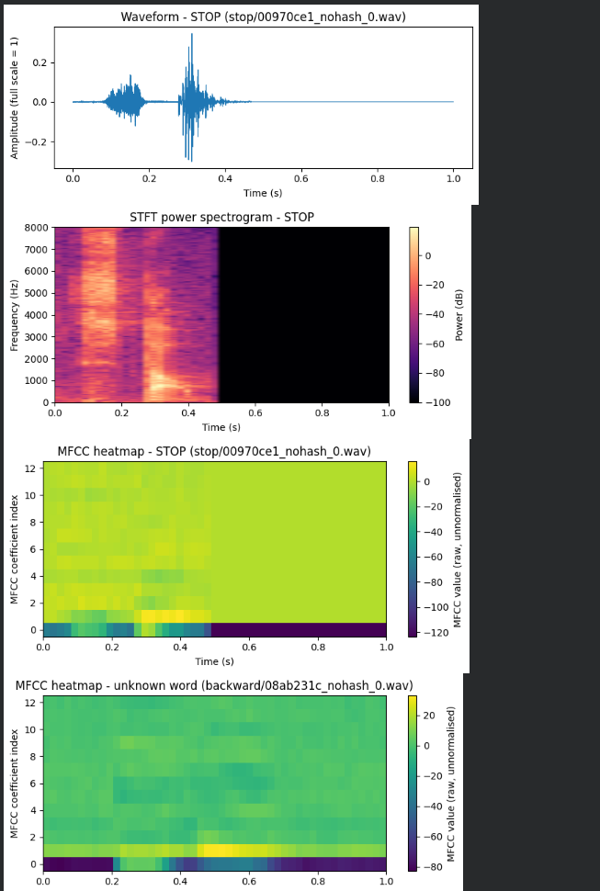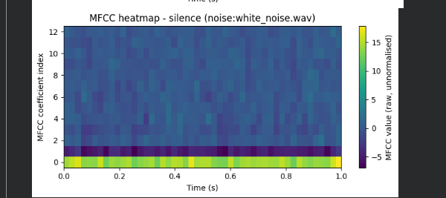
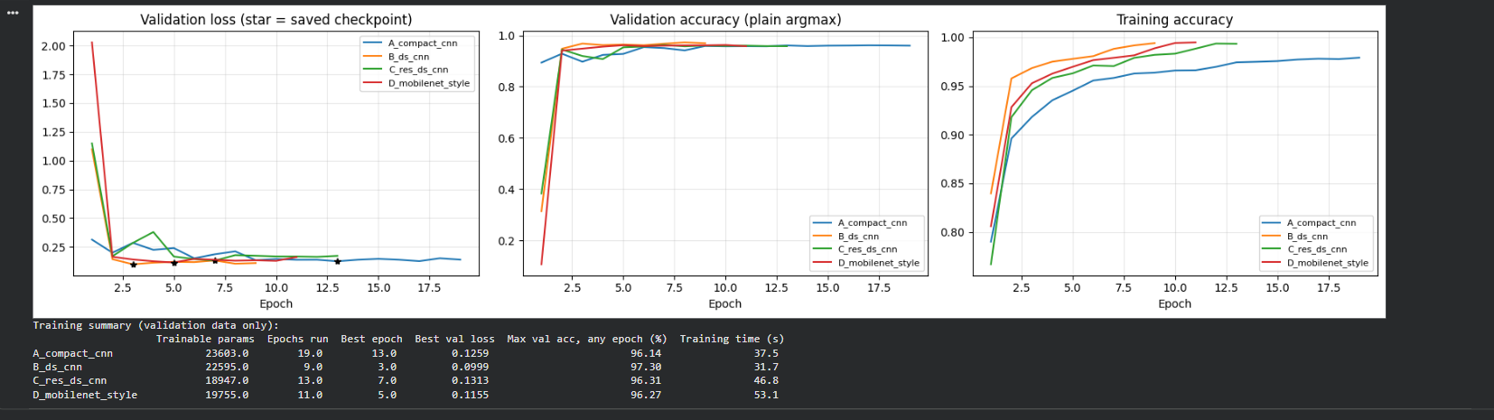
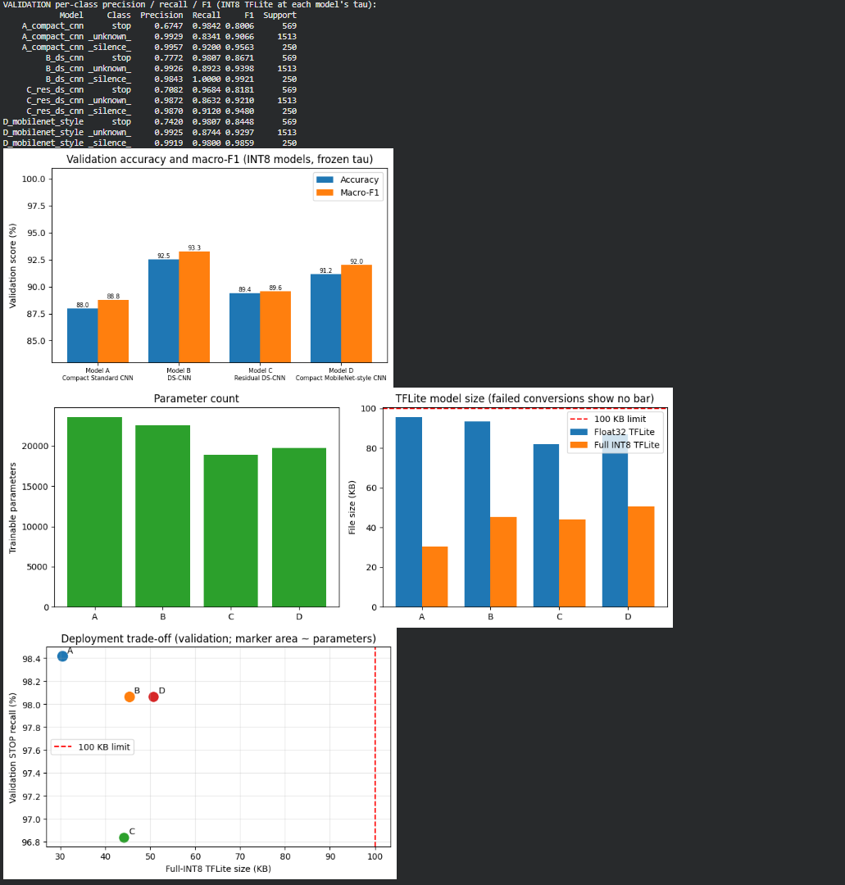
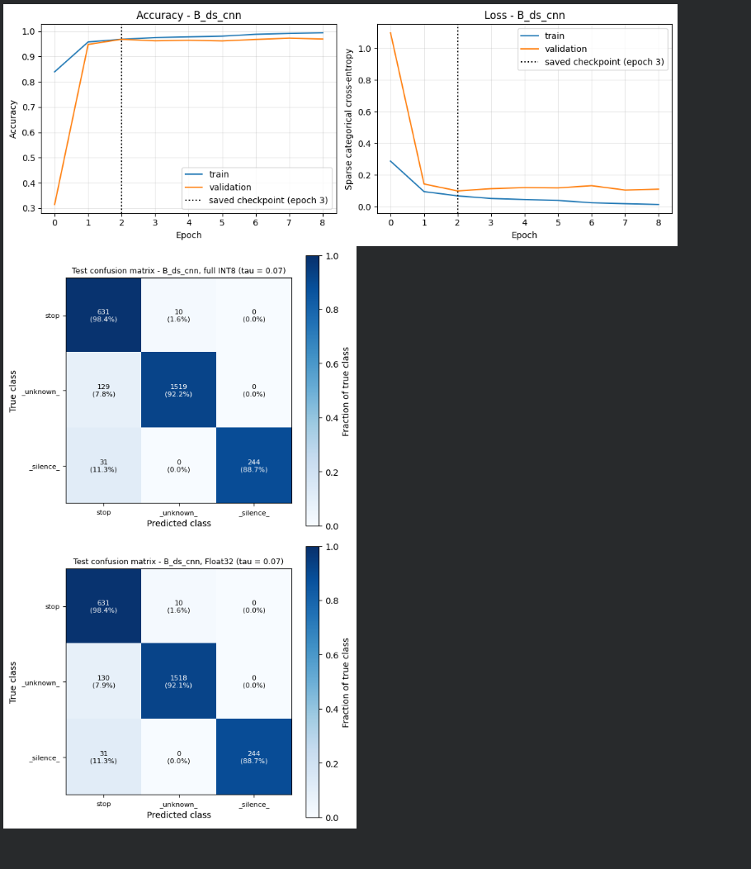
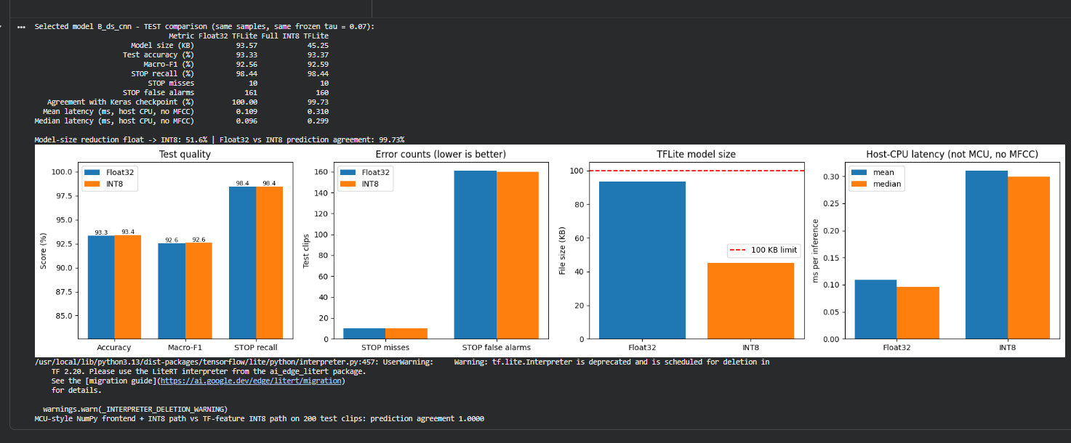
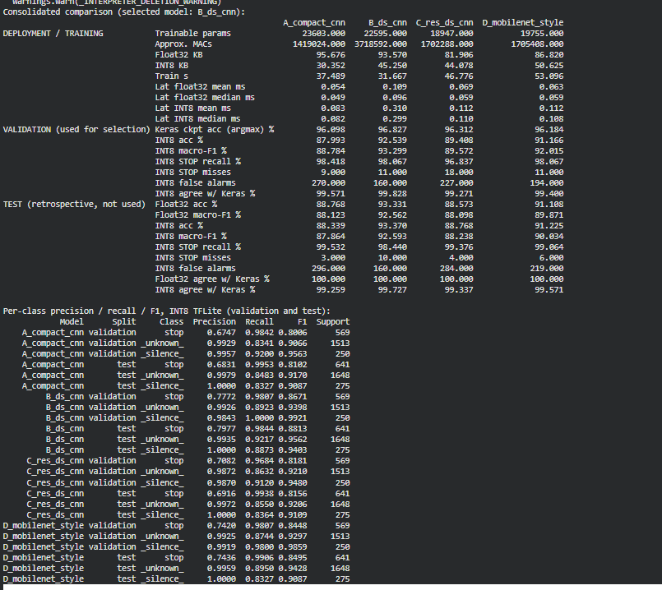
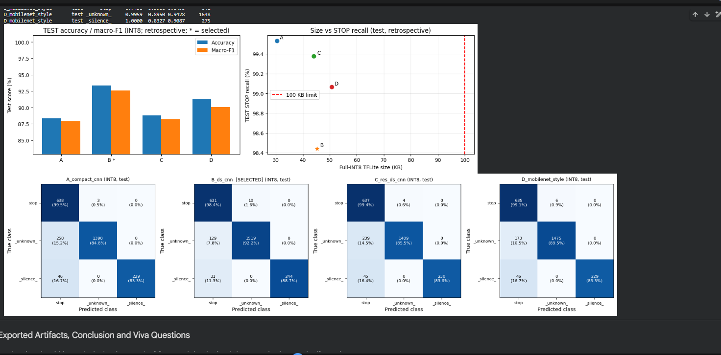

CONCLUSION:
Thus, a keyword spotting model was developed using MFCC features and four lightweight CNN architectures to recognise the commands STOP, UNKNOWN, and SILENCE. The models were compared based on classification performance and deployment efficiency, followed by Float32 and INT8 quantisation to evaluate model size, accuracy, and inference latency. This experiment demonstrates the potential of TinyML for offline voice-based emergency stop systems on resource-constrained devices.

